Changes to the Simplified Process – Indictable Crime – Trial application form

This ATLAS user guide provides information about completing the new ‘Solicitor Advocate Briefing’, ‘Preferred Barrister Briefing’, ‘Non-Preferred Barrister Briefing’ and ‘Senior Counsel’ menu items.

Glossary
‘Major Criminal Trial’ is a criminal trial that is likely to last more than 15 days.
‘Non-Preferred Barrister’ means a barrister who is not on the Criminal Trial Preferred Barrister List.
‘Preferred Barrister’ means a barrister who is on the Criminal Trial Preferred Barrister List.
‘Standard Criminal Trial’ is a criminal trial that is likely to last 15 days or less.
‘Transitional period’ means the period from 31 July 2015 to 30 September 2015, inclusive.

New features in the Simplified Process – Indictable Crime – Trial application form
There are four new menu items:
- SOLICITOR ADVOCATE BRIEFING;
- PREFERRED BARRISTER BRIEFING;
- NON-PREFERRED BARRISTER BRIEFING; AND
- SENIOR COUNSEL

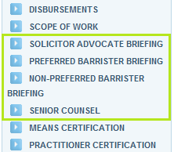
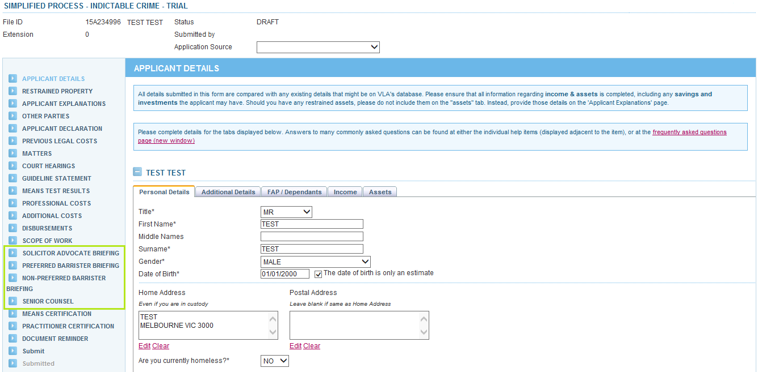

Solicitor advocate briefing
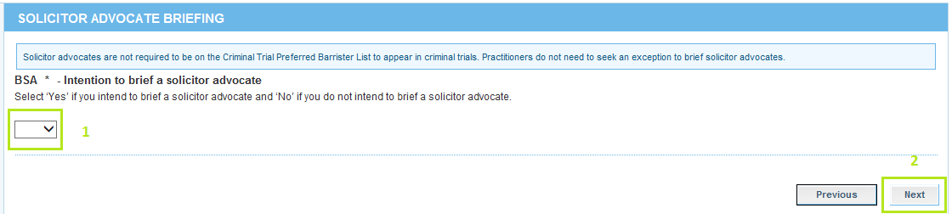

- Select ‘Yes’ or ‘No’ depending on whether you intend to brief a solicitor advocate.
- If you select ‘Yes’ and click ‘Next’, you will move to the MEANS CERTIFICATION screen. You will skip the PREFERRED BARRISTER BRIEFING, NON-PREFERRED BARRISTER BRIEFING and SENIOR COUNSEL screen. You will not be prompted to provide the details of who you intend to brief as the solicitor advocate. However, you are required to provide this information when you submit a claim.
If you select ‘No’ and click ‘Next’, you will move to the PREFERRED BARRISTER BRIEFING screen.

Preferred barrister briefing
From 31 July 2015, practitioners seeking a new grant of legal assistance for trial will be required to indicate who they intend to brief.
If the trial commences during the transitional period, you will see the below on the PREFERRED BARRISTER BRIEFING screen:
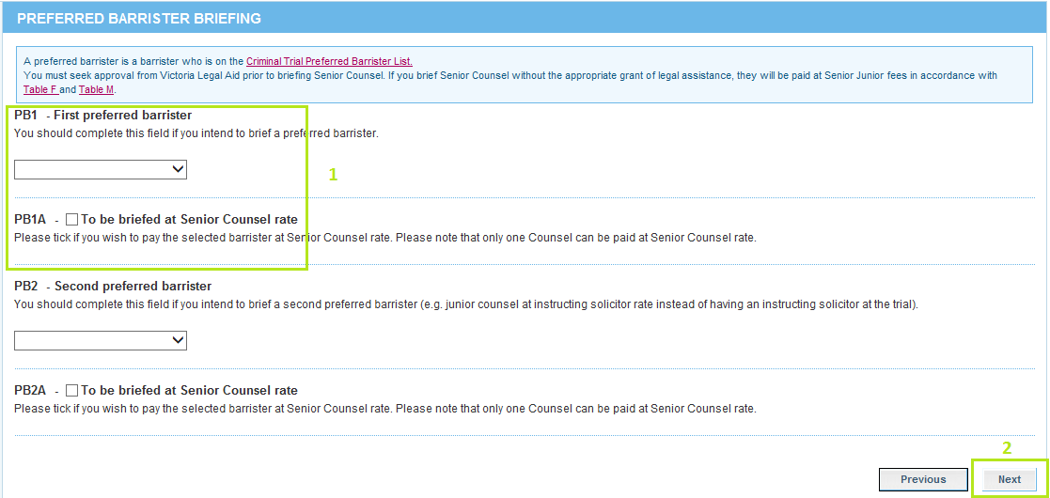
- Fields ‘PB1’ and ‘PB1A’ should be considered together (similarly fields ‘PB2’ and ‘PB2A’ should be considered together).
Fields ‘PB1A’ or ‘PB2A’ should only be completed if you are seeking assistance for Senior Counsel and would like to brief a Preferred Senior Counsel at Senior Counsel rate. Leave these fields blank if you are not seeking assistance for Senior Counsel.
If you intend to brief only one Preferred Barrister at Senior Junior fees, select a barrister from the ‘PB1’ field and click ‘Next’.
Leave fields ‘PB1’, ‘PB1A’, ‘PB2’ or ‘PB2A’ on the PREFERRED BARRISTER BRIEFING screen blank if you do not intend to brief a Preferred Barrister.
- If you do not complete any fields and click ‘Next’, you will move to the NON-PREFERRED BARRISTER BRIEFING screen.
If you ticked fields ‘PB1A’ or ‘PB2A’ in addition to selecting a barrister and click ‘Next’, you will move to the NON-PREFERRED BARRISTER BRIEFING screen (where you will need to complete the required fields) and then SENIOR COUNSEL screen, otherwise you will move to the NON-PREFERRED BARRISTER BRIEFING and then MEANS CERTIFICATION.
If the trial commences outside of the transitional period, you will see the below on the PREFERRED BARRISTER BRIEFING screen:
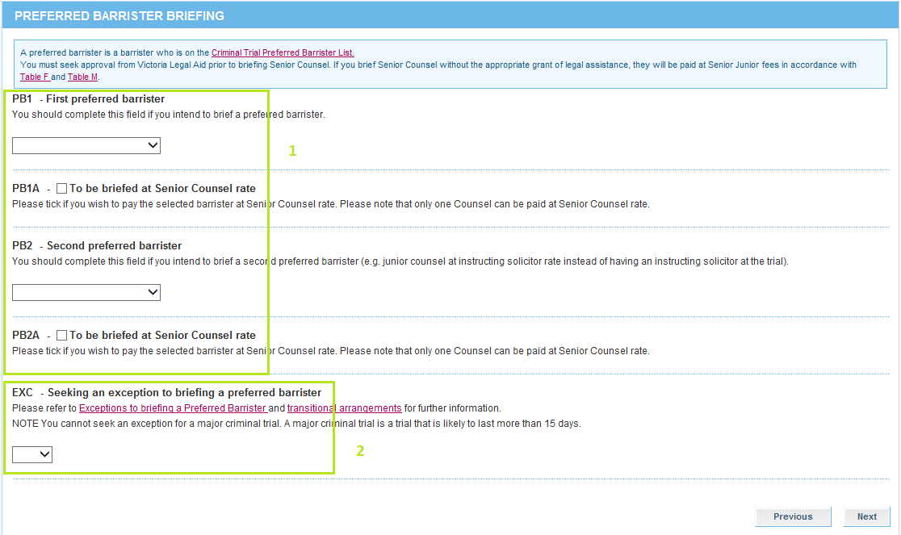

- See point 1 on page 3. Complete the relevant field/s.
- You must complete the ‘EXC *’ field before clicking ‘Next’.
If you select ‘No’ to seeking an exception to briefing a Preferred Barrister, you must select a Preferred Barrister.
If you select ‘Yes’ and click ‘Next’, you will move to the NON-PREFERRED BARRISTER BRIEFING screen.

Non-preferred barrister briefing
If the trial commences during the transitional period, you will see the below on the NON-PREFERRED BARRISTER BRIEFING screen:

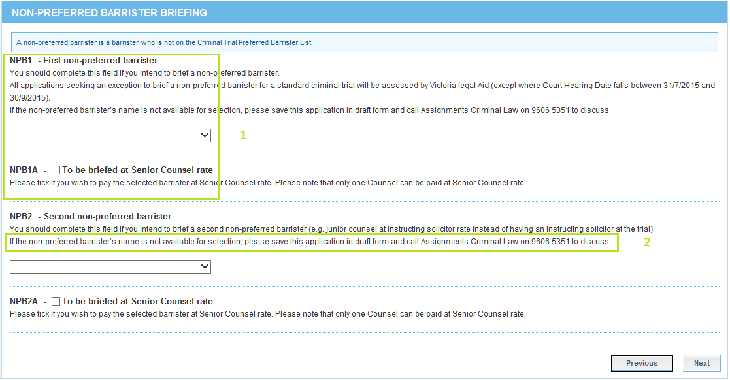

- Fields ‘NPB1’ and ‘NPB1A’ should be considered together (similarly fields ‘NPB2’ and ‘NPB2A’ should be considered together).
Fields ‘NPB1A’ or ‘NPB2A’ should only be completed if you are seeking assistance for Senior Counsel and would like to brief a Non-Preferred Senior Counsel at Senior Counsel rate. Leave these fields blank if you are not seeking assistance for Senior Counsel.
If you intend to brief only one Non-Preferred Barrister at Senior Junior fees, select a barrister from the ‘NPB1’ field and click ‘Next’.
- If you cannot find a Non-Preferred Barrister’s name in the drop down menu, save the application in draft form and contact the Grants and Quality Assurance, Stakeholder Relations teamto discuss.
You may not be able to find a Non-Preferred Barrister’s name in the drop down menu because they may not be registered as a Service Provider on ATLAS. If this is the case, you should send a copy of a recent tax invoice from the barrister which includes their name, contact details, payment details and ABN to Grants@vla.vic.gov.au. TheCo-ordinator, Major Criminal Cases must approve addition of the barrister before forwarding the information onto the ATLAS helpdesk team. Once the barrister is registered as a Service Provider on ATLAS, you will be able to select their name from the drop down menu.

If the trial commences outside of the transitional period, you will see the below on the NON-PREFERRED BARRISTER BRIEFING screen:
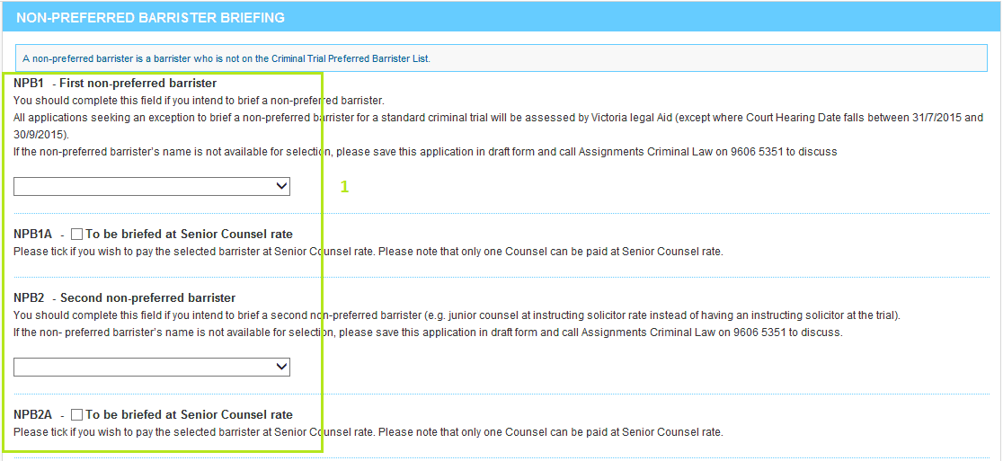
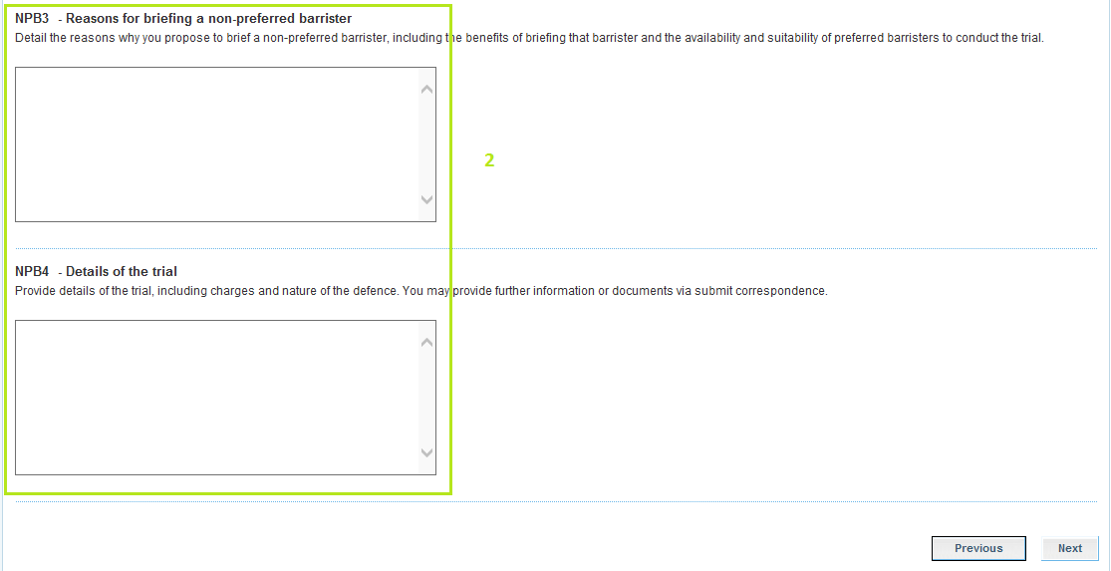

- See points 1 & 2 on page 5. Complete the relevant field/s.
- Where you have requested an exception to brief a Non-Preferred Barrister, you must complete fields ‘NPB3’ and ‘NPB4’.
If you ticked fields ‘NPB1A’ or ‘NPB2A’ in addition to selecting a barrister and click ‘Next’, you will move to the SENIOR COUNSEL screen, otherwise you will move to the MEANS CERTIFICATION screen.

Senior counsel

If you ticked either ‘PB1A’ or ‘PB2A’ in the PREFERRED BARRISTER BRIEFING screen or ‘NPB1A’ or ‘NPB2A’ in the NON-PREFERRED BARRISTER BRIEFING screen, you must complete the SENIOR COUNSEL screen.
You may provide further information or documents via submit correspondence.
