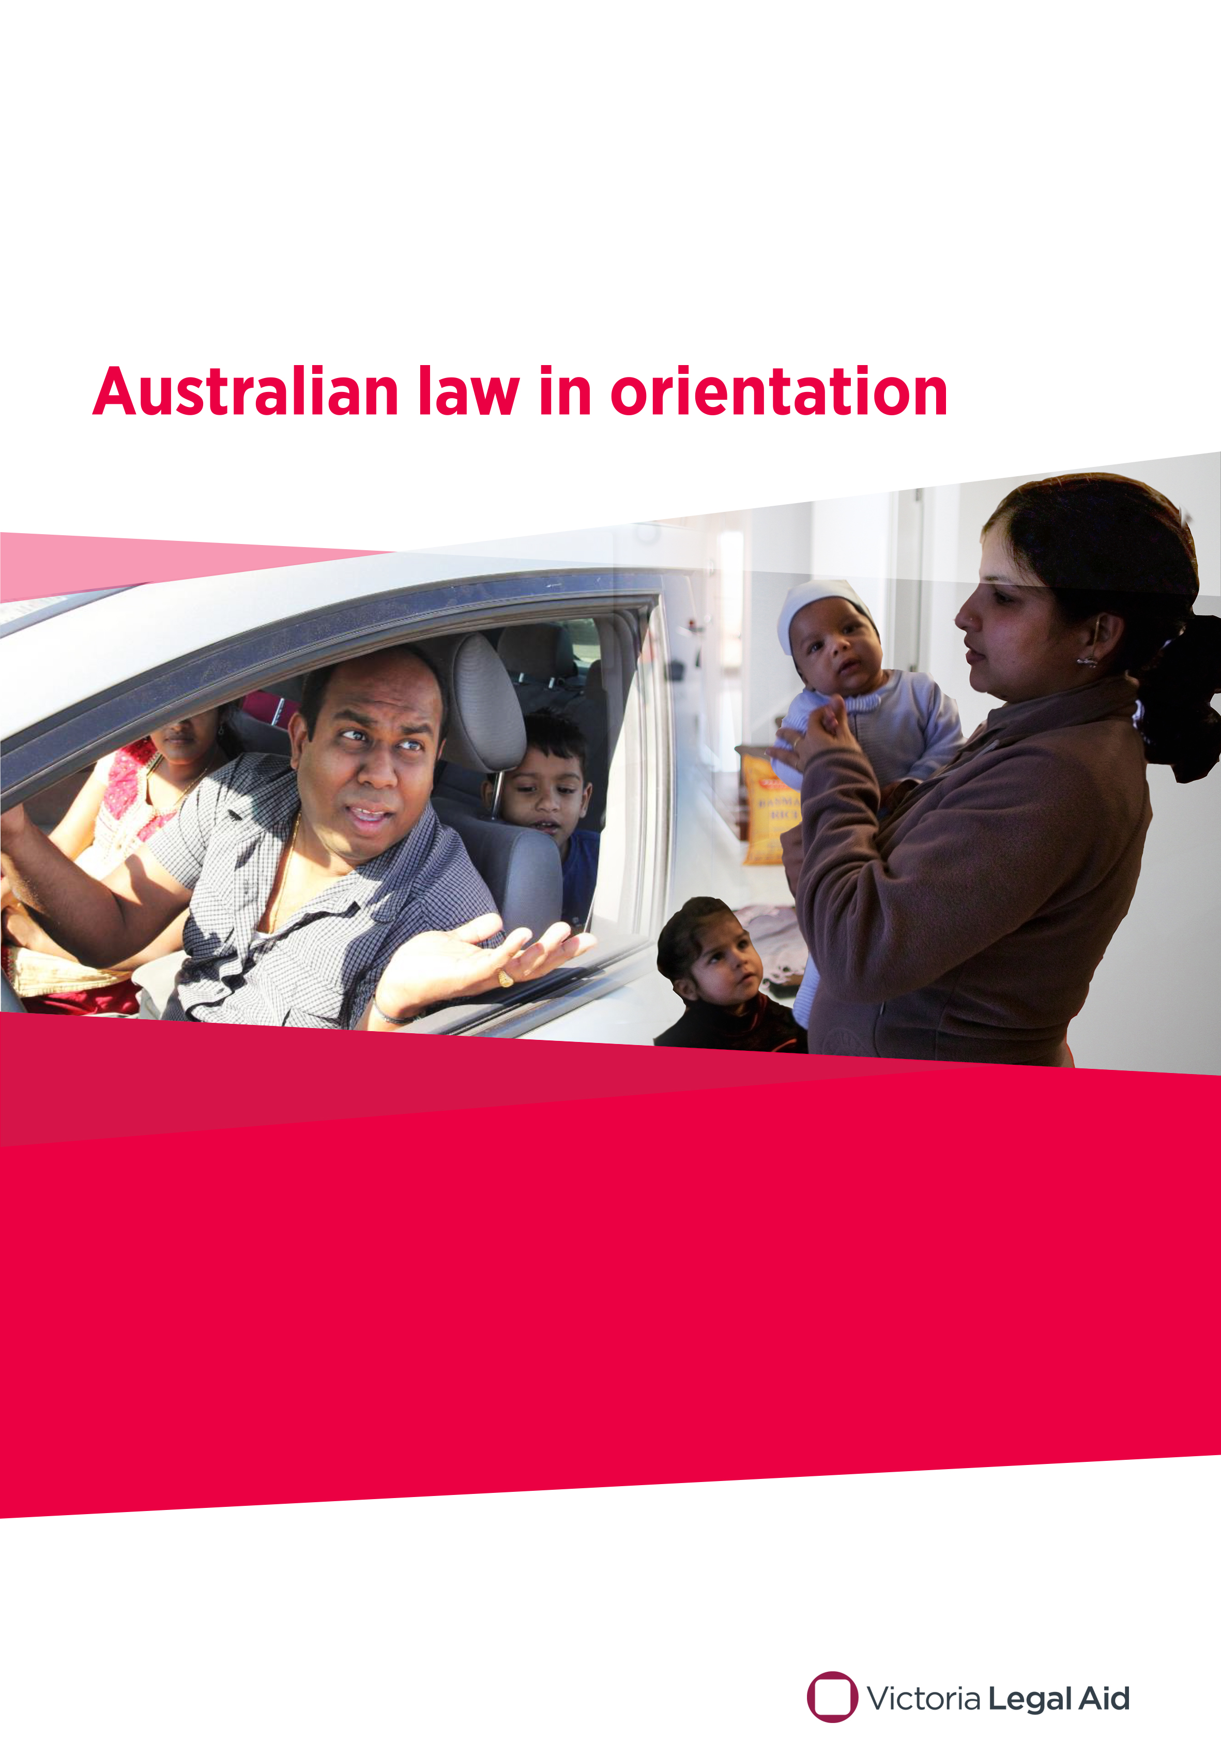
December 2020

Speakers’ notes
Australia’s legal system, Child protection and parenting, Driving, Family violence and Police
Do you need these notes in a different format?
Please ring us on (03) 9269 0234 and ask for Publications. We can talk with you about what you need.
Produced by Victoria Legal Aid
Victoria Legal Aid
570 Bourke Street
Melbourne VIC 3000
For free information about the law and how we can help you:
• visit our website www.legalaid.vic.gov.au
• use our Legal Help Chat on the website, Monday to Friday, 8 am to 5 pm, excluding public holidays
• call Legal Help on 1300 792 387, Monday to Friday, X am to X pm, excluding public holidays.
For business queries, call (03) 9269 0234.
First edition January 2017, minor updates in 2019 and 2020
Acknowledgments: We thank AMES for their input into the original version of this resource.
© 2020 Victoria Legal Aid.
This work is licensed under a Creative Commons Attribution 4.0 licence. You are free to re-use the work under that licence, on the condition that you credit Victoria Legal Aid as author, indicate if changes were made and comply with other licence terms. The licence does not apply to any images, photographs or branding, including the Victoria Legal Aid logo.
Disclaimer: The material in this publication is a general guide only. It is not legal advice. If you need to, please get legal advice about your own particular situation.
All stories, examples and case studies in these notes are fictional and do not relate to cases run by Victoria Legal Aid.
Victoria Legal Aid
Victoria Legal Aid is a government-funded agency set up to ensure that people who cannot afford to pay for a private lawyer can get help with their legal problems. We provide free information for all Victorians, family dispute resolution for disadvantaged families, provide lawyers on duty in most courts and tribunals in Victoria, and fund legal representation for people who meet our eligibility criteria. We help Victorian people with legal problems about criminal matters, family breakdown, child protection, family violence, child support, immigration, social security, mental health, discrimination, guardianship and administration, tenancy and debt.
Changes to the law
The law changes all the time. To check for changes you can visit our website, use our Legal Help Chat or call us.
Contents
About these speakers’ notes 6
Australian law in orientation 6
Using the speakers’ notes 6
Working with interpreters 7
Australia’s legal system 8
Before the session 8
Day of the session 8
Length of the session 8
Overview of slides 8
Slide 1 – Australia’s legal system 9
Slide 2 – Today’s session 9
Slide 3 – Gahmal and Abdi 10
Slide 4 – Who makes laws? 10
Slide 5 – What laws are there? 11
Slide 6 – Who must follow the law? 12
Slide 7 – What happens if you do not follow the law? 12
Slide 8 – What happens at court? 13
Slide 9 – What penalties are there? 13
Slide 10 – Free legal help 14
Slide 11 – Abdi wants to know 14
Slide 12 – Who does what? 15
Child protection and parenting 16
Before the session 16
Day of the session 16
Length of the session 16
Overview of slides 16
Slide 1 – Child protection and parenting 17
Slide 2 – Today’s session 17
Slide 3 – Meena and her children 18
Slide 4 – Home alone 18
Slide 5 – Meena and Susan 18
Slide 6 – What does the law say about beating? 19
Slide 7 – Free help 19
Slide 8 – Who can help Meena look after her children? 20
Driving 21
Before the session 21
Day of the session 21
Length of the session 21
Overview of slides 21
Slide 1 – Driving 22
Slide 2 – Today’s session 22
Slide 3 – Ram’s new car 23
Slide 4 – Licences 23
Slide 5 – Is Ram ready to drive? 24
Slide 6 – What does Ram need to do? 24
Slide 7 – Other driving laws 24
Slide 8 – What penalties are there? 25
Slide 9 – Insurance 25
Slide 10 – Free help 26
Slide 11 – What are some driving laws in Australia? 26
Family violence 27
Before the session 27
Day of the session 27
Length of the session 27
Overview of slides 27
Slide 1 – Family violence 28
Slide 2 – Today’s session 28
Slide 3 - Radha 29
Slide 4 – What is wrong with Ajay’s actions? 29
Slide 5 – What can Radha do? 30
Slide 6 – Family violence intervention orders 30
Slide 7 – Free help 31
Slide 8 – True or false? 31
Police 32
Before the session 32
Day of the session 32
Length of the session 32
Overview of slides 32
Slide 1 – Police 33
Slide 2 – Today’s session 33
Slide 3 – Police 34
Slide 4 – Gahmal and Abdi 34
Slide 5 – Name and address 34
Slide 6 – Correct information 34
Slide 7 – Other police questions 35
Slide 8 – Police details 35
Slide 9 – What can happen? 35
Slide 10 – What happens at court? 36
Slide 11 – True or false? 36
Extra resources 37
Where to get help 37
Australia’s legal system 37
Child protection 37
Driving 37
Family violence 37
Police 38

About these speakers’ notes

Australian law in orientation
Australian law in orientation is an education kit for Victorian educators, teachers and community workers teaching people who:
- have been in Australia for less than six months
- have low or no English and very basic legal literacy.
The education kit includes:
- these speakers’ notes
- five picture-based PowerPoint documents.
The PowerPoint documents cover the following legal topics:
- Australia’s legal system, including voting and going to court
- driving
- police
- child protection
- family violence.
We based the PowerPoint documents on our What’s the law? Australian law for new arrivals kit (www.legalaid.vic.gov.au/find-legal-answers/free-publications-and-resources/whats-law-australian-law-for-new-arrivals-education-kit).
We originally developed this resource with AMES Australia, to meet the curriculum requirements of the Onshore Orientation Program that provides some legal information to recently arrived humanitarian entrants in the Australian Government’s Humanitarian Settlement Services Program. This is a program for refugees and humanitarian entrants aged 15 years and over, to help them understand Australian society, laws and culture.

Using the speakers’ notes
The Australian law in orientation education kit is for an educator, teacher or community worker to use to deliver legal education classes. This could include:
- TAFE teachers
- VCAL (Victorian Certificate of Applied Learning) teachers
- EAL (English as Another Language) teachers
- community workers
- settlement information officers
- multicultural workers
- settlement workers
- lawyers.
The speakers’ notes are a guide to using each PowerPoint document. The speakers’ notes include:
- the purpose of each slide in the PowerPoint document
- what to say to students or participants about each slide
- suggested discussion questions for each slide, where relevant.
There should be enough legal background information for each PowerPoint document. However, we also include a section Extra resources at the back with links to legal websites. You may want to visit these for further reading.
We have written the speakers’ notes and the PowerPoints to be very basic, for people with basic levels of legal and English literacy. If you need an education kit for students or participants with higher levels of literacy, you may want to use our What’s the law? Australian law for new arrivals kit (www.legalaid.vic.gov.au/find-legal-answers/free-publications-and-resources/whats-law-australian-law-for-new-arrivals-education-kit).

Working with interpreters
The education kit is easy to use with an interpreter or by a bilingual worker.

Australia’s legal system

Before the session
To help you run a session on Australia’s legal system, we suggest you first:
- read the PowerPoint document
- read these speakers’ notes
- do more research into the topic if you want. You can look at the websites in the Extra resources section.

Day of the session
You will need:
- a device such as a tablet, laptop or computer
- a data projector, with the correct cords to connect to the device
- a blank space to project on
- the Australia’s legal system PowerPoint document downloaded onto your device.
We include activities at the end of the PowerPoint. You can run the activity as a group activity. You may want to print it out and hand out copies, to run it as an individual activity.

Length of the session
If you run the session using the PowerPoint document and the speakers’ notes, it will probably take about 20 minutes, including questions and discussion.

Overview of slides

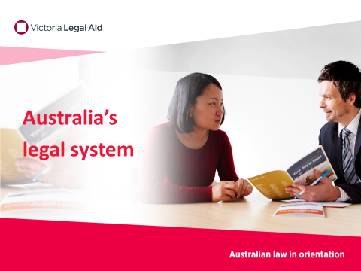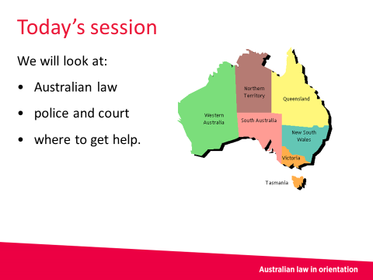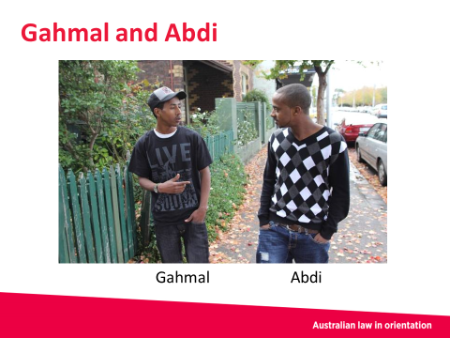
Slide 1 Slide 2 Slide 3
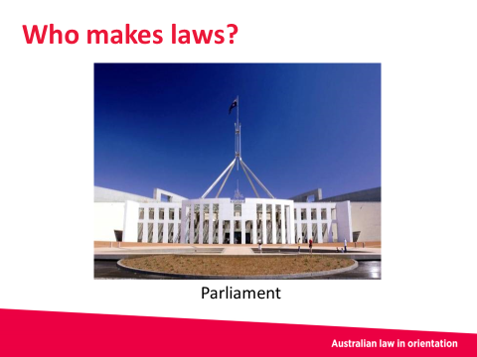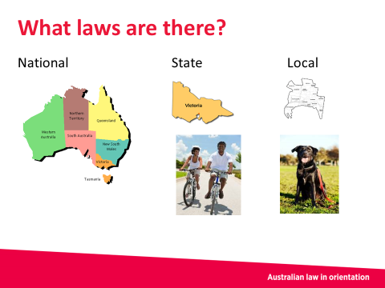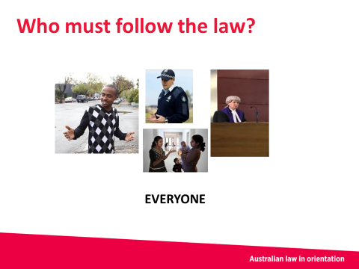
Slide 4 Slide 5 Slide 6
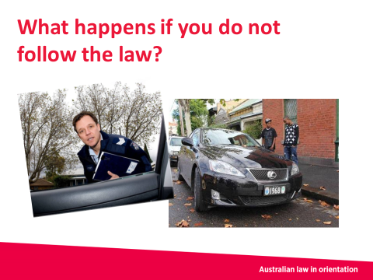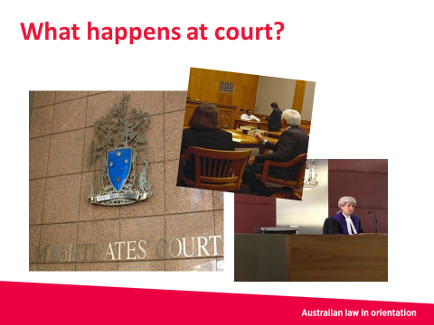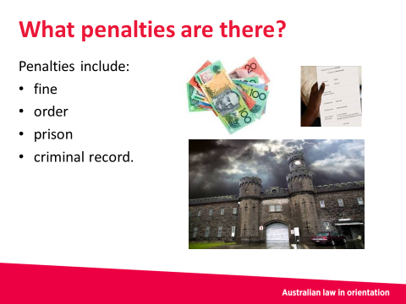
Slide 7 Slide 8 Slide 9
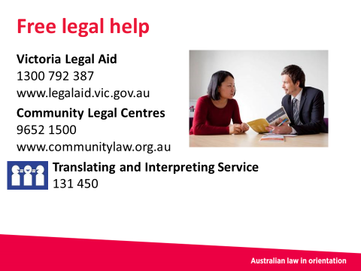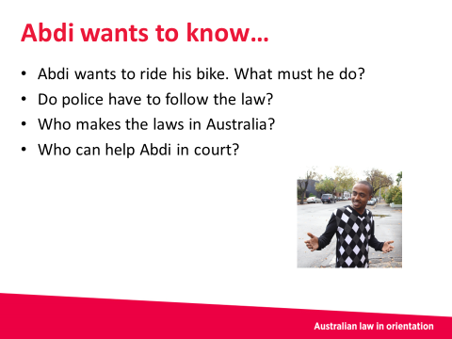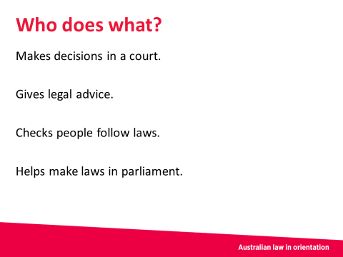
Slide 10 Slide 11 Slide 12

Slide 1 – Australia’s legal system

About the slide
This is the introductory slide.

What to let the students or participants know
Key things to note:
- Victoria Legal Aid produced the Australian law in orientation kit and this PowerPoint document
- Contact details for Victoria Legal Aid and other services are provided at the end of the PowerPoint document.

Discussion
Suggested questions include:
- What did you know about Australian laws before you got to Australia?
- What have you learnt since you got here?
Note – please use your knowledge of the participants in how you might frame the opening questions. You may want to note that people do not have to tell any personal stories about themselves or family members getting in trouble with the law.

Slide 2 – Today’s session
About the slide
This slide gives an overview of the session.

What to let the students or participants know
This session covers:
- Australian law, including how Australian and Victorian laws are made
- the role of police and courts
- where to get legal help.

It’s useful to know that:
- some laws apply to every state and territory in Australia
- some laws apply only to an individual state or territory. Victoria, the orange state in the slide, has laws that are different to the other states or territories
- the law in Australia and in Victoria might be very different from the law in countries you have lived in.

Discussion
Suggested questions include:
- What are some of the laws in the country you have come from?
Note – please use your knowledge of the participants in how you might frame this question. You may want to note that people do not have to tell any personal stories about themselves or family members getting in trouble with the law.

Slide 3 – Gahmal and Abdi
About the slide
This slide introduces two characters – Gahmal and Abdi.

What to let the students or participants know
In today’s session, we are following two characters – Gahmal and Abdi. We will be following Abdi’s story.
Abdi talks to his friend Gahmal, who has been in Australia for a while. Abdi has gotten into trouble with the police and has to go to court. Abdi recently arrived in Australia. He wants to know about Australian laws.
Throughout this session, we will help answer Abdi’s questions, and what he needs to do at court.

Discussion
Suggested questions include:
- If you got in trouble with the police, who would you go to within your family for advice about what to do? Within your community? Within your friendship network?
- If you had a friend who got in trouble with the police, what would you say to them?
Note – please use your knowledge of the participants in asking these questions. If the class is very new, they may not yet feel comfortable sharing this information.

Slide 4 – Who makes laws?

About the slide
This slide focusses on how laws are made in Australia.

Notes to the speakers
Abdi wanted to know about Australian laws. He wants to know who makes the laws.
The laws are made by parliament. Parliament is a group of politicians who we vote for at elections. All Australian citizens 18 years and older must vote. You choose who you vote for, and people cannot be paid to vote a certain way.
In making laws, parliament listens to different people in the community and is supposed to make laws to protect society.
There is a parliament making laws for all of Australia. There is also a parliament making laws for Victoria.

Discussion
Suggested questions include:
- Can anyone recognise the building in the picture?
Answer: It is national Parliament House in Canberra.
- Has anyone been here? What was it like for you?
- Do you know who the Prime Minister of Australia is?
Answer: The Prime Minister is the leader of the national parliament. The current Prime Minister is… (For the answer, if you do not know who the current Prime Minister is, you can check on the Prime Minister of Australia website (www.pm.gov.au/).
- Do you know who the Premier of Victoria is?
Answer: The Premier is the leader of the parliament in Victoria. The current Premier is… (For the answer, if you do not know who the current Premier is, you can check on the Premier of Victoria website (www.premier.vic.gov.au/#results).

Slide 5 – What laws are there?

About the slide
This slide builds on the last slide.

What to let the students or participants know
There are three levels of laws in Australia:
- national laws for the whole country of Australia, also referred to as Commonwealth laws
- state or territory laws (for example, Victoria)
- local laws (for example, Brimbank City Council, which is the local council for areas including Sunshine and St Albans).
Here are some examples of laws:
- There are national laws about immigration, and about coming to Australia to visit, study or live
- There are state laws in Victoria about riding bicycles. You must wear a helmet whenever you ride a bicycle and you must follow road rules, like stop signs and traffic lights
- There are Victorian laws about driving a car. These might be different to laws in other states
- There are local laws about pets. There are rules about what kind of animals you can have in your home and how you should clean up after them in public
- There are also local laws about rubbish bins, and how much noise you can make when you are at home. The laws in your local council might be different to the laws in other local councils.
As we mentioned in the last slide, parliament makes laws. For some laws, different government departments are responsible for putting the laws into action. For example, for immigration law, the Department of Immigration and Border Protection is the government department responsible for making sure people follow the law.
For other law laws, like criminal law or driving laws, the police are responsible for making sure people follow these laws.

Discussion
Suggested questions include:
- What are some of the rules you have to follow in your local council area for putting out rubbish?
- What are some of the rules you have to follow when driving a car?
- What are some of the rules you have to follow when using public transport?

Slide 6 – Who must follow the law?

About the slide
This slide builds on the last slide. Having established what some laws are, it is now important to talk about who has to follow the law.

What to let the students or participants know
Laws apply to everyone. It is important to know that:
- Everyone must follow the law:
- Everyone who lives in or visits Australia must follow national laws
- Everyone who lives in or visits Victoria must also follow Victorian laws
- Everyone who lives in or visits a council area in Victoria must also follow the laws of that council area
- In Australia the law applies equally to everyone, including police, judges, lawyers and politicians. It does not matter what religion or race you are, or whether you are male or female
- In Australia, the government, courts, police, media and religion are independent. This means they all work separately.

Discussion
Suggested questions include:
- Why do you think everyone has to follow the laws?

Slide 7 – What happens if you do not follow the law?

About the slide
This slide builds on the last slide. Having established that everyone must follow the law in Australia, it is now important to establish that there are consequences for breaking the law. In this slide we also return to Abdi.

What to let the students or participants know
Police can check that people are following certain types of law. For example, there are certain laws about:
- driving
- stealing
- hurting other people
- drugs.
The police are supposed to help protect society from dangerous things happening.
If you do not follow certain laws, police might catch you. If the police catch you breaking the law, you might have to go to court.
In our story, the police caught Abdi driving a car without a proper licence. Afterwards, the police sent Abdi a letter telling him he must go to court.
Abdi is worried he will not know what to say in court, and he does not have any money for a lawyer.

Discussion
Suggested questions include:
- Where is your closest court?
(For the answer, you may need to do some research into the closest courts to you and to your participants. You can check the Magistrates’ Court of Victoria website (www.mcv.vic.gov.au). Most local council areas have a court).

- Do lawyers cost money?
Answer: Some lawyers do cost money. For example, if you need a lawyer to help you buy a house, you will probably have to pay for their service. For going to court, lawyers at Victoria Legal Aid and at a community legal centre can often give some sort of help for free. It is important to know that lawyers are independent from the court and from police. Generally, lawyers do not share information with courts and police unless you want them to.

Slide 8 – What happens at court?

About the slide
In this slide we see what happens to Abdi at court.

What to let the students or participants know
Abdi goes to court. He gets to court at 9am and has to wait for a few hours until it is his turn.
When Abdi is in the courtroom, first the police talk about what laws they think Abdi has broken. Then Abdi has a chance to tell his story.
After listening to what the police have said and what Abdi said, the judge or magistrate decides if Abdi broke the law and if Abdi should be punished. Judges and magistrates are independent and must also follow the law.
Discussion
- What do you think ‘independent’ means?
Answer: It means they are not on anyone’s side. They treat both sides equally. If the judge or magistrate decides that Abdi broke the law, they will decide on a penalty (a punishment).

Slide 9 – What penalties are there?

About the slide
In this slide we find out more about what sort of punishment (penalty) Abdi might get.

What to let the students or participants know
The judge or magistrate might give Abdi a penalty, which is a punishment for breaking the law. Note – it is important to say ‘might’. Not everyone gets a penalty; it depends on what law was broken and the circumstances as to why a person broke the law.
The penalty might be:
- a fine – this means Abdi pays money
- a court order – this means Abdi has to do certain things. The order will be written down
- a criminal record – this is a list that shows what laws Abdi has broken. The police keep the list up-to-date.
If Abdi gets a criminal record, this might show up if he applies for a:
- job and the employer asks for a police check
- Working With Children Check card
- visa for travelling to some countries.
A criminal record may mean Abdi does not get the job or the Working With Children Check card, or that he cannot visit some countries.
If someone breaks a very serious law, they might get a penalty that sends them to prison for a certain amount of time.
You can still get in trouble for breaking a law even if you did not know about the law. ‘I didn’t know’ is not an excuse.

Discussion
Suggested questions include:
- Why do you think there are different penalties?
Answer: The answer to this can be quite complex. To summarise, over time, the Australian and Victorian legal systems have judged that different laws have different levels of seriousness. Breaking a very serious law will mean a heavier punishment. For example, murdering someone.

Slide 10 – Free legal help

About the slide
In this slide, we talk about places where people can get free legal help.

What to let the students or participants know
Abdi’s story is finished now. Now it’s time to talk about places that Abdi could have gotten help from. You can also get help from these places if you find yourselves in trouble with the law.
Everyone can get free information about the law. That means Abdi can get free legal help. He can also get a free interpreter if he needs one.
A lawyer can also help before Abdi goes to court or on the day at court. Lawyers help people solve their legal problems and help people understand the law. It is important to know that lawyers are independent from the court and from police. Generally, lawyers do not share information with courts and police unless you want them to.
For free legal help:
- Call Victoria Legal Aid on 1300 792 387. You can also call Legal Help to see if you can get help from a Victoria Legal Aid lawyer before going to court or on the day at court. Victoria Legal Aid tries to help the people who need it most and so they cannot give everyone the same level of help.
- Find your nearest community legal centre by calling (03) 9652 1500. A lawyer at a community legal centre may be able to help.
Victoria Legal Aid has telephone workers who speak other languages. If there is not a worker who speaks in your language, you can call the Translating and Interpreting Service on 131 450 to get an interpreter in your language for any of these services.
Note – If you have copies of Victoria Legal Aid’s Legal Help wallet cards, either in English or the language you are presenting in, pass these out to the group. You can order Legal Help cards from the Victoria Legal Aid website (www.legalaid.vic.gov.au). Click on ‘Order free publications and resources’, then ‘About Victoria Legal Aid’.

Slide 11 – Abdi wants to know

About the slide
This is an activity slide. The questions relate to what we went through in the session. If you have time, you can run this activity and the next one.

About the activity
Ask each question and ask for an answer.
The answers are as follows:
- Abdi wants to ride his bike. Does he have to wear a helmet?
Answer: Yes. In Victoria, he must wear a helmet.
- Do police have to follow the law?
Answer: Yes. Everyone must follow the law.

- Who makes the laws in Australia?
Answer: Parliament. Parliament is made up of politicians who are elected.
- Who can help Abdi in court?
Answer: Victoria Legal Aid or a community legal centre.

Slide 12 – Who does what?

About the slide
This is a second activity slide.

About the activity
Read out each job description on the left and ask the group which person, on the right, does that job.
The answers are as follows:
- Makes decisions in court
Answer: Judge.
- Gives legal advice
Answer: Lawyer.
- Checks people follow laws
Answer: Police officer.
- Helps make laws in parliament
Answer: Politician.

Child protection and parenting

Before the session
To help you run a session on Child protection and parenting, we suggest you first:
- read the PowerPoint document
- read these speakers’ notes
- do more research into the topic if you want. You can look at the websites in the Extra resources section.

Day of the session
You will need:
- a device such as a tablet, laptop or computer
- a data projector, with the correct cords to connect to the device
- a blank space to project on
- the Child protection and parenting PowerPoint document downloaded onto your device.
We include activities at the end of the PowerPoint document. You can run the activity as a group activity. You may want to print it out and hand out copies, to run it as an individual activity.

Length of the session
If you run the session using the PowerPoint document and the speakers’ notes, it will probably take about 20 minutes, including questions and discussion.

Overview of slides
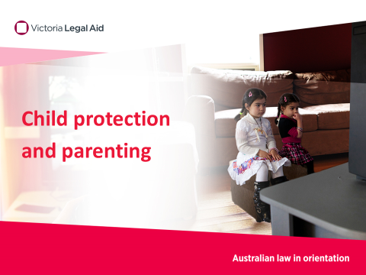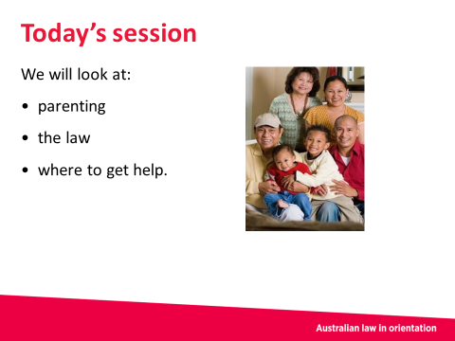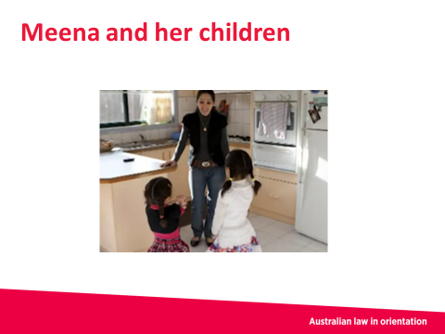
Slide 1 Slide 2 Slide 3
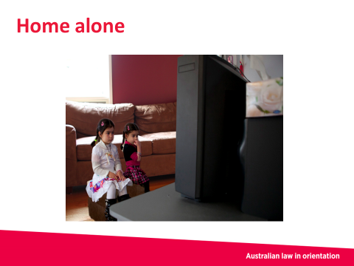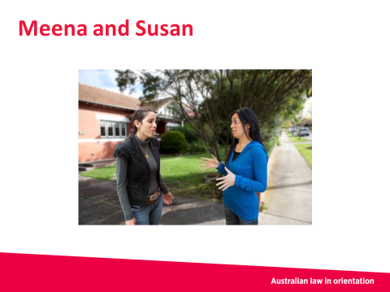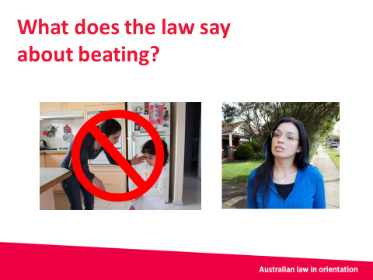
Slide 4 Slide 5 Slide 6
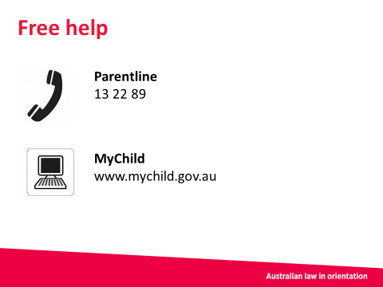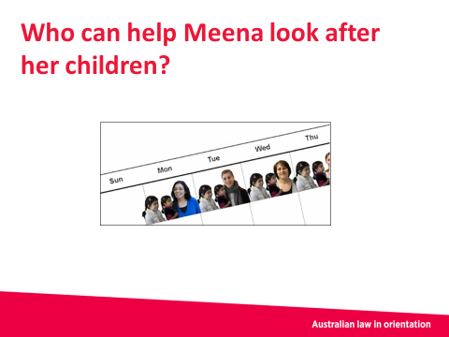
Slide 7 Slide 8

Slide 1 – Child protection and parenting

About the slide
This is the introductory slide.

What to let the students or participants know
Key things to note:
- Victoria Legal Aid produced the Australian law in orientation kit and this PowerPoint document
- Contact details for Victoria Legal Aid and other services are provided at the end of the PowerPoint document.

Discussion
Suggested questions include:
- What do you think ‘child protection’ means?
(There are no right or wrong answers at this stage. The session will go into what child protection means).

Slide 2 – Today’s session
About the slide
This slide gives an overview of the session.

What to let the students or participants know
This session covers:
- parenting
- the law
- where to get help.
There are laws to protect children from harm by anyone in the community, including parents and family members. These laws allow the government to do things to protect children if the government thinks children are being hurt in any way.
Different cultures and families have different ways of bringing up children. Australian laws understand this but they do not let parents hurt children, even when parents are teaching their children how to behave.
The law says the ‘best interests’ of the child must always be respected. This means that the health and wellbeing of the child, and the way the child is cared for and treated, are of most importance for the law.

Discussion
Suggested questions include:
- Are there any differences between your childhood and how you think children are raised in Australia?

Slide 3 – Meena and her children
About the slide
This slide introduces the character Meena.

What to let the students or participants know
We will use a story about Meena to help us think about parenting and child protection laws.
Meena is a single mother with no partner and no other family in Australia. She has two children, aged three and five years old.
Meena is busy working. She must work during the school holidays. She has no-one to look after the children when they are not at school.
Meena leaves the children home alone when she goes to work.
She tells them to stay inside and not talk to anyone.

Slide 4 – Home alone

About the slide
This slide continues the story of Meena.

What to let the students or participants know
Meena leaves her children home alone because she needs to work. However, Meena’s children are too young to stay at home alone. It is not safe. The children might get worried or upset. If an emergency happens, such as a fire or an accident, the children might not know what to do. This could be dangerous.
The law says that if children are left with no adult to look after them, Meena might not be looking after her children properly.
Meena could get a fine and have to pay a lot of money. Meena could even be put in prison if it is very serious.
The Department of Health and Human Services might also get involved. This is a section of the government that looks into reports of children being hurt or not looked after properly.
The law does not say at what age children are allowed to stay home alone and be safe. It can depend on their age, how long they are left alone and the situation.

Slide 5 – Meena and Susan

About the slide
This slide continues the story of Meena and introduces the character of Susan.

What to let the students or participants know
Meena returns home from work and her children are not there.
Meena’s neighbour Susan tells her that they were playing on the street and Susan looked after them for the day.
Meena is angry at the children for not listening to her. Meena tells Susan that she will have to beat the children for being naughty.
Beating means hurting a child physically, for example, hitting them or pushing them.

Discussion
Suggested questions include:
- Do you think there is anything wrong with Meena beating her children?

Slide 6 – What does the law say about beating?

About the slide
This slide builds on the last one and focusses on beating.

What to let the students or participants know
The law says people cannot beat children. All parents must follow this law.
In our story, Susan is worried about Meena’s children being hurt. She calls the Department of Health and Human Services. Susan tells them that Meena might beat her children. The Department of Health and Human Services must investigate Susan’s report. They can do things to stop children being hurt. Even if Meena does not actually beat her children, if she has said that she will, this is enough for the Department of Health and Human Services to investigate. This could even mean removing the children from Meena’s care if the Department of Health and Human Services think they are unsafe.
Some people in the community, like teachers and doctors, must report to the Department of Health and Human Services or police if they think a child is being hurt. This is called mandatory reporting.
Discussion
Suggested questions include:
- Are there other ways Meena could have dealt with her children that did not involve beating them or hurting them?

Slide 7 – Free help

About the slide
In this slide we talk about places where people can get free legal and other help.

What to let the students or participants know
Meena’s story is finished now. Now it’s time to think about places that Meena could get help from. You can also get help from these places.
For all parents, across all cultures, parenting can be hard at times. Sometimes we yell, lose control or cry when we are trying to get our children to do the right thing.
There are parenting programs that support mothers and fathers who are looking after children by themselves, like Meena. These programs can help the mothers and fathers make family rules to help children behave and learn.
Meena can call Parentline on 13 22 89 and ask for help. This is a free telephone counselling service for parents and carers of children.
Meena can find child care for her children when she is at work. There are different types of child care. You can visit the Child Care Finder (www.childcarefinder.gov.au) for information.
If Meena has to go to court, or if she is talking to the Department of Health and Human Services, she can get free legal help from Victoria Legal Aid on 1300 792 387. Or she can find her nearest community legal centre by calling (03) 9652 1500. It is important to know that lawyers are independent from the court and from police. Generally, lawyers do not share information with courts and police unless you want them to.
Meena can also speak with a lawyer even if the Department of Health and Human Services is not involved. She may want to get general information or advice. The lawyer will keep this information private unless the lawyer is concerned that the child or children are at immediate risk of harm.
Victoria Legal Aid has telephone workers who speak other languages. If there is not a worker who speaks in Meena’s language, she can call the Translating and Interpreting Service on 131 450 to get an interpreter in her language for any of these services.

Slide 8 – Who can help Meena look after her children?

About the slide
This is an activity slide. The question relates to what we went through in the session. If you have time, you can run this activity.

About the activity
This activity aims to get the group talking about parenting and who can help.
Ask around the room so that everyone has a chance to suggest a response.
Go through these options with the group about who can help Meena look after her children when she is at work:
- child care
- babysitter
- friends
- neighbours
- family.

Driving

Before the session
To help you run a session on Driving, we suggest you first:
- read the PowerPoint document
- read these speakers’ notes
- do more research into the topic if you want. You can look at the websites in the Extra resources section.

Day of the session
You will need:
- a device such as a tablet, laptop or computer
- a data projector, with the correct cords to connect to the device
- a blank space to project on
- the Driving PowerPoint document downloaded onto your device.
We include activities at the end of the PowerPoint document. You can run the activity as a group activity. You may want to print it out and hand out copies, to run it as an individual activity.

Length of the session
If you run the session using the PowerPoint document and the speakers’ notes, it will probably take about 20 minutes, including questions and discussion.

Overview of slides
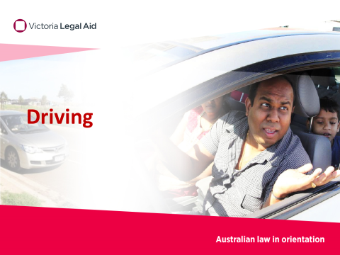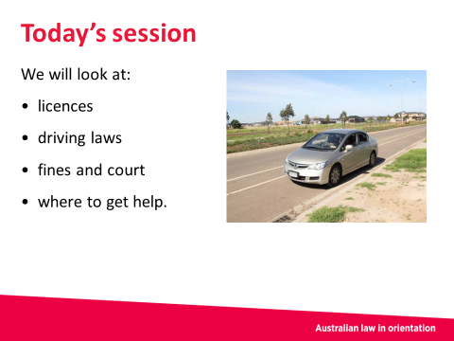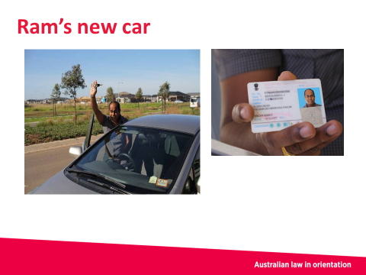
Slide 1 Slide 2 Slide 3
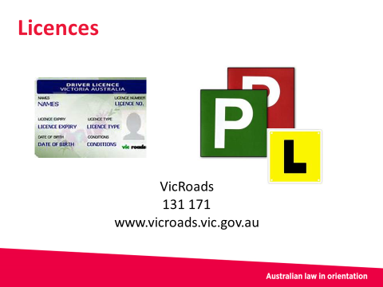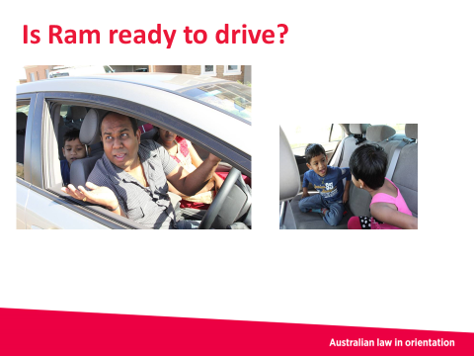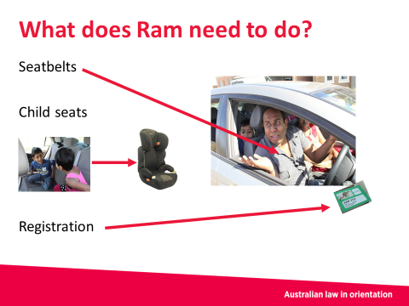
Slide 4 Slide 5 Slide 6
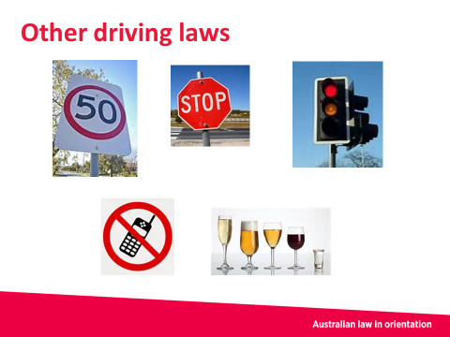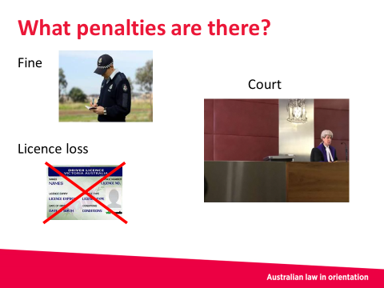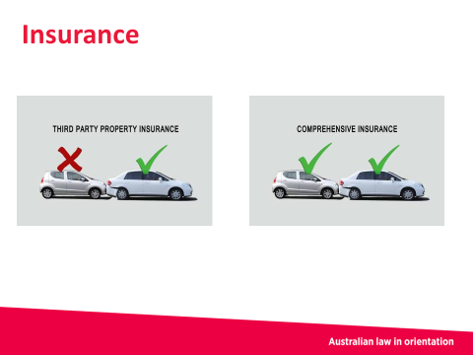
Slide 7 Slide 8 Slide 9
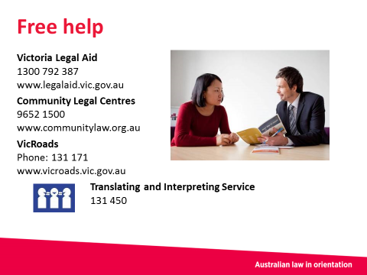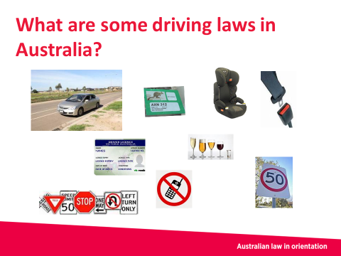
Slide 10 Slide 11

Slide 1 – Driving

About the slide
This is the introductory slide.

What to let the students or participants know
Key things to note:
- Victoria Legal Aid produced the Australian law in orientation kit and this PowerPoint document
- Contact details for Victoria Legal Aid and other services are provided at the end of the PowerPoint document.

Discussion
Suggested questions include:
- Has anyone got their Victorian licence? What was it like sitting the test?

Slide 2 – Today’s session
About the slide
This slide gives an overview of the session.

What to let the students or participants know
There are many driving laws in Australia. It is important to know them if you want to drive. It is your responsibility to learn them.
If you do not follow these laws, you can get fines and maybe even lose your licence.
Today we will talk about:
- licences
- car registration
- seatbelts and child seats
- driving laws, sometimes called road rules

- fines and going to court
- where to get help.

Discussion
Suggested questions include:
- What sort of driving laws do you have to follow when you drive in Victoria?
(For the answers, there are a lot of laws to follow. To help you prepare for what the participants might discuss, you may want to look at the VicRoads website (www.vicroads.vic.gov.au).

Slide 3 – Ram’s new car
About the slide
This slide introduces the character of Ram.

What to let the students or participants know
We will use a story about Ram to help us think about driving laws.
Ram is new to Australia. He has a wife, Lakshmi, and two children.
Ram has just bought a new car and is happy because it helps him get a new job, and it helps his wife get all the shopping home.
Ram is driving his new car with his licence from his home country.

Slide 4 – Licences
About the slide
This slide builds on the last one and focusses on the importance of having a Victorian licence.

What to let the students or participants know
There are different types of licences in Victoria. If you have a learner permit, you must show your yellow L-plates in the front and back windows of the car. You can only drive when there is a fully licensed driver next to you.
There are also rules you must follow when you get your P-plate licence (red or green plates). VicRoads can give you information on these rules.
Because Ram is now living in Victoria, he needs a valid Victorian driver licence to legally drive in Victoria.
There are different rules about licences in every state and territory.
For Ram to get his driver licence in Victoria, he must pass a test on driving and road rules. He has to pay money to take the test and get his licence.
He can get an interpreter for the test if he needs one.
Ram must renew his licence before it runs out. This costs money.
Ram can contact VicRoads on 131 171 for more information about licences.

Discussion
Suggested questions include:
- Is Ram breaking the law by driving and not having a Victorian licence?
Answer: It depends on how long Ram has been in Victoria for. There are rules about how long you can drive in Australia with an overseas licence. Ram should contact VicRoads to find out these rules, because he may need to get an Australian licence very soon.

Slide 5 – Is Ram ready to drive?
About the slide
This slide is about what happens next for Ram.

What to let the students or participants know
Ram has now passed his Victorian licence test. He now has a valid Victorian driver licence.
Ram is ready to start driving his new car. He wants to take his wife, Lakshmi, and his children for a drive.

Discussion
- Have a look at the pictures here. Is Ram ready to drive? Is there anything he needs to do before he drives away?
The answers are in the next slide.

Slide 6 – What does Ram need to do?
About the slide
This slide follows on from the previous slide.

What to let the students or participants know
If you looked closely, no one in the car was wearing a seat belt. This is against the law.
Before Ram drives the car, he must make sure everyone in the car, including himself, wears a seatbelt.
The police can give Ram a fine if he does not wear a seatbelt.
Ram must also get child seats for his children.
Children under seven years old must sit in child seats. Child seats are special seats you need to buy and put on top of the normal seats in the car.
Ram must also register his car. Registering a car makes sure it can be identified if something happens to it, and that it meets safety standards.
If Ram is driving and living in Victoria, he must pay for registration with VicRoads every year.
If Ram is caught driving a car that is not registered, the police may give him a fine.
A car must be roadworthy to be registered. Roadworthy means a mechanic must check the car and say it is safe to drive.
Discussion
- Why do you think the law requires people to wear a seatbelt in a car?
Answer: This is to help keep people safe when driving.

Slide 7 – Other driving laws
About the slide
We have talked about licences and wearing seatbelts, and getting car registration. This slide follows on from the previous slides and outlines more driving laws.

What to let the students or participants know
There are many other laws that Ram must follow when he drives:
- drinking – there are laws about how much alcohol you can drink before you drive. People on L-plates and P-plates cannot drink any alcohol. There are also limits for people on full licences
- drugs – you cannot take drugs when you drive
- speed – there are laws about how fast you can drive. You must follow the speed limit signs on the roads
- mobile phones – you cannot use your mobile phone when you drive.
There are many other laws on the road. For example, you must follow signs and traffic lights on the road.

Slide 8 – What penalties are there?
About the slide
This slide is about punishments (penalties) for breaking the law.

What to let the students or participants know
If Ram does not follow driving laws, he can get in trouble with the law.
The police have the main responsibility for making sure people follow driving laws.
A police officer may see or know about someone breaking the law. For example, the police officer may be on the road. The police officer may catch Ram and stop Ram when he is driving.
The police officer might give Ram a fine, which will mean Ram has to pay money. Some examples of when Ram might get a fine are if:
- Ram is not wearing a seatbelt
- Ram’s children are not in proper child seats
- Ram does not follow a road rule, such as stopping at a red traffic light.
If the law Ram breaks is more serious, he may have to go to court. Ram might have to go to court if he is found:
- driving after drinking too much alcohol
- driving very fast
- driving dangerously.
At court, Ram may get penalties such as:
- a fine – this means Ram pays money
- a court order – this means Ram has to do certain things. The order will be written down
- licence loss – this means Ram cannot drive for a certain amount of time.
If Ram breaks a very serious law, he might get a penalty that means he spends time in prison.
If Ram has not followed the law and has an accident, his insurance may not cover him.

Slide 9 – Insurance
About the slide
This slide is about insurance. Insurance is important information that many people new to Australia want to know about. Include it in your presentation if you have time.

What to let the students or participants know
Insurance is money Ram pays every year so that if he has an accident, he can get help from the insurance company to pay for damage.
There are different types of insurance you can get. When you pay for registration for your car, you get automatic insurance to cover the cost of people injured in any accident. However, this does not pay for car damage. If you want to get insurance to cover the costs of car damage, you have to organise it and pay for it yourself.
There are two types of insurance you can get to cover the costs of car damage:
- third party property insurance – pays for damage to the other person’s car (not your car)
- comprehensive insurance – pays for damage to both your car and the other person’s car. It is more expensive.
When you get insurance from an insurance company, it is important to ask how much ‘excess’ you have to pay. This is the amount you must pay if you make an insurance claim, for example, if you get into an accident. Once you pay the excess, then the insurance company will pay for the rest of the damages.
It is important to get insurance. If you are in an accident and it is your fault, and if you do not have insurance, you will have to pay for the damage. It may be very expensive.

Slide 10 – Free help

About the slide
In this slide we talk about places where people can get free legal and other help.

What to let the students or participants know
Ram’s story is finished now. Now it’s time to think about places that Ram could have gotten help from. You can also get help from these places if you find yourselves in trouble with the law.
If Ram has to go to court because he has trouble paying a fine, he can get free legal help.
If you have trouble with driving and the law, you can call Victoria Legal Aid on 1300 792 387 for free legal help, or visit the Victoria Legal Aid website (www.legalaid.vic.gov.au). Or find the nearest community legal centre by calling (03) 9652 1500. It is important to know that lawyers are independent from the court and from police. Generally, lawyers do not share information with courts and police unless you want them to.
Victoria Legal Aid has telephone workers who speak other languages. If there is not a worker who speaks in your language, you can call the Translating and Interpreting Service on 131 450 to get an interpreter in your language for any of these services.
You can contact VicRoads on 131 171 to find out more about licences, registering your car and rules about child seats.

Slide 11 – What are some driving laws in Australia?

About the slide
This is an activity slide. The question relates to what we went through in the session. If you have time, you can run this activity.

About the activity
Ask participants to name some driving laws.
Key laws include:
- you must have a valid driver licence to drive
- children must be in child seats
- everyone in the car must wear seatbelts
- your car must be registered
- you must follow road rules and signs
- you must follow the speed limits
- you must not use a mobile phone when driving
- you must follow rules about drinking alcohol.

Family violence

Before the session
To help you run a session on Family violence, we suggest you first:
- read the PowerPoint document
- read these speakers’ notes
- do more research into the topic if you want. You can look at the websites in the Extra resources section.

Day of the session
You will need:
- a device such as a tablet, laptop or computer
- a data projector, with the correct cords to connect to the device
- a blank space to project on
- the Family violence PowerPoint document downloaded onto your device.
We include activities at the end of the PowerPoint document. You can run the activity as a group activity. You may want to print it out and hand out copies, to run it as an individual activity.

Length of the session
If you run the session using the PowerPoint document and the speakers’ notes, it will probably take about 20 minutes, including questions and discussion.

Overview of slides
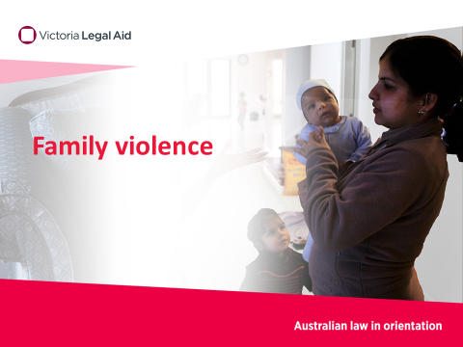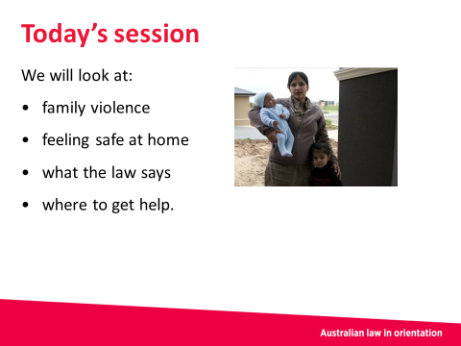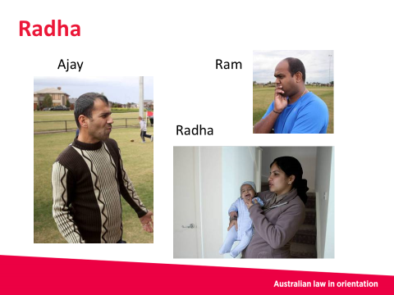
Slide 1 Slide 2 Slide 3
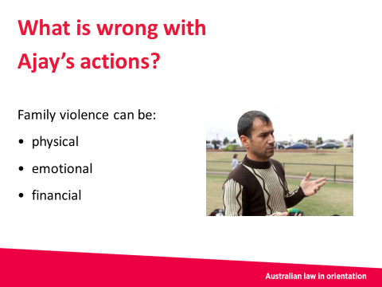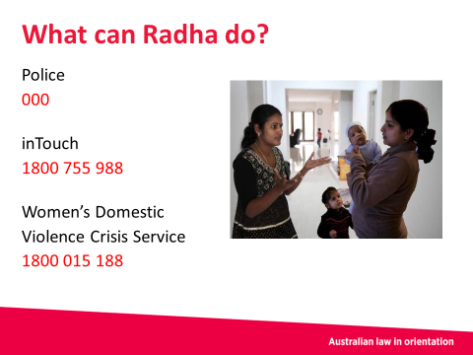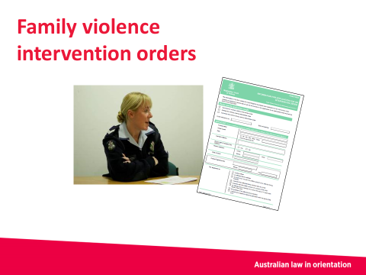
Slide 4 Slide 5 Slide 6
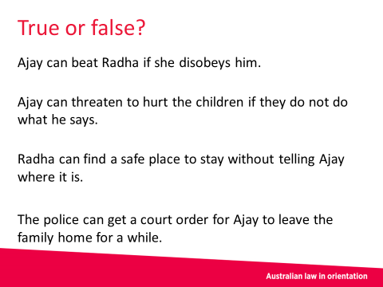
Slide 7 Slide 8

Slide 1 – Family violence

About the slide
This is the introductory slide.

What to let the students or participants know
Key things to note:
- Victoria Legal Aid produced the Australian law in orientation kit and this PowerPoint document
- Contact details for Victoria Legal Aid and other services are provided at the end of the PowerPoint document.

Slide 2 – Today’s session
About the slide
This slide gives an overview of the session.

What to let the students or participants know
This session covers:
- family violence
- feeling safe at home
- what the law says
- where to get help.
In Australia the law says everyone has a right to feel safe.
Family violence laws help protect people who are scared that someone in their family might hurt them.

Discussion
Suggested questions include:
- What family members do family violence laws apply to?
Answer: Family includes:
- People who share an intimate personal relationship. For example, married, de facto or domestic partners, boyfriends and girlfriends, whether or not there is a sexual relationship
- Parents and children, including children of an intimate partner
- Relatives by birth, marriage or adoption. This includes in-laws and cousins
- People you treat like a family member. For example, a carer, guardian or person who is related to you within the family structure of your culture.
Note – please use your knowledge of the participants in how you might frame discussions of family violence. You may want to note that people do not have to tell any personal stories about themselves or family members.

Slide 3 - Radha
About the slide
This slide introduces the character Radha.

What to let the students or participants know
We will use a story about Radha to help us think about family violence and the law.
Radha is having problems with her husband, Ajay. Radha gets scared of Ajay because he gets angry. He says she spends too much of his money. He does not give her enough money to buy food and he does not like the food she cooks. Ajay throws things around the house and sometimes he hits her.
Radha wants to stay at Ram’s house. Ram is her brother. Ram is worried about Radha and her safety at home.

Slide 4 – What is wrong with Ajay’s actions?
About the slide
This slide focuses on Ajay.

What to let the students or participants know
Ajay has no right to hit Radha. What he is doing is family violence. This is wrong and against the law.
Family violence is behaviour by someone towards a person in their family which is controlling or makes their family member feel afraid or unsafe. Family violence includes physical acts, like beating, hitting or pushing. It also includes other ways of hurting people in an emotional or financial way. For example, Ajay’s actions might make Radha feel unsafe as Ajay gets angry, throws things and sometimes hits her.
Radha might also feel worried for her children. They could be in the house when Ajay is violent. It is not safe or healthy for the children to see this.
Actions may be family violence if someone:
- beats a family member
- controls the household money or puts pressure on a family member to get money or property
- does not let their family member see friends and family
- does not let their family member leave the house or make any friends
- does not let their family member practise their religion or culture
- threatens to hurt a family member, children or someone close to them
- makes their family member have sex or do other sexual acts (even if they are married)
- calls their family member mean names or yells at them in a way that makes them scared (verbal abuse)
- threatens to send the family member back to their home country, to prison or to any other place
- does any of these actions in front of children.
Discussion
If you do not talk about all the types of family violence, you may want the students or participants to name them. A suggested question might be:
- As well as physically hurting another family member, what are other ways that one family member could hurt or have control over another family member?
Answer: Refer to the list above for examples.

Slide 5 – What can Radha do?
About the slide
This slide focuses on what Radha can do and gives the details for some services.

What to let the students or participants know
There is no shame in asking for help.
If Radha is in immediate danger she can call the police on 000. She can get an interpreter if she needs one.
In Australia there are many services to support Radha and help her feel safe, such as:
- inTouch – free call 1800 755 988. This is a multicultural centre against family violence
- safe steps 24/7 family violence response line – 1800 015 188. They can provide a safe place for women to go with a secret address.
Radha can also talk to friends and family she trusts about her problems with Ajay and finding a safe place to stay for a while.
Ajay can also get help with anger issues or other problems he may have. He can call the Men’s Referral Service on 1300 766 491.

Discussion
You could also lead the discussion of this slide by first posing the question What do you think Radha can do if she does not feel safe at home? Then go into the above answers.

Slide 6 – Family violence intervention orders
About the slide
This slide focuses on family violence intervention orders. This slide is optional. Include it in your presentation if you have time, and if the group you are presenting to want to know about family violence intervention orders.

What to let the students or participants know
Radha can also apply to the court for a family violence intervention order. A family violence intervention order is a court order to protect a family member, children and property. The order will have rules about how Ajay can behave. A family violence intervention order will not go on Ajay’s criminal record.
An order will stop Ajay from doing certain things, such as hurting or threatening Radha or the children. Threatening means saying you are going to do something, for example, if Ajay tells Radha that he is going to hurt her.
The order could also make Ajay move out of the family home for a while if it is not safe for Radha and the children.
If police have been involved they can apply for an order for Radha. That means Radha has two options. She can apply for one herself or the police can do it.
‘Applying’ means Radha or the police are asking for the court to make the order. It is up to the court to decide.
If the court makes an order, Ajay must follow the rules in the order exactly.
If Ajay breaks the order, it is serious and the police can charge him. He may have to go to court and he might get a large fine or could even go to jail. He may get a criminal record.
A family violence intervention order is usually made for a certain period of time. Before it is due to finish, Radha can ask for it to go longer if she still feels unsafe.
Both Radha and Ajay can get help and advice about how they can make the whole family feel safe.

Slide 7 – Free help

About the slide
In this slide we talk about places where people can get free legal help.

What to let the students or participants know
Radha’s story is finished now. Now it’s time to think about places that Radha could have gotten extra help from. You can also get help from these places.
If Radha has to go to court or wants to get a family violence intervention order, she can get free legal help by calling Victoria Legal Aid on 1300 792 387, or visit the Victoria Legal Aid website (www.legalaid.vic.gov.au). Or she can find her nearest community legal centre by calling (03) 9652 1500. It is important to know that lawyers are independent from the court and from police. Generally, lawyers do not share information with courts and police unless the person they are helping wants them to.
Victoria Legal Aid has telephone workers who speak other languages. If there is not a worker who speaks in Radha’s language, she can call the Translating and Interpreting Service on 131 450 to get an interpreter in her language for any of these services.

Slide 8 – True or false?

About the slide
This is an activity slide. The questions relate to what we went through in the session. If you have time, you can run this activity.

About the activity
Read out each statement and ask the group to decide if it is true or false.
The answers are as follows:
- Ajay can beat Radha if she disobeys him
Answer: False.
- Ajay can threaten to hurt the children if they do not do what he says
Answer: False.
- Radha can find a safe place to stay without telling Ajay where it is
Answer: True.
- Police can get a court order for Ajay to leave the family home for a while
Answer: True.

Police

Before the session
To help you run a session on Police, we suggest you first:
- read the PowerPoint document
- read these speakers’ notes
- do more research into the topic if you want. You can look at the websites in the Extra resources section.

Day of the session
You will need:
- a device such as a tablet, laptop or computer
- a data projector, with the correct cords to connect to the device
- a blank space to project on
- the Police PowerPoint document downloaded onto your device.
We include activities at the end of the PowerPoint document. You can run the activity as a group activity. You may want to print it out and hand out copies, to run it as an individual activity.

Length of the session
If you run the session using the PowerPoint document and the speakers’ notes, it will probably take about 20 minutes, including questions and discussion.

Overview of slides

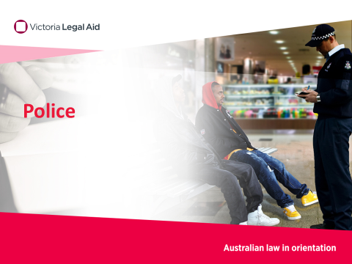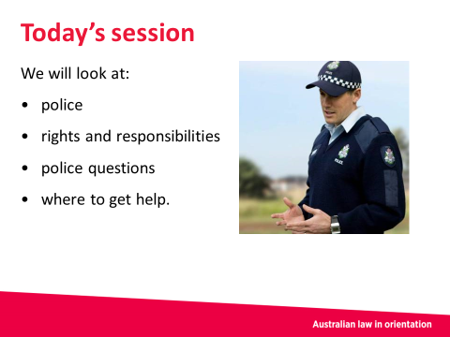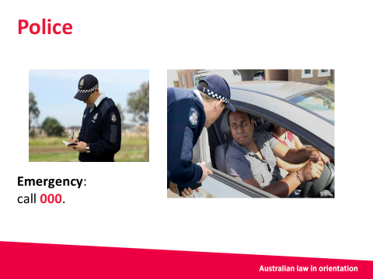
Slide 1 Slide 2 Slide 3
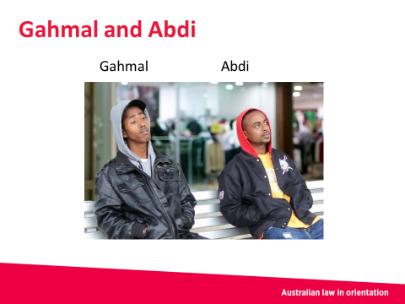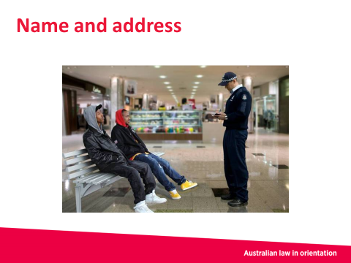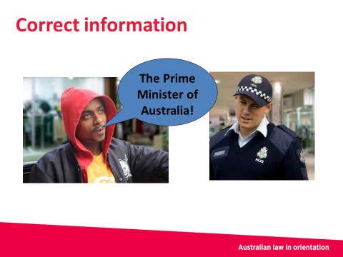
Slide 4 Slide 5 Slide 6
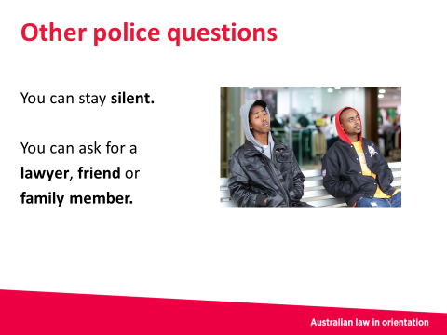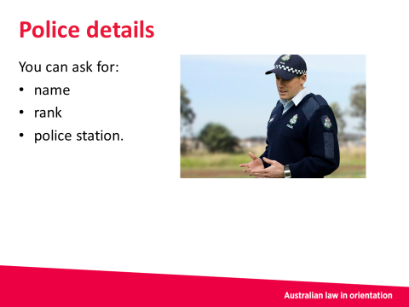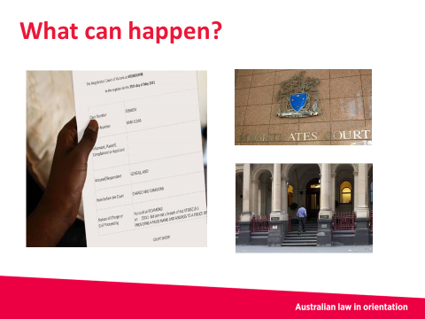
Slide 7 Slide 8 Slide 9
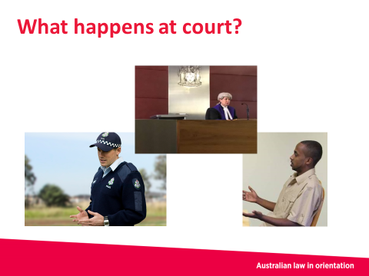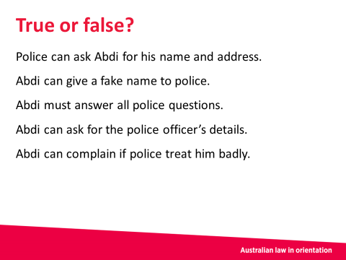
Slide 10 Slide 11

Slide 1 – Police

About the slide
This is the introductory slide.

What to let the students or participants know
Key things to note:
- Victoria Legal Aid produced the Australian law in orientation kit and this PowerPoint document
- Contact details for Victoria Legal Aid and other services are provided at the end of the PowerPoint document.

Slide 2 – Today’s session
About the slide
This slide gives an overview of the session.

What to let the students or participants know
This session covers:
- what the police do
- your rights and responsibilities when you see or talk with a police officer in Australia
- what police can ask you, and what you can ask them
- where to get legal help.

Discussion
Suggested questions include:
- Where are places that you might see or talk to a police officer?
Answer: Some places include a police station, a train station, your home or when you are driving.

Slide 3 – Police
About the slide
This slide introduces discussion about the police and what they do.

What to let the students or participants know
In Australia, police are in the community to help stop crimes and try to help keep people safe.
Most police wear a blue and white uniform. All police carry a badge which shows their identification.
Police officers must follow the law. They cannot do whatever they want.
You cannot pay police money to do things. This is called a bribe.
Police have some powers to stop you in the street. If a police officer thinks you have done something against the law, they may ask you questions.
If there is an emergency, you can call the police on 000.

Discussion
Suggested questions include:
- Is there a difference between the way police work in Victoria and the way they work in other countries?

Slide 4 – Gahmal and Abdi
About the slide
This slide introduces the characters of Gahmal and Abdi.

What to let the students or participants know
We will use a story about Gahmal and Abdi to talk about what police do.
Abdi and Gahmal are at a shopping centre. A police officer comes up to them and asks them some questions.
Abdi and Gahmal do not know why they are being questioned. They ask the police officer why he wants to know.
The police officer says that someone who looks like Abdi committed a crime in the area.

Slide 5 – Name and address
About the slide
This slide continues the story of Gahmal and Abdi.

What to let the students or participants know
The police officer asks Abdi for his name and address. The police officer says Abdi has to give it to him.
A police officer can ask for your name and address if they have a good reason to believe you have broken the law or are about to break the law.
The police officer must tell you what law they think you have broken.

Slide 6 – Correct information
About the slide
This slide continues the story of Gahmal and Abdi.

What to let the students or participants know
When the police officer asks Abdi for his name, Abdi makes a joke and says, “The Prime Minister of Australia!”
Abdi must give his correct name and address to police in these situations.
It is against the law to provide a fake name and address.
You should always stay calm when dealing with police. It might feel unfair or embarrassing, but staying calm is better for you.

Slide 7 – Other police questions
About the slide
This slide continues the story of Gahmal and Abdi.

What to let the students or participants know
Abdi finally gives the police officer his real name and address.
Then the police officer asks him about what he and Gahmal are doing at the shopping centre.
Abdi does not have to give any other information after he has said his correct name and address.
He can stay silent if the police officer asks him other questions.
He can ask for a lawyer, friend or family member to help him.

Slide 8 – Police details
About the slide
This slide continues the story of Gahmal and Abdi, focusing on Abdi.

What to let the students or participants know
Abdi feels unsure about what is going on, so Abdi asks the police officer for his details.
If a police officer asks you for your name and address, then you can ask them for their details. They must give you their name, their rank and the police station where they work if you ask. This can help you if you need to make a complaint later.
If you think the police have been unfair, you can complain. You have the right to be treated fairly.
Speak to Victoria Legal Aid to help you make a complaint.

Discussion
Suggested questions include:
- What do you think ‘rank’ means?
Answer: It is what level of police officer they are.

Slide 9 – What can happen?
About the slide
This slide continues the story of Abdi.

What to let the students or participants know
A few weeks later, Abdi gets a letter. It says the police have charged him for giving a fake name and address to a police officer. The letter says Abdi must go to court.
Even though Abdi was joking when he said his name was the Prime Minister of Australia, it is still against the law to give wrong information about his name to police.

Slide 10 – What happens at court?
About the slide
This slide continues the story of Abdi. It also talks about legal services that can provide help.

What to let the students or participants know
Abdi should go to court on the date the letter says. If he does not go to court, he could get arrested. You can also get help from these places if you find yourselves in trouble with the law.
When Abdi is at court, first the police talk about what laws they think Abdi has broken. Then Abdi can tell his story. He can say if he agrees with the police.
Then the judge or magistrate decides if Abdi broke the law and if he should be punished.
If you need to go to court, you should get legal help. Call Victoria Legal Aid on 1300 792 387 or find your nearest community legal centre by calling (03) 9652 1500. It is important to know that lawyers are independent from the court and from police. Generally, lawyers do not share information with courts and police unless you want them to.
Victoria Legal Aid has telephone workers who speak other languages. If there is not a worker who speaks in your language, you can call the Translating and Interpreting Service on 131 450 to get an interpreter in your language for any of these services.
You may be able to see a duty lawyer on the day of your court hearing. Duty lawyers are lawyers at court who help people who do not have their own lawyer. They can give legal advice and sometimes represent people at court. Whether a duty lawyer can help you will depend on the details of your situation.

Slide 11 – True or false?

About the slide
This is an activity slide. The questions relate to what we went through in the session. If you have time, you can run this activity.

About the activity
Ask the group if each statement is true or false. You can go around the room and ask small groups to answer one question each. After discussing each statement, click on the slide for the answer to appear.
The answers are:
- Police can ask Abdi for his name and address if they think he has broken the law
Answer: True.
- Abdi can give a fake name to police
Answer: False.
- Abdi must answer all police questions
Answer: False.
- Abdi can ask for the police officer’s details
Answer: True.
- Abdi can complain if the police treat him badly
Answer: True.

Extra resources

Where to get help

Websites mentioned in the speakers’ notes
- Federation of Community Legal Centres (www.fclc.org.au)
- Victoria Legal Aid (www.legalaid.vic.gov.au)

Other websites
- Law Handbook online – for a broad overview of information on many legal topics (www.lawhandbook.org.au)

Australia’s legal system

Websites mentioned in the speakers’ notes
- Magistrates’ Court of Victoria (www.mcv.vic.gov.au)
- Prime Minister of Australia website (www.pm.gov.au)
- Premier of Victoria website (www.premier.vic.gov.au)
Other websites
- Australian Electoral Commission (www.aec.gov.au)
- Australian Parliament House (www.aph.gov.au/visit_parliament)
- Parliament of Victoria (www.parliament.vic.gov.au/visit)
- Victorian Electoral Commission (www.vec.vic.gov.au/)
- Victorian Government – local councils (www.vic.gov.au/government-economy/local-councils/victorian-local-councils.html)

Child protection

Websites mentioned in the speakers’ notes
- Child Care Finder (www.childcarefinder.gov.au)
Other websites
- Children’s Court of Victoria – Child protection (www.childrenscourt.vic.gov.au/jurisdictions/child-protection)
- Department of Human Services – Child protection services.dhhs.vic.gov.au/service-providers/child-protection)

Driving

Websites mentioned in the speakers’ notes
- VicRoads (www.vicroads.vic.gov.au)

Other websites
- Consumer Affairs Victoria – Car insurance (www.consumer.vic.gov.au/motor-cars/buying-a-new-car/before-you-buy-a-new-car/insurance)
- Fines Victoria (https://online.fines.vic.gov.au/)
- Magistrates’ Court of Victoria (www.mcv.vic.gov.au)

Family violence

Other websites
- Domestic Violence Resource Centre Victoria (www.dvrcv.org.au)
- Our Watch (www.ourwatch.org.au)
- Women’s Legal Service Victoria (www.womenslegal.org.au)
- inTouch (www.intouch.org.au)

Police

Other websites
- Police Accountability Project (www.policeaccountability.org.au)
- Independent Broad-based Anti-corruption Commission (www.ibac.vic.gov.au)
- Magistrates’ Court of Victoria (www.mcv.vic.gov.au)
- Street Smart – targeted to young people (www.streetsmartvic.com.au/about)
- Victoria Police (www.police.vic.gov.au)

