Personal safety intervention orders: mention hearing

Self-help guide for respondents
July 2020
This guide is for you if:
- someone applied for a personal safety intervention order against you
- you are 18 or over
- you do not have lawyer today.

How will this guide help me?
This self-help guide has information on:
- if a duty lawyer can help you today (page 2)
- words you might hear in court today (pages 3–4)
- what today is about, where to go and what you will need to do (pages 5–8)
- information about your options in court today, including what you can say in court (pages 9–16)
- space to write (pages 17 and 20)
- what do to if you do not come to an agreement today and where to get more help (pages
18–‍19).
Disclaimer: The material in this publication is a general guide only. It is not legal advice. If you need to, please get legal advice about your situation.

This guide has pictures
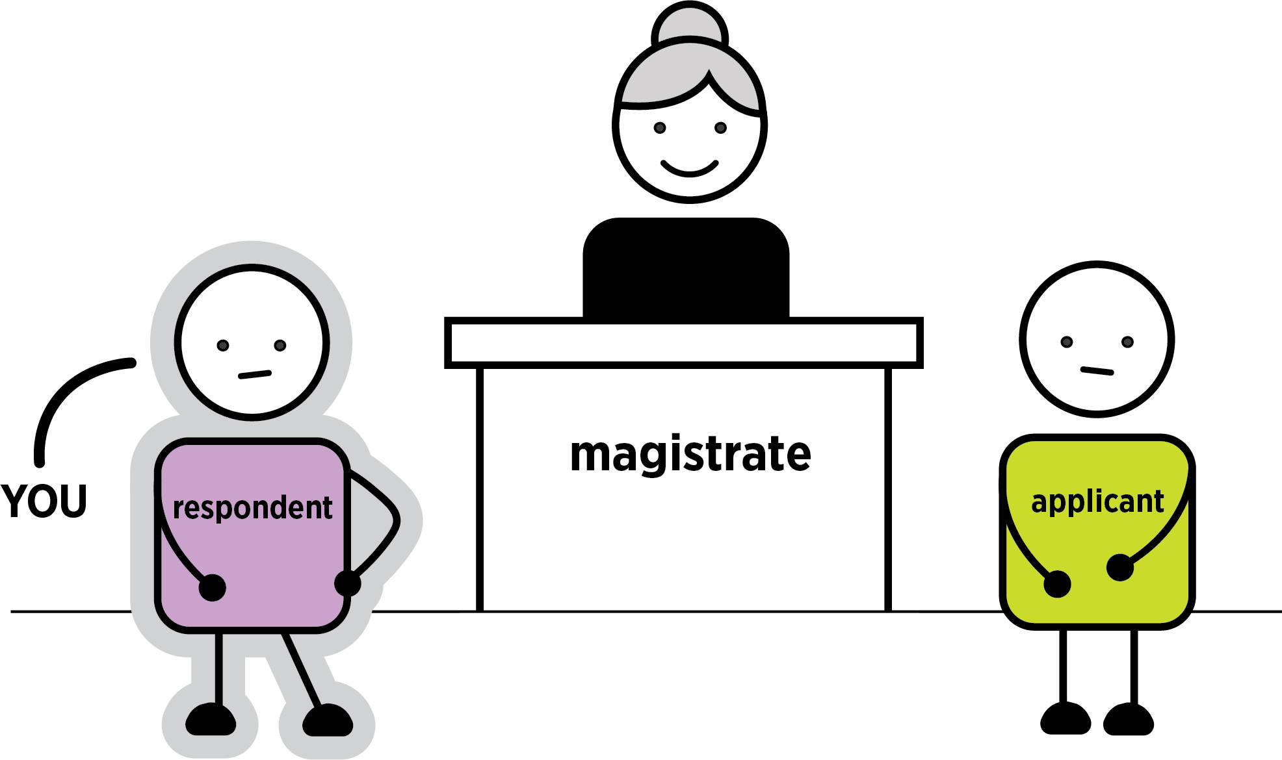
This booklet has pictures of actions you might have to do today.

When you see a this means there are questions you can ask yourself to help make a decision.
When you see a this is what you can say.
When you see an this is important information.
Words you might hear today are explained on page 3. These words are also in bold the first time they appear in this booklet. The word conditions, rules a person must follow, is always in bold. Other legal words are explained in the text.
If you have any questions about personal safety intervention orders, or what happens at court, you can call Victoria Legal Aid’s Legal Help on 1300 792 387.

Can a duty lawyer help me today?
A duty lawyer, a free lawyer who works at court, may be able to help you today if:
- you are under 18. Tell the registrar.
- you have a cognitive or neurological disability. Tell the registrar. If a duty lawyer is here today, they may be able to help you. If a duty lawyer is not here today, you can ask to adjourn (put off) your case until you talk to a lawyer.
- you have been charged with criminal offences to do with to this application for an intervention order. Tell the registrar.

What are some words I might hear today?

Words about people
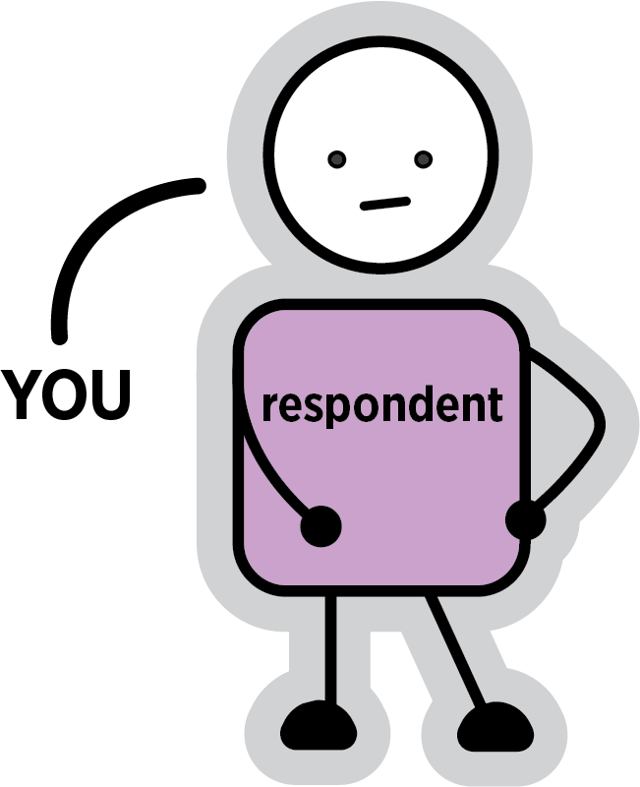
Respondent. This is you.
Applicant. The person who applied for a personal safety intervention order. If the police applied on their behalf, the police are the applicant and the other person are called the protected person.
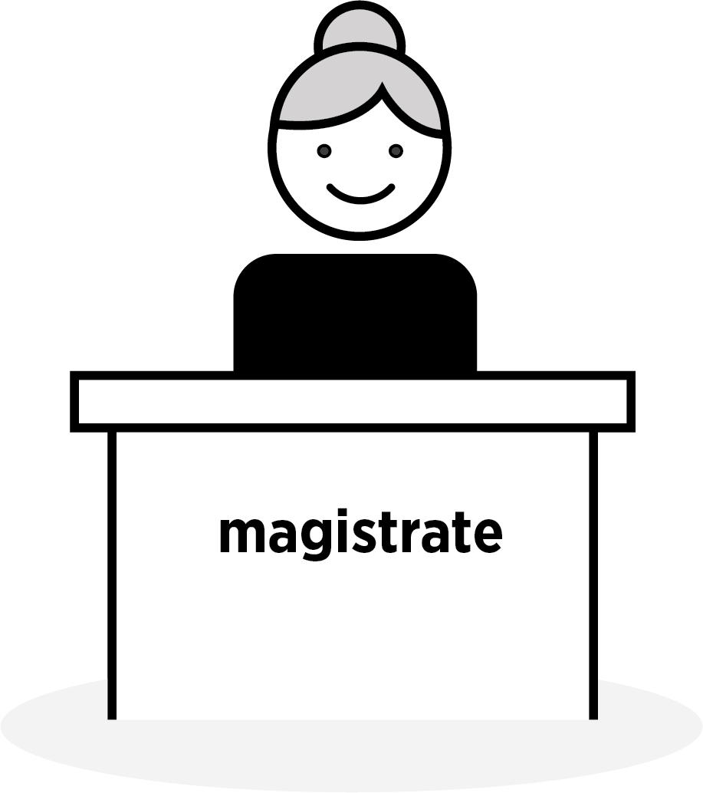
Magistrate. The person in charge of the court room today.

Mediator. An independent, trained professional who talks to people about their situation and tries to work out an agreement.
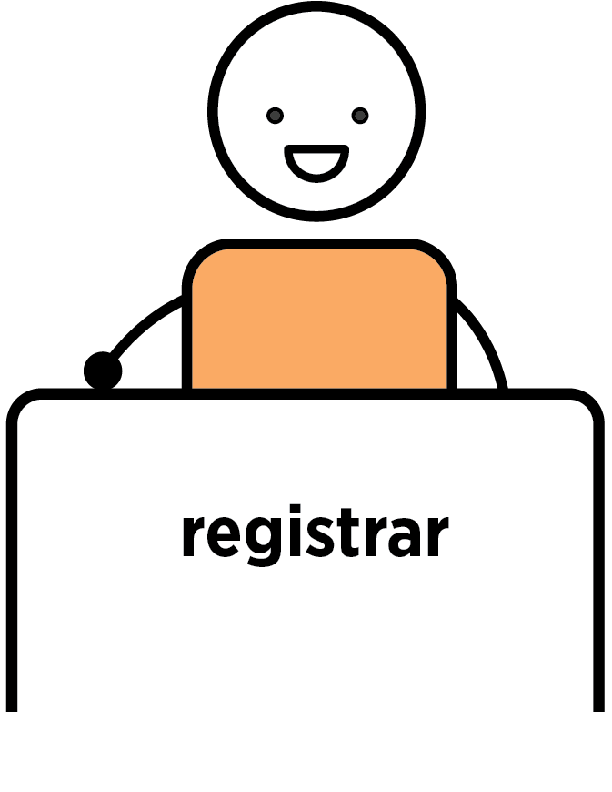
Registrar. A person who works in court and helps the magistrate. They sit at the registry, which is like the front desk for the court.

Words about processes
Case, hearing, mention or matter. When you come to court to talk about your legal issue.
Mediation. When you and the applicant talk to a trained professional to see if you can come to a safe ‍agreement.
Mention hearing. The type of hearing that is happening today. It is when you and the applicant speak to the magistrate to work out what happens next.
This booklet also talks about directions hearings and contested hearings. These are hearings which may happen if you do not come to an agreement today.

Words about paperwork
Application. When a person asks the court for something. For example, asking for a personal safety intervention order.
Conditions. Rules that people must follow. For example, a personal safety intervention order might have a condition that the respondent must not contact the applicant.
Personal safety intervention order. When the court says a person must follow certain rules, or they will break the law. There are two types of these. An interim (temporary) order will last until your case is decided. A final order lasts for as long as the magistrate sets it for.

What is today about?
You are at court today because someone has applied for a personal safety intervention order against you. This may be a person you know. It may be the police applying on behalf of someone else.
A personal safety intervention order is when the court says the respondent must not do certain things to the applicant or protected person, like contact them, or you will be breaking the law.
Today is called a mention hearing. This means today is the first day that a magistrate will talk to both you and the person who has asked for the order (the applicant). The magistrate will see if you can both agree how to safely work things out. If there is a mediator at court today, you may be able to talk to them to see if mediation is possible instead of taking through your options with the magistrate.
A magistrate may have already made an interim (temporary) intervention order against you. If they have, make sure you read the conditions (rules) in the order. You must follow these rules. This includes while you are waiting today. Police can charge you for breaking the law if you do not.

Where do I go?
Go to the front desk, or registry at the court. If there is an information counter at court, you can ask where you need to go.
Tell the registrar you are here for ‘a personal safety intervention order mention hearing’.
The registrar can tell you what court room you are in and where you should wait.
Tell the registrar if you need an interpreter.
The registrar can also give you copies of your paperwork if you do not have it. This can include:
- the application for a personal safety intervention order. This has a summary of what the applicant said you did. It also has conditions (rules) the applicant is asking you to follow
- an interim intervention order, if the applicant asked for one.
The registrar can tell you what will happen today, but they cannot give you legal advice. If you want legal advice, you can call Victoria Legal Aid’s Legal Help line on 1300 792 387.

What will I need to do today?
Today is a mention hearing. You may be able to talk to a mediator or talk to the magistrate in court.
You also must follow the rules of any interim order (if there is one) until a final decision is made.

Talk to a mediator
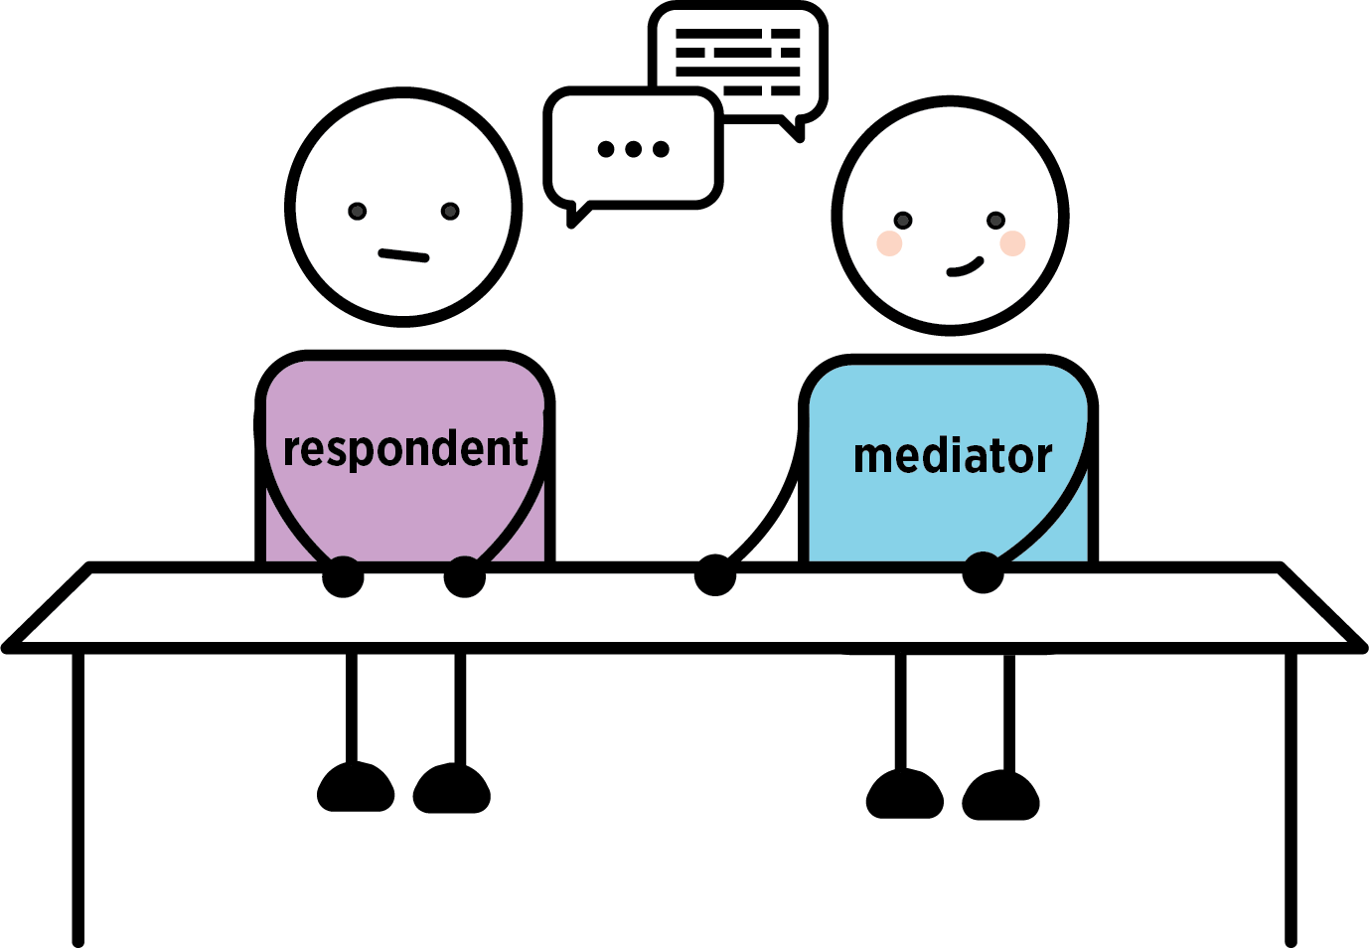
There may be a mediator at court today. The most a mediator can usually do today is a mediation assessment. This means they will talk to you and the applicant to see if mediation is possible. If mediation is possible, you will have to go into court and tell the magistrate you have agreed to mediation. The magistrate will adjourn (put off) your case until you have had a mediation session.
A mediation session is when you talk to the mediator to see if you and applicant can come to a safe ‍agreement.

Talk to the magistrate in court
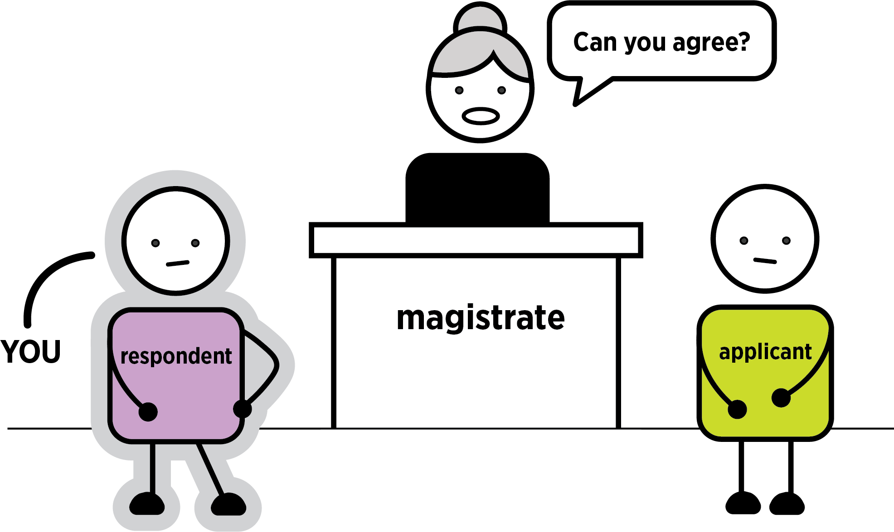
Today is not a day to tell your side of the story in detail.
The magistrate will ask you if you can come to an agreement. You have three options that you and the applicant can agree to:
- Mediation. A mediator will talk to both of you to try and reach an agreement. See page 9.
- A final intervention order. This means you agree to follow set conditions (rules). See page 12.
- An undertaking. Instead of an order, this is a written promise to the applicant and the court to follow set conditions. See page 15.

The applicant may not agree with what you are asking for. If this happens, you can ask for one of the other options.
If you can reach a safe agreement today, you may not have to come back to court.
If you cannot reach an agreement after talking to the magistrate, you will have to come back to court for a contested hearing. You may also need to come back to court for a directions hearing. See page ‍18.
If the police applied for an order against you, you will need to talk to the police before going into the courtroom about what option you want. They may tell you what they will agree to and what they will not agree to before you go into court. Do not talk to the protected person.

Option one: mediation

What is mediation?
Mediation is when you talk to a mediator to see if you and the applicant can come to a safe agreement.
A mediator is an independent, trained professional who will listen to both you and the applicant. They will listen to what happened and what you want. They can help you make an agreement.
If you do not want to be in the same room as the applicant, you can talk to the mediator separately. This is called shuttle mediation.

There are two steps to mediation
Step one: a mediation assessment. This is where the mediator will see if mediation is possible between you and the applicant. This could happen today if the mediator is here.
Step two: a mediation session. You can talk to the mediator about what happened to make the other person apply for an order and whether you and the other person can safely work something out. This usually happens on another day at a place called the Dispute Settlement Centre of Victoria.

What does mediation mean for my court case?
Your case will be adjourned (put off) while you go to a mediation session. If you both agree on a safe way forward, and stick to the agreement, you may not have to come back to court. Ask the mediator about this.
You may need to come back to court and tell the magistrate about the agreements made in mediation. Ask the mediator about this.
You can also call Victoria Legal Aid’s Legal Help line on 1300 792 387 if you have any questions about your mediation agreement and whether you need to go back to court.

What are the benefits of mediation?
- You get to tell your side of the story.
- You can talk about the situation with the support of a trained, independent person.
- If you reach an agreement, you will not have to come back to court for a contested hearing. Contested hearings can be stressful and it will be months before you come back to court.
- If you cannot come to an agreement, this will not impact what happens at a contested hearing.
- If you reach an agreement, the application for an intervention order against you will stop.

What are the consequences of mediation?
- The agreement must work for both you and the other person. You may have to change your behaviour.
- If you do not follow the agreement you reach in mediation, you may have to come back to court.

Questions to ask yourself about mediation
- Can my situation be solved by talking it through?
- Is it likely that I will keep seeing this person? For example, are they a neighbour or a colleague?
- Is it likely I will have to talk to this person in the future?
If the answer is yes to any of the above questions, mediation could be a good option for you.
If you have been accused of violence or stalking, or been charged with a criminal offence to do with this intervention order application, you may not be able to do mediation.

What do I say in court?
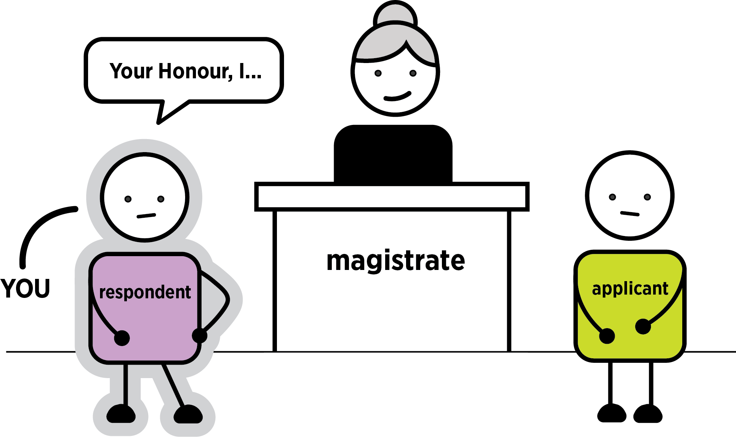

If you want mediation
The magistrate may ask you in court if you have considered mediation.
You can say: ‘Your Honour, I would like to do mediation’.
The magistrate will ask the applicant if they agree.

What will happen next?
If the applicant agrees, you may be able to see a mediator today for an assessment.
If you cannot see a mediator today, you will see a mediator another day. Ask the registrar for details.
If the applicant does not agree, the magistrate can send you to a mediation assessment. The magistrate could also ask if you and the applicant can agree on another option.

If you do not want mediation
You can say: ‘Your Honour, I do not want to do mediation’.
You may need to tell the magistrate why you do not want mediation.
The magistrate can send you to a mediation assessment, or they may ask if you and the applicant can agree on another option.

Option two: a final intervention order
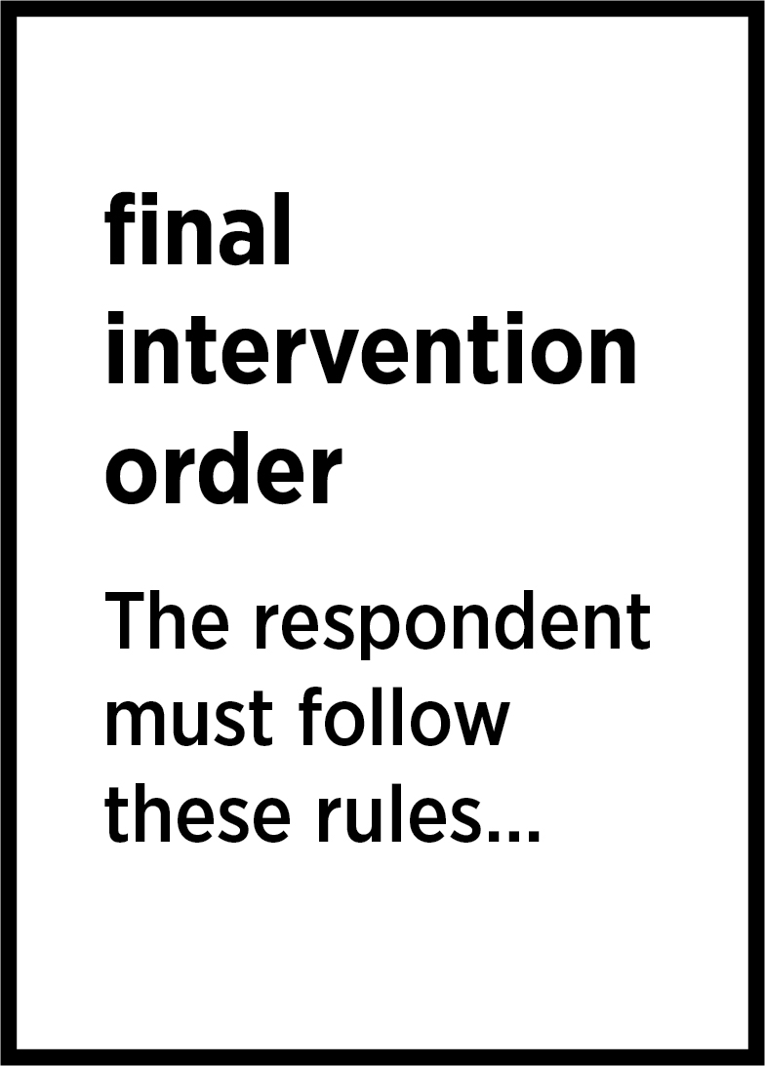
Today you can consent (agree) to a final intervention order.
This means that you agree to the court making the conditions (rules) in the application into a final intervention order. You can do this without agreeing with what was said about you in the application. This is called ‘consent without admissions’.
If you agree to the order, you will have to follow the conditions (rules) in it. The magistrate decides how long you have to do this for. This is normally for 12 months but can be longer or shorter.
If you want to agree to a final intervention order, it is very important you read the conditions (rules) in the order. You are agreeing to follow these rules for as long as the order lasts. The police can arrest you if you break any of the rules.
If you do not agree with some of the rules, you can ask for them to be changed. The magistrate will only allow the rules to be changed today if the applicant agrees.
An order is not a criminal record. You have not committed a crime by having an order. But if you break any of the rules of the order, this is a crime.

Benefits of agreeing to a final intervention order
- If you follow the conditions (rules) you will not have to come back to court.
- You avoid waiting for months for a contested hearing.
- You may be able to change the rules of the order if the applicant agrees.
- Agreeing to final intervention order is not the same as a criminal record.
- Agreeing to an order cannot be used as evidence against you if you need to come to court on criminal charges to do with this intervention application.

Consequences of agreeing to a final intervention order
- You must follow the rules of the order for as long as it lasts.
- If you break the rules of the order, the police can charge you with a crime. If you are found guilty, you could get a fine, go to jail or get a criminal record.

Questions to ask yourself
- Have I acted in a way that made the other person feel scared? If so, it may be difficult to contest (argue against) an order.
- Do I understand what rules I have to follow (the conditions of the order)?
- Do the conditions mean I cannot go to work? Or walk to the shops?
- How far do I have to stay away from the other person? Would this make it difficult for me to get to work or study or any other appointments?

What do I say in court?
If you want to agree to a final intervention order, you can choose to do it one of two ways.

Agree to the order as it is
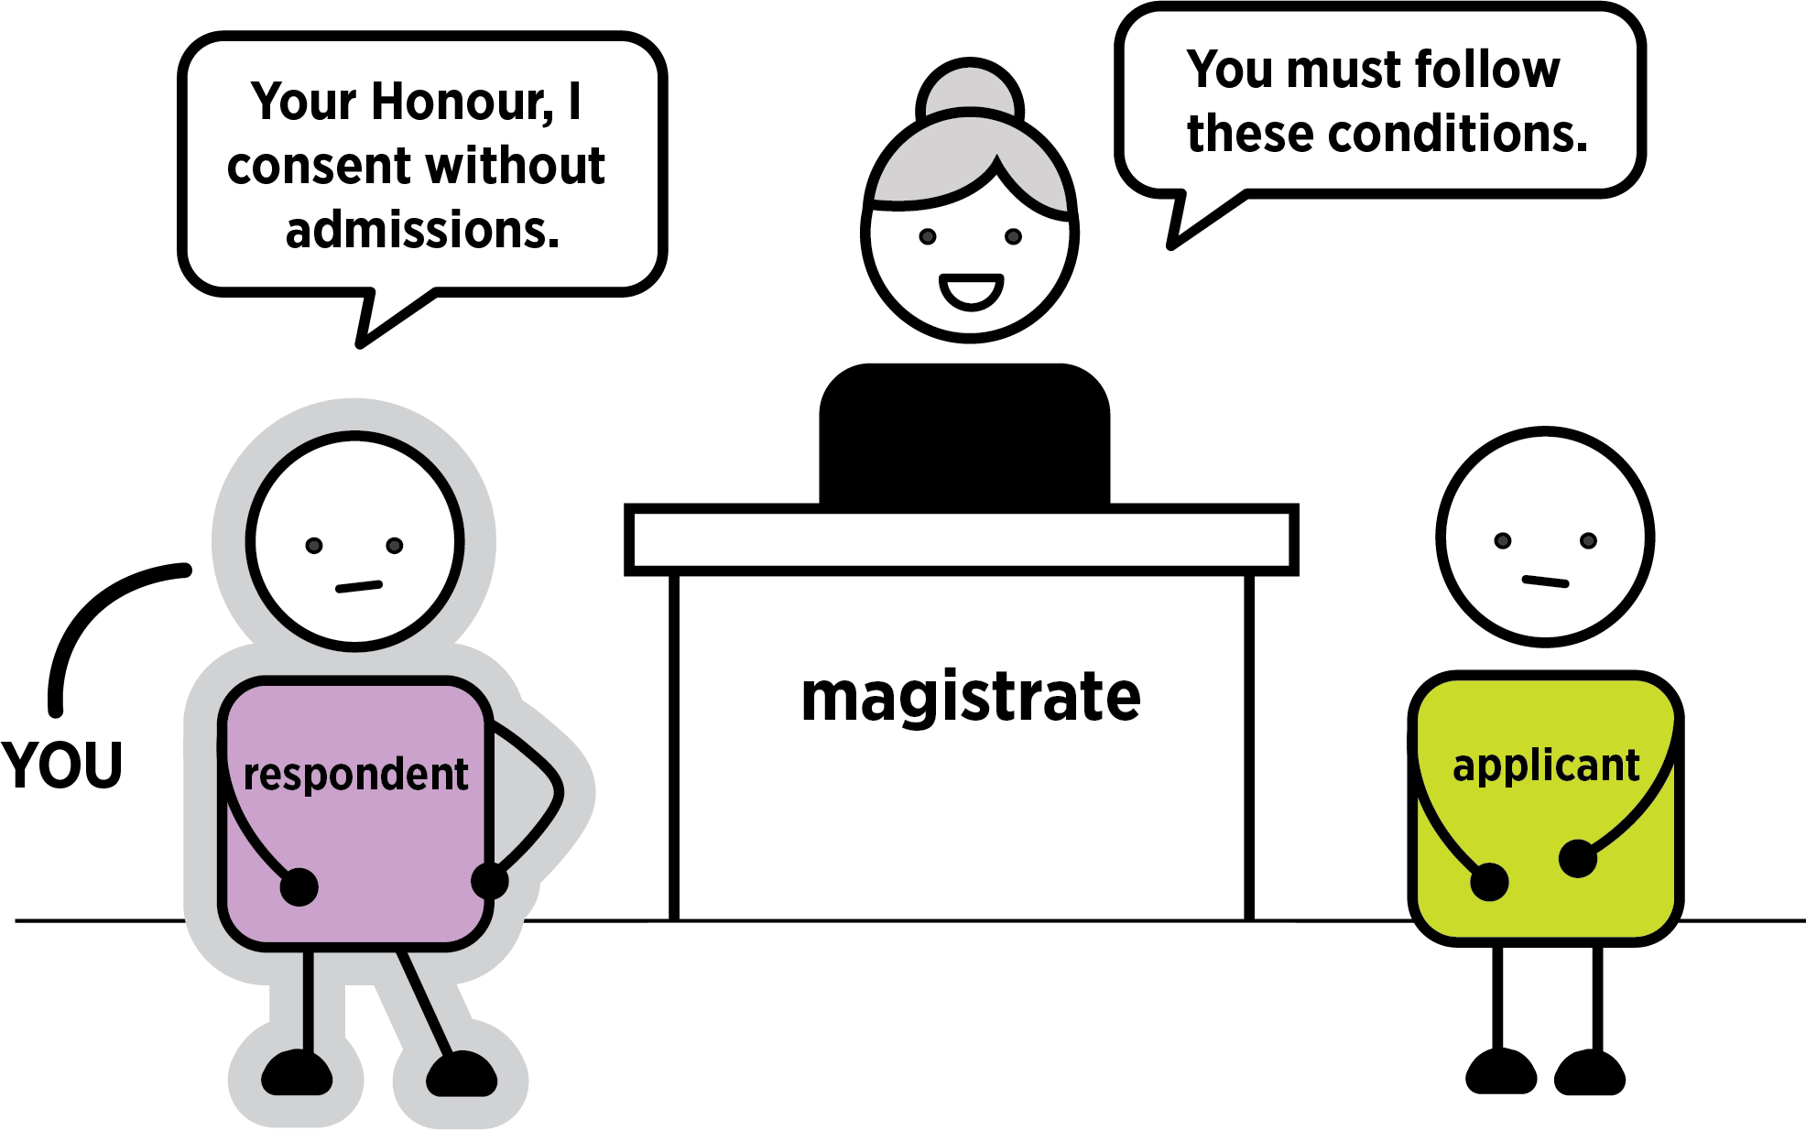
Today the magistrate will ask you if they agree to the order the applicant asked for.
You can say: ’Your Honour, I would like to consent without admissions to the whole order’.
Consenting without admissions means you do not admit to everything that was said about you in the application, but you are agreeing to follow the rules of the order.

Agree to the order but change some of the conditions
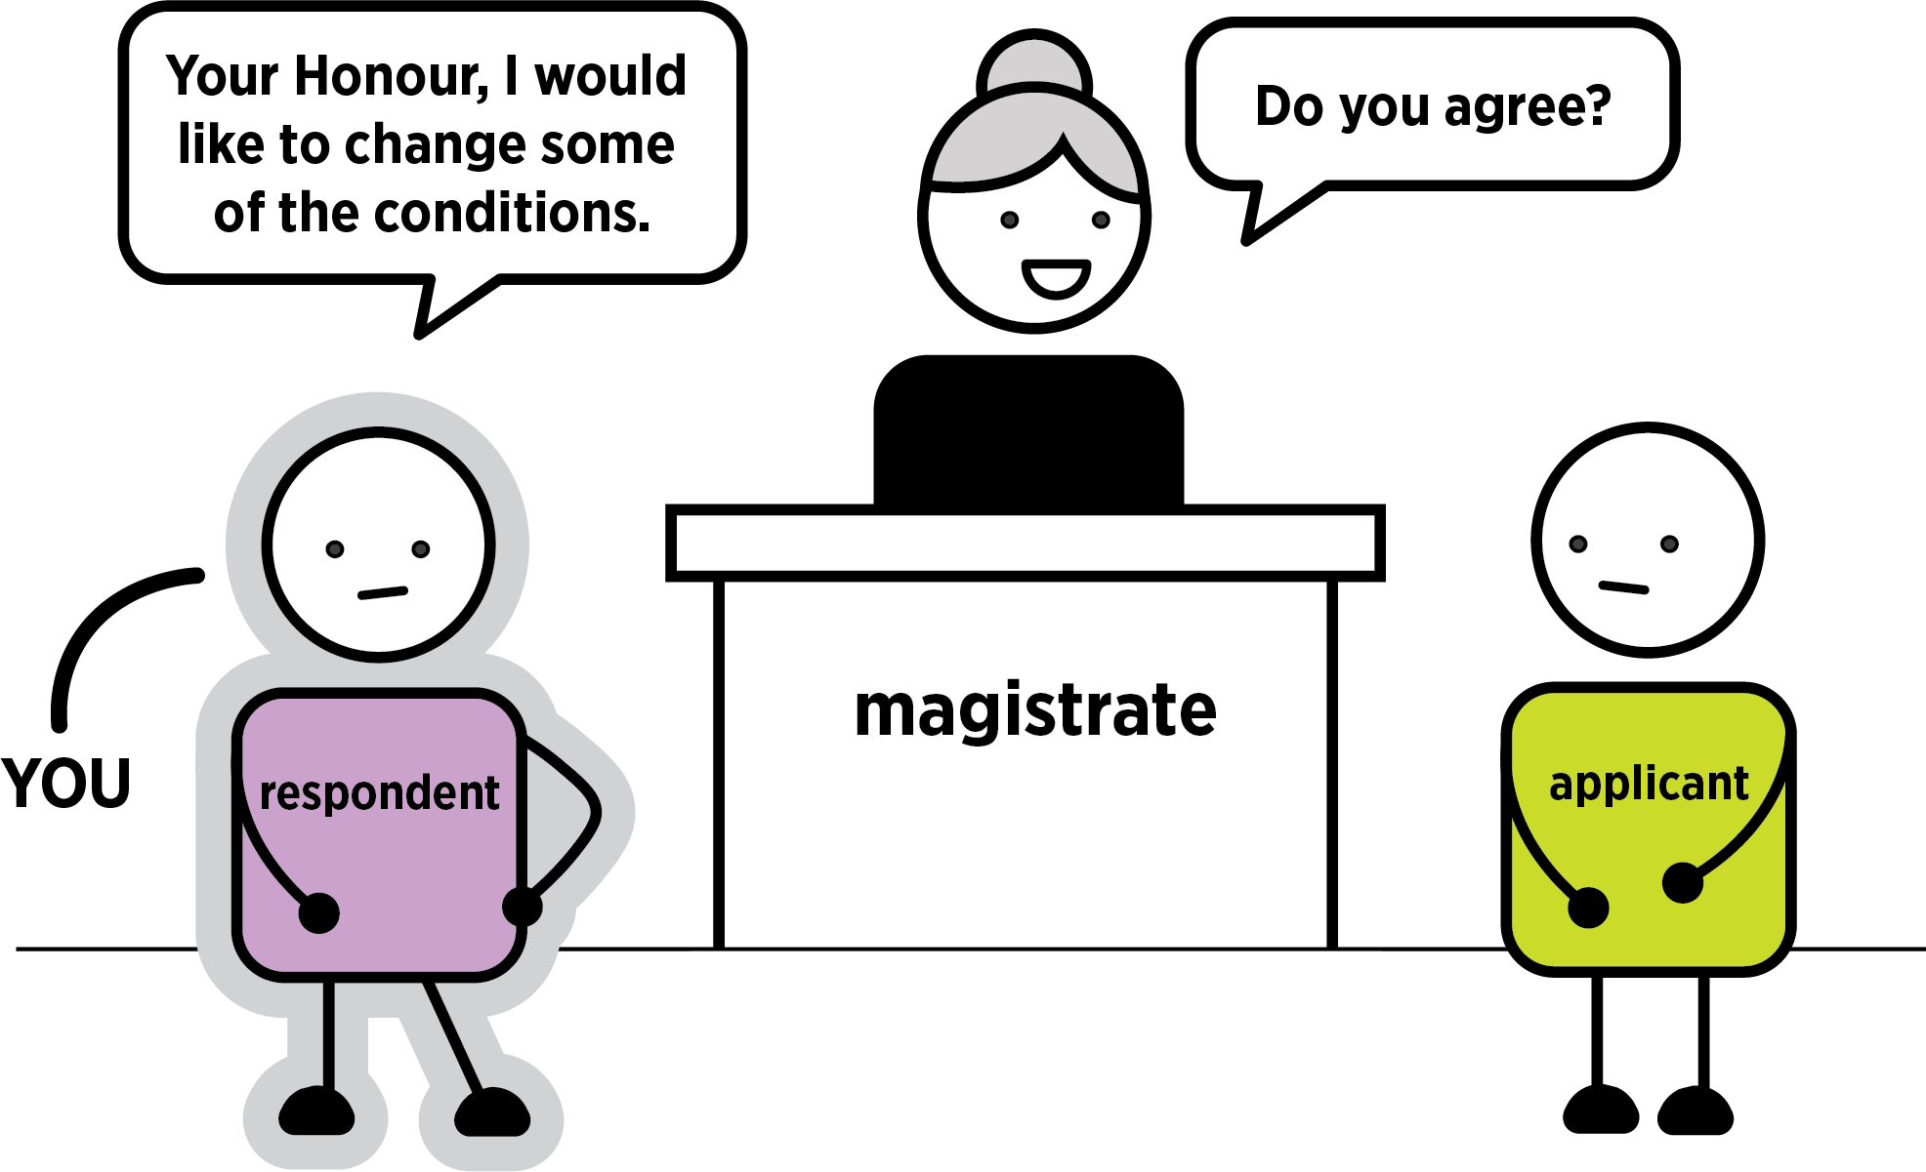
You can say: ‘Your Honour, I would like to consent without admissions, but I would like to change some conditions.’
Then tell the magistrate what conditions (rules) you want changed.
The magistrate will ask the applicant if they agree to the changes in conditions.
If they do, you have agreed to an intervention order. This is normally 12 months, but the magistrate can make it longer or shorter.

What happens if the applicant agrees with the order?
The registrar will print out the final intervention order. Make sure you understand how long the order is for and what rules you must follow. If there is anything you do not think you can do, or do not understand, tell the registrar. If you need legal advice about the order, call Victoria Legal Aid’s Legal Help line on 1300 792 387.

What happens if the applicant does not agree with the changes?
If the applicant does not agree to these changes, the magistrate may ask if you can both agree to another option. If you and the applicant cannot agree, you may have to come back for a contested hearing. See page 18.

Option three: undertaking
You can ask for an undertaking instead of an order.

What is an undertaking?
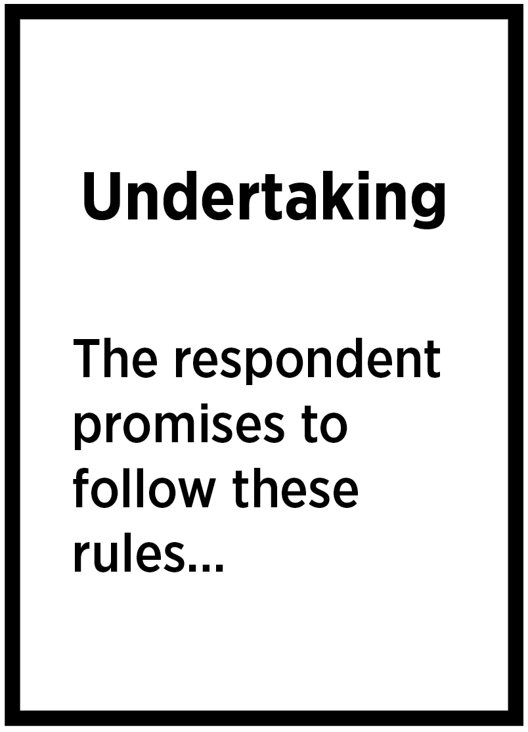
An undertaking is a written promise you make to the applicant and the court that you will follow certain conditions (rules). This promise normally lasts for 12 months, but it can be for longer or shorter. The magistrate decides the length.
You are not agreeing that you did what the applicant said you did in their application. You are promising the court to follow the conditions in the undertaking.

How does an undertaking work?
You promise to agree to the conditions (rules). These can be the same as the ones you find in the application.
If you agree to the undertaking, the application for an order against you is withdrawn (stopped).
An undertaking is different to an intervention order. It is a promise to the court, not a court order. That means that police will not charge you if you break your promise, unless you have also broken the law.
If you break the conditions (rules) of the undertaking, the applicant can restart their application and you will have to go back to court. They can ask for an intervention order and tell the court about your breaking the conditions of the undertaking.

Benefits of an undertaking
- If you follow the undertaking, you do not have to come back to court
- If the applicant agrees to an undertaking, they are agreeing to stop the application.

Consequences of an undertaking
- If you do break the conditions of the undertaking, the applicant can restart their application for an order. You will have to come back to court.
- The applicant can still call the police if you do anything that scares them.

Questions to ask yourself
- Do I understand what I am promising not to do?
- Do the conditions (rules) mean I cannot go to work or walk to the shops?
- How far do I have to stay away from the other person? Will this make it difficult for me to get to work, study or any other appointments?
- Can I follow the conditions for as long as the undertaking will last? If not, I can ask to change the conditions.

What do I say in court?

To ask for an undertaking
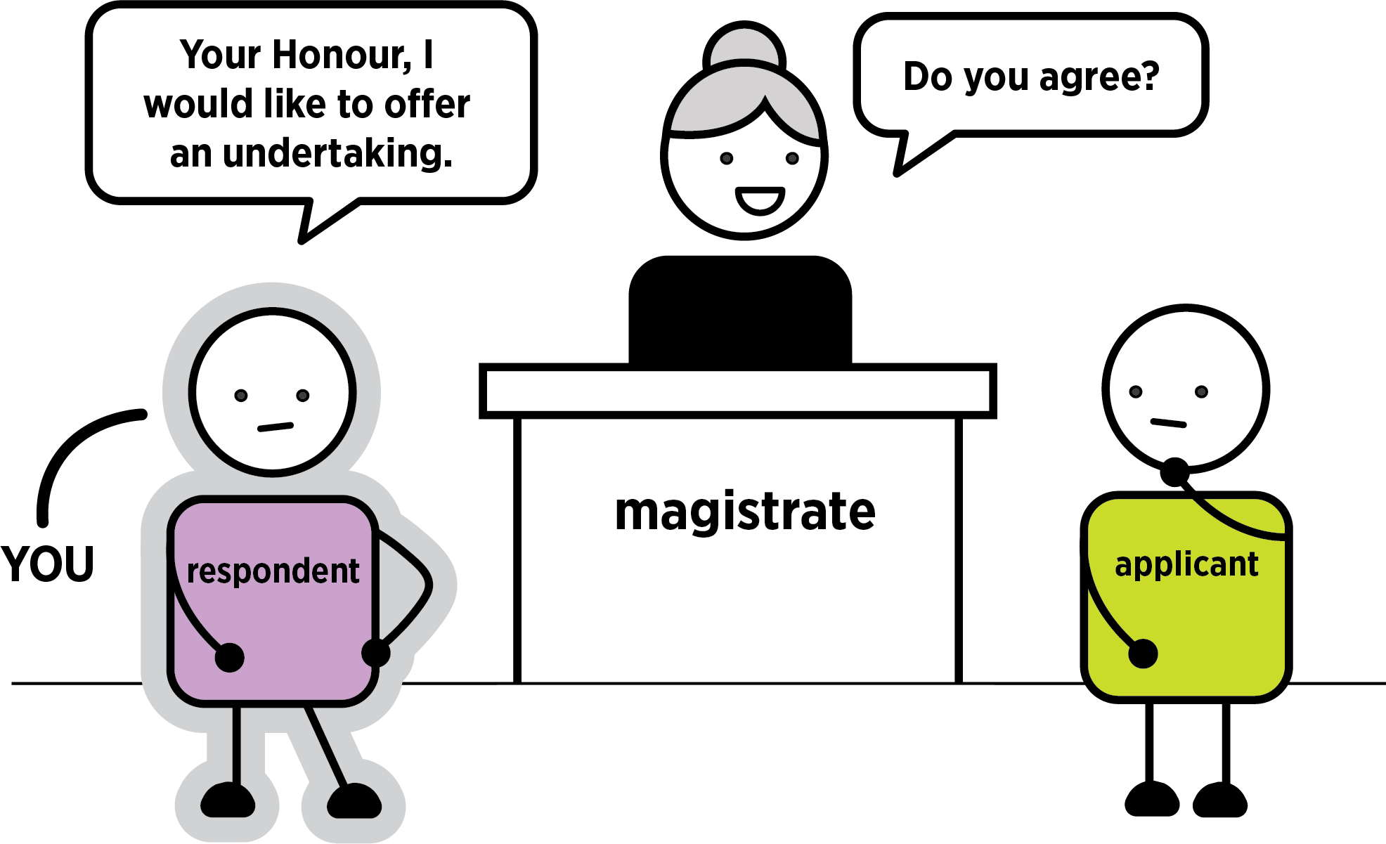
You can say: ‘Your Honour, I would like to offer an undertaking’.
The magistrate will ask the applicant if they agree.
If the applicant agrees, the registrar will type up the undertaking. The magistrate will read out the conditions. Listen to these rules. If there is anything you cannot do, ask the magistrate to change it.

To ask to change the conditions (rules)
You can say: ‘Your Honour, I would like to change these conditions’.
Tell the magistrate which ones you want to change.
The magistrate will ask the applicant if they agree.
If the applicant agrees, the registrar will type up the undertaking. The magistrate will read out the conditions.

If the applicant does not agree
If the applicant does not agree to an undertaking or changes in the conditions, the magistrate may ask if you and the applicant can agree on another option.

Notes space
__________________________________________________________________________________
__________________________________________________________________________________
__________________________________________________________________________________
__________________________________________________________________________________
__________________________________________________________________________________
__________________________________________________________________________________
__________________________________________________________________________________
__________________________________________________________________________________
__________________________________________________________________________________
__________________________________________________________________________________
__________________________________________________________________________________
__________________________________________________________________________________
__________________________________________________________________________________
__________________________________________________________________________________
__________________________________________________________________________________
__________________________________________________________________________________
__________________________________________________________________________________
__________________________________________________________________________________
__________________________________________________________________________________
__________________________________________________________________________________
__________________________________________________________________________________
__________________________________________________________________________________
__________________________________________________________________________________
__________________________________________________________________________________
__________________________________________________________________________________
__________________________________________________________________________________
__________________________________________________________________________________
__________________________________________________________________________________
__________________________________________________________________________________
__________________________________________________________________________________
__________________________________________________________________________________
__________________________________________________________________________________

If you cannot agree today: a contested hearing
If you and the applicant cannot agree to mediation, a final intervention order or an undertaking today, you may have to come back to court for a contested hearing. This is when a magistrate decides if a final intervention order is needed. You may also need to come back for a directions hearing before the contested hearing.
Any evidence that comes up at the contested hearing can be used by police if you have come back to court for criminal charges to do with this application.
If the matter is adjourned (put off) for a contested hearing, the applicant can ask for an interim (temporary) order until a final decision is made. They can ask for an interim order at any time before you go back to court.
If there is an interim (temporary) intervention order, you have to follow conditions (rules) until the contested hearing. If you break any of the rules, you could be charged by the police.

Can a contested hearing happen today?
No. It can take a long time before you come back to court. It will depend on when the court can hear it.

What do I need to do now?
You should get legal advice before a contested hearing. A lawyer can help explain what will happen and tell you how to prepare. Sometimes a lawyer will represent you (speak for you) in court. You can go to a community legal centre, a private lawyer or call Victoria Legal Aid’s Legal Help line on 1300 792 387.
You can ask them about:
- what happens at a directions and contested hearing
- what you need to do to get ready for a directions and contested hearing
- how many times you need to come back to court.

Was this self-help guide useful to you?
Please email feedback to: cle@vla.vic.gov.au or call (03) 9269 0234.

More help and information

Victoria Legal Aid
For free information about the law and how we can help you
- visit Victoria Legal Aid’s website (www.legalaid.vic.gov.au)
- ask questions on webchat from 9 am to 5 pm, Monday to Friday.
- call our Legal Help phone line on 1300 792 387 from 8 am to 6 pm, Monday to Friday excluding public holidays.

Federation of Community Legal Centres.
Help to find a community legal centre near you.
Tel: (03) 9652 1500
Website: Visit the Federation of Community Legal Centres’ website (www.fclc.org.au)

Law Institute of Victoria
The Law Institute of Victoria can help you find a private lawyer.
Tel: (03) 9607 9950
Website: Visit the Law Institute of Victoria’s website (www.liv.asn.au)

Dispute Settlement Centre of Victoria
Information on mediation.
Tel: 1300 372 888 (Melbourne). For other area visit the website.
Website: Visit the Dispute Settlement Centre of Victoria’s website (www.disputes.vic.gov.au)

Do you need help calling us?
Translating and Interpreting Service
Tel: 131 450
National Relay Service
TTY: 133 677
Speak and listen: 1300 555 727
Internet relay users: Visit the National Relay Service website (https://nrschat.nrscall.gov.au)
SMS relay: 0423 677 767
© 2020 Victoria Legal Aid. This work is licensed under a Creative Commons Attribution 4.0 licence (http://creativecommons.org/licenses/by/4.0/) The licence does not apply to any images, photographs or branding, including the Victoria Legal Aid logo.

Notes space
__________________________________________________________________________________
__________________________________________________________________________________
__________________________________________________________________________________
__________________________________________________________________________________
__________________________________________________________________________________
__________________________________________________________________________________
__________________________________________________________________________________
__________________________________________________________________________________
__________________________________________________________________________________
__________________________________________________________________________________
__________________________________________________________________________________
__________________________________________________________________________________
__________________________________________________________________________________
__________________________________________________________________________________
__________________________________________________________________________________
__________________________________________________________________________________
__________________________________________________________________________________
__________________________________________________________________________________
__________________________________________________________________________________
__________________________________________________________________________________
__________________________________________________________________________________
__________________________________________________________________________________
__________________________________________________________________________________
__________________________________________________________________________________
__________________________________________________________________________________
__________________________________________________________________________________
__________________________________________________________________________________
__________________________________________________________________________________
__________________________________________________________________________________
__________________________________________________________________________________
__________________________________________________________________________________
__________________________________________________________________________________

