Separated? Need to talk about the kids? Try mediation

Mediation can help families
Victoria Legal Aid has a mediation service, called Family Dispute Resolution Service (FDRS). We help families going through separation. At a mediation, a trained mediator sits down with you and the other parent or carers, and helps you to all talk about family arrangements, to see if you can agree on a plan together, with the help of lawyers, instead of going to court.
Lots of families use mediation to help them sort out arrangements for children. Separation is very difficult for everyone in a family. It can be hard to talk about personal family issues, but we will try to make it easier for you. Mediation is also confidential.
Mums, dads, grandparents or other family members worried about what’s going on for children can get legal help to try mediation. We offer a culturally appropriate service for Aboriginal and Torres Strait Islander people. We work closely with other services who work with Aboriginal and Torres Strait Islander people, too.

How our service can help you
Our Family Dispute Resolution Service can:
- help you to find a lawyer and let you know about other places (like health services) that could also help, depending on what you need
- talk to you and the other parent or carer to make sure mediation will be safe and is right for your family
- talk to you about having a support person with you during mediation, or at any time we need to talk to you about your family
- arrange for the children to have a say, if everyone agrees and we think it will be ok for them
- organise a meeting with a trained mediator if everyone agrees. This can be near where you live, or by telephone, and with an Aboriginal mediator, too.
We listen, to work out how we can help and so we can learn to do things better.

How you can use our service
To use our service, you or the other parent or carer needs to have a lawyer, and funding from Victoria Legal Aid. Even if you aren’t eligible for our mediation service, we can still help you get legal advice and other help.
Talking to a lawyer can help you make decisions. You may be thinking about court, but mediation may work better for you and your family.

Find out more
Call 1800 136 832 (toll free) or (03) 9269 0500
Email fdrs@vla.vic.gov.au
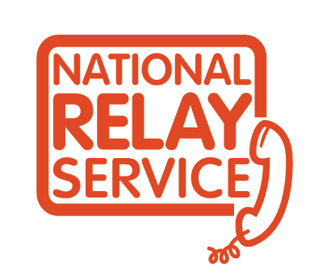
www.legalaid.vic.gov.au/fdrs
If you find it hard to hear or speak you can use the National Relay Service to call us

