How we can help with legal problems

We made this information on the land of the Wurundjeri people.
JANUARY
This information was made in January 2022. It may change.
Legal problems can make you feel:
- upset
- worried
- sad
- angry.
We know you might feel like this when you talk to us.

We can help you with your legal problems.

How to tell us about your legal problem
There are four ways to tell us about your legal problem.
You can:
- call Legal Help on 1300 792 387.
- write to us on our Legal Help Chat. This is on our website.
- come to one of our offices.
- talk to an Aboriginal community engagement officer if there is one in your area.
Before you talk to us, get any paperwork about your legal problem.

Paperwork may be a fine, a letter or email that is from a court, a lawyer or the police.

Phone Legal Help

You can call Legal Help on 1300 792 387.

Legal Help is open Monday to Friday, 8 am to 6 pm. It is closed on public holidays.

It will cost the same as a local phone call.

Anyone can call Legal Help.

If you call Legal Help you may have to wait.

Call early in the morning if you can.

It may be faster to use our Legal Help Chat.

Can someone call for me?

Yes.
A worker or support person you trust can call us.

It would be good for you to be with your worker or support person when they call.

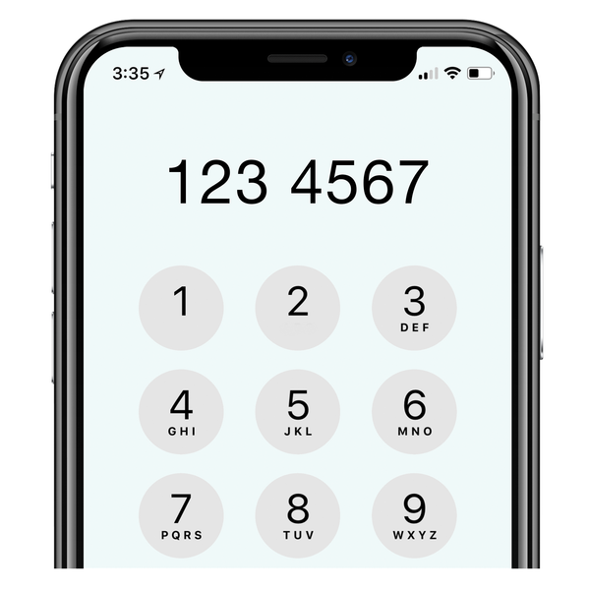

Workers should press four when asked.

Can I use the National Relay Service?
Yes. There are five ways you can use this service.
- TTY users: call 133 677 then call 1300 792 387.

- Speak and Listen: call 1300 555 727 then call 1300 792 387.

- Internet relay: go to nrschat.nrscall.gov.au then phone 1300 792 387.

- SMS relay: text 0423 677 767.

- Video relay: use Skype or the National Relay Service app.

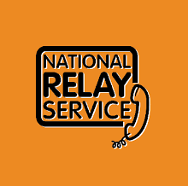
You need to join the National Relay Service before you can use it.

Can I talk in my language?
Our staff can speak other languages. If we do not speak your language, we will find someone who can. This is called an interpreter.

Click on this link to see if we speak your language.

Write to us on webchat
You can write to us on our website in the Legal Help Chat and our staff will write back to you.
If you need more help, staff may tell you to call Legal Help.

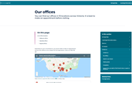
Visit us
We have offices across Melbourne and other places in Victoria.

Find out where we have offices.

You can visit an office to get legal information anytime. You will need to make a time to talk to a lawyer.

Our offices have ramps or lifts and you can bring your service animal.

Talk to an Aboriginal community engagement officer
We have people called Aboriginal community engagement officers.
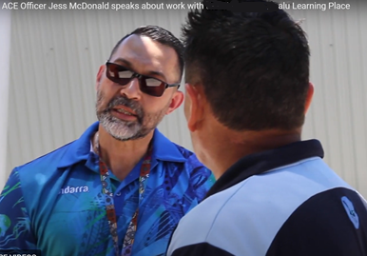

They work in the community.

They can talk to you about your legal problem and how to get help.
Click on the link to find out more about Aboriginal community engagement officers.

What happens when you tell us about your legal problem?
We will ask you questions so we know what help we can give you.

Everything you tell us is private.
We will not tell anyone what you say unless you tell us we can.

We can help with lots of legal problems.

If we cannot help you, we will tell you who can.

This may be a community legal centre or a lawyer who does not work for Victoria Legal Aid.

How we can help

Legal information and what you can do

We can tell you about the law and different things you can do.

We may also be able to:

- send you information
- talk to you before court

- help you to find other services and supports
- write letters

- speak for you in court.

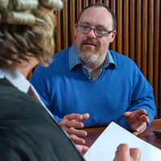
To know if we can help, you will need to tell us:

- your legal problem

- how much money you have.

We may be able to give more help if you:

- are Aboriginal and/or Torres Strait Islander

- have a disability or a mental health issue

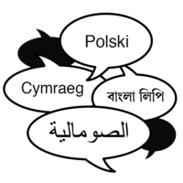
- don’t speak English very well.

We can get you support to communicate with us, like interpreters or the National Relay Service.

We can communicate with you in ways that you find helpful.

Tell us how you want us to give you information.

Duty lawyers

Duty lawyers can help with some legal problems in court.
If you do not have a lawyer, you can ask for a duty lawyer.

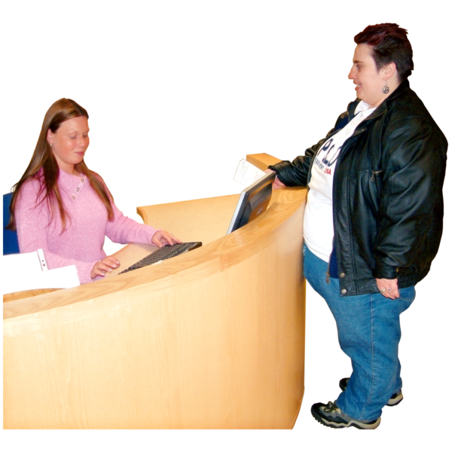
Our duty lawyers work at law courts in Victoria.
Ask the court if you can talk to a duty lawyer.

If you are going to the Magistrates’ Court because the police said you broke the law, you may be able to talk to a duty lawyer before going to court.

Click on the link to find out more about our Help Before Court service.

You can also ask the court about other services that can help you.

If you are going to the family law court, you may be able to talk to our Family Advocacy and Support Services before going to court.

Other support
We can give other support for your legal problem.

Independent Mental Health Advocacy can support you if you are made to go to hospital for your mental health.

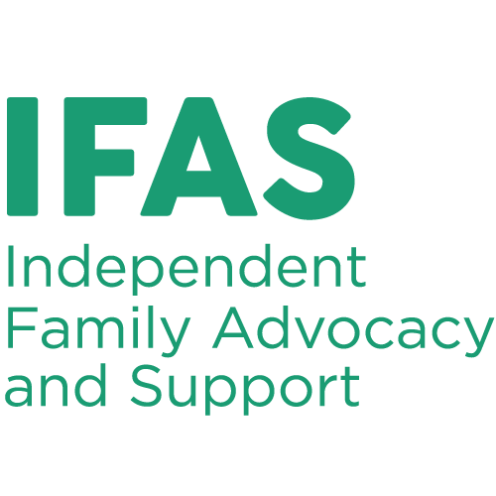
Our Independent Family Advocacy and Support can support parents and carers if child protection wants to take their child.

Our Family Dispute Resolution Service can support you to agree on things like who looks after the children, if you and your partner are not going to be together anymore.

Find more information about your legal problem
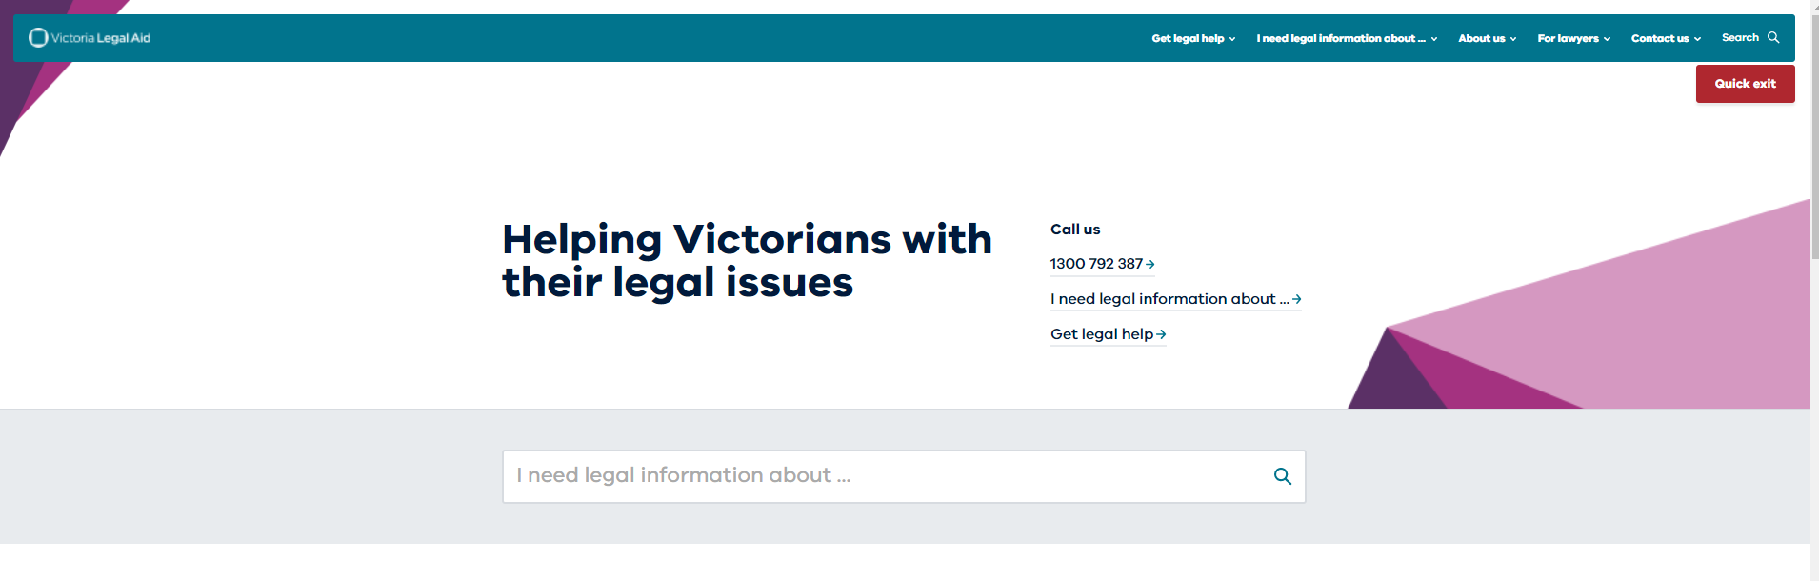

Our website has lots of information about legal problems.

You can make the words bigger or use a screen reader.

Do you have information in easy read or in my language?

We have free booklets in easy read and in different languages.

Click on our publications page for the booklets.

You can use a screen reader to read our booklets.

You can also click on the Supporting Justice webpage from RMIT University.

Acknowledgements
We had help with making this page:

VLA Consumer Advisory groups
- Shared Experience and Support
- Speaking from Experience.

Victorian Advocacy League for Individuals with Disability.
This was

