Barristers’ claims and the new process for payments
Direct payments by VLA to barristers will now be made when both the lawyer and the barrister are registered for GST. If either party is not registered for GST, contact Grants and Quality Assurance on (03) 9269 0600 for information about claims.

Old Process
- The lawyer engaged the barrister and the barrister made a claim to the lawyer for the work done.
- The lawyer claimed in ATLAS for the work done by the barrister.
- VLA paid the lawyer for the full amount and provided the Recipient Created Tax Invoice (RCTI) to the lawyer for the full amount. VLA sent a remittance notice when the funds were transferred to the lawyer.
- The lawyer paid the barrister after receiving the funds from VLA.
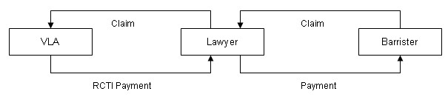
New Process
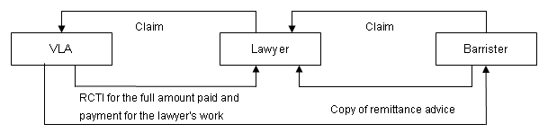
- The lawyer engages the barrister and the barrister makes a claim to the lawyer for the work done.
- The lawyer reassigns the claim for the barrister’s work in Atlas to the barrister.
- VLA pays the barrister for the barrister’s claim, at the direction of the lawyer, and sends a remittance notice to the barrister when the funds are transferred to the barrister’s account.
- The barrister’s clerk provides a copy of the remittance notice to the lawyer so that the lawyer knows that VLA has paid the barrister’s claim.
How to pay a barrister directly from ATLAS web
- Go to Submit New Claim.
- Enter the File ID.
- Remove your firm name from the Payee Service Provider field.
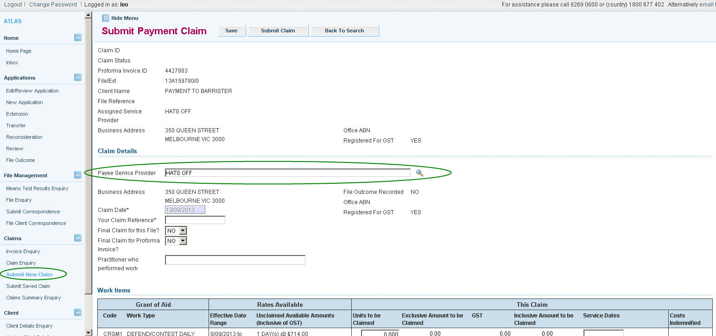

- Click on the pick list (magnifying glass) next to the Payee Service Provider field.
- Change the Service Type to barrister and in the Office field enter in the name of the barrister to be paid and click search.
- Click on the hyperlink of the name of the barrister to be paid.

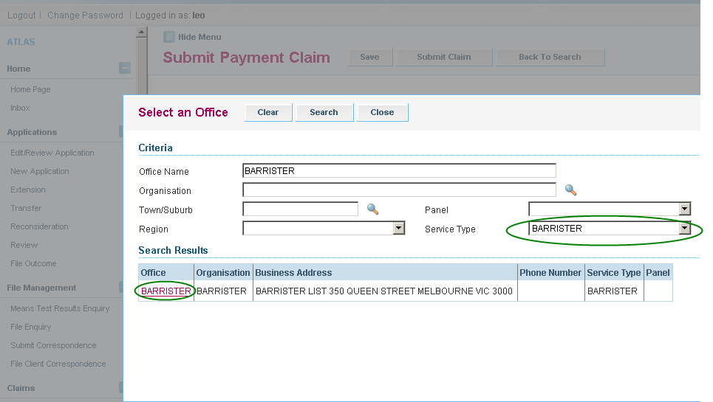

- The name of the barrister selected should now be displayed in the Payee Service Provider field. If the name of the barrister is not displayed, you must contact the barrister’s clerk and ask them to contact Grants and Quality Assurance on 9269 0600 and provide payment details to VLA.

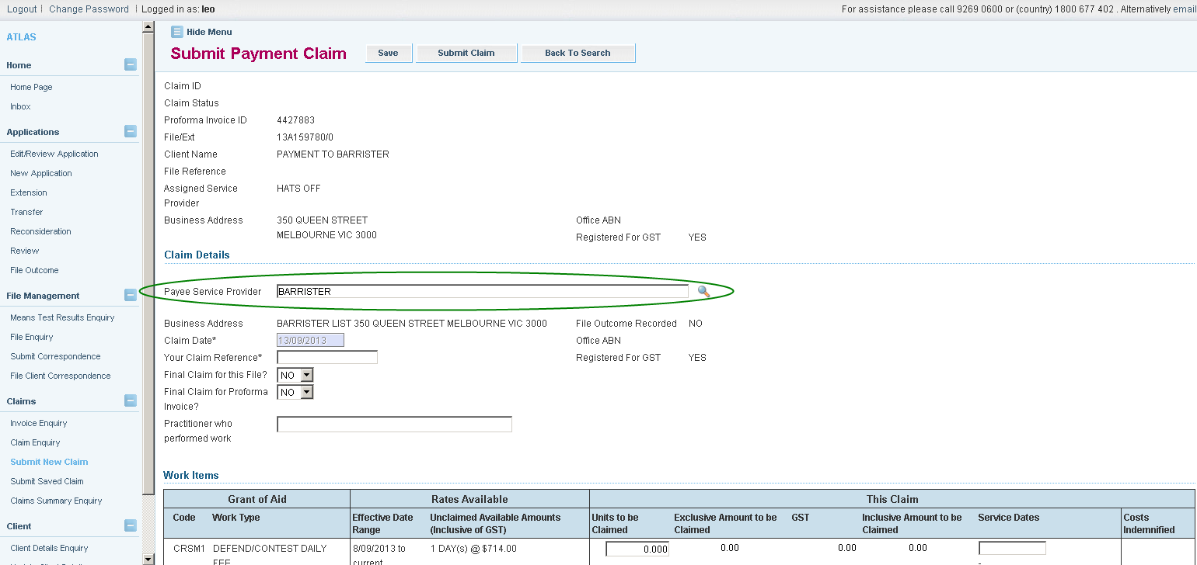

- In the section ‘Your Claim Reference’ enter in the fee slip number for the barrister you are entering. It is mandatory to use the barrister’s fee slip number so that the clerks can confirm receipt of payment.

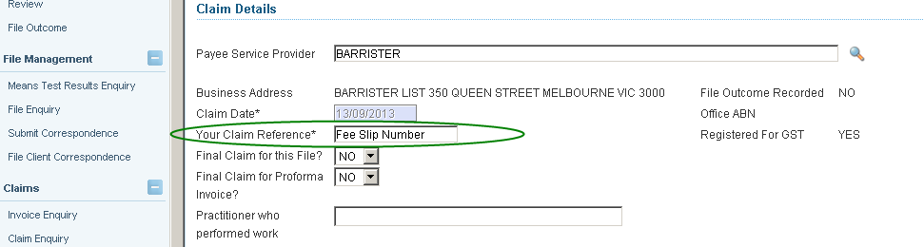

- You will see that the certification that lawyers make has changed. The certification now confirms that you are directing VLA to pay the barrister on your behalf.

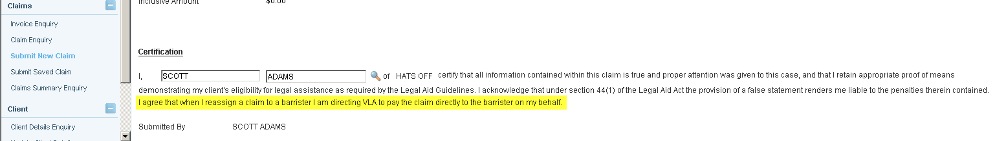

- Fill in the claim details for barrister costs and submit claim.
- Once the claim has been certified, the PDF of tax invoice will display the Payee Office as the barrister nominated in the claim form and funds will be directly paid to the barrister’s account, at the lawyer’s direction.

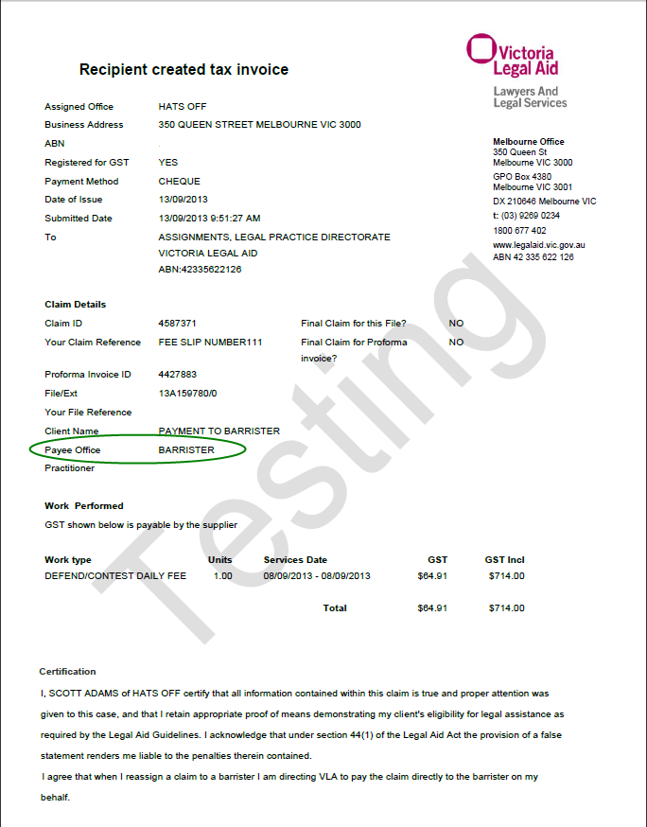

- The barrister will receive a remittance notice for the amount they are paid. We have asked the barrister’s clerks to provide a copy of that remittance notice to the lawyer who made the claim.
The remittance will now display a message which says:
“Barristers briefed by a private practitioner pursuant to a grant of assistance are receiving this payment at the direction of the private practitioner, and not pursuant to any retainer or other relationship with Victoria Legal Aid.”

