Victoria Legal Aid (VLA)

Client Experience Survey 2024

Summary report (accessible version)

Quality and Compliance Statement

This project was conducted in accordance with the international quality standard ISO 20252, the international information security standard ISO 27001, as well as the Australian Privacy Principles contained in the Privacy Act 1988 (Cth). ORIMA Research also adheres to the Privacy (Market and Social Research) Code 2021 administered by the Australian Data and Insights Association (ADIA).

Acknowledgments

ORIMA pays respect to Aboriginal and Torres Strait Islander Peoples past and present, their cultures and traditions and acknowledges their continuing connection to land, sea and community.

We would also like to acknowledge and thank all the participants who were involved in our research for their valuable contribution.

Contents

Project overview 1

Background 1

Research approach 1

Respondent profile 2

Qualitative fieldwork 3

Summary of key results 5

Access 8

Experience 9

Expertise 9

Communication 10

Person-centred 11

Support needs and considerations 12

Comments and suggestions for assisting clients with support needs 14

Legal capability 15

Resolution 16

Resolution status 16

Resolution – fully resolved matter 17

Resolution – partly or unresolved matter 18

Wellbeing 19

Stress 19

Overall Wellbeing 20

Mental health 20

Overall client satisfaction 22

Overall satisfaction comparisons by cohorts 23

Overall satisfaction trends 24

Key themes from client interviews 26

Defining resolution 26

Service level expectations for resolution 26

Working together 26

Use of support need information 26

The complete personal context 27

Information for agency 27

# Project overview

## Background

Victoria Legal Aid (VLA) is an independent statutory authority established under the Legal Aid Act 1978. VLA provides legal information, advice and representation to members of the Victorian community who are most disadvantaged and in need of support. Services provided by VLA and private practitioners are intended to be accessible, tailored to clients' needs and capabilities, and help people to address legal problems.

VLA has sought feedback through client surveys since 2011, to assess the extent to which it meets clients’ needs. In 2022, VLA adopted an outcomes approach with the development of VLA’s Outcomes Framework 2022-30 and the Outcomes and Evidence Agenda 2022-26. The first outcome, ‘clients have increased access to justice’ is directly related to the client journey with VLA. This outcome has been further broken down to better understand the client journey along with the impact of VLA’s services.

These client outcome areas are:

* Access to VLA services;
* Experience of VLA services;
* Impact on client legal capability,
* Resolution of clients’ legal problems; and
* Impact on client wellbeing.

In 2023, VLA first commissioned ORIMA Research to conduct the Client Experience Survey. In 2024, VLA commissioned ORIMA Research to conduct the survey again, in addition to the conduct of follow-up qualitative interviews with select clients. This report presents a summary of the findings from the research.

## Research approach

The research approach had five stages:

1. **Project establishment, which included:**
   1. Project inception and planning
2. **Establishment of survey tools and processes**
   1. Questionnaire refinement and finalisation
   2. Sample preparation and validation
   3. Online survey programming
3. **Quantitative fieldwork (29 January to 29 February 2024)**
   1. Online survey invitations and reminders distributed via email and SMS
   2. Computer Assisted Telephone Interviewing (CATI)
4. **Qualitative fieldwork (8 April to 24 April 2024)**
   1. In-depth interviews with n=30 clients, conducted via telephone
5. **Data analysis and reporting**
   1. Data cleaning and analysis
   2. Survey data weighted by service offering, service type and law type
   3. Preparation of a summary and comprehensive report

## Respondent profile

### Sampling approach

The survey was sent to a stratified random sample of n=20,935 VLA clients who received services between 1 June to 30 November 2023. The sampling strata were based on service offering, service type and law type (see table below). Certain groups were oversampled to allow for more robust analysis and reporting. Survey data was then weighted by known population proportions.

The sample did not include clients aged under 18 or any client who had received a family law service where the risk level of seeking their feedback was deemed to be too high.

### Response rate

**4%** of clients responded in 2024, which was 802 clients out of 20,935 clients.

### Profile of responding sample compared to the in-scope population

A summary of the responding sample compared to the in-scope population is provided in Table 1.

Table : Profile of responding sample compared to the in-scope population

| Overall | Population count | Population proportion | Responding sample count | Responding sample proportion (unweighted) |
| --- | --- | --- | --- | --- |
| Total | 24,908 | 100% | 802 | 100% |
| Service offering | - | - | - | - |
| In-house practitioner | 22,741 | 91% | **702** | 88% |
| Private practitioner | 2,188 | 9% | **100** | 12% |
| Service type | - | - | - | - |
| Duty Lawyer | 14,373 | 57% | **384** | 48% |
| Legal Advice | 8,237 | 33% | **308** | 38% |
| Casework | 2,455 | 10% | **113** | 14% |
| Law type | - | - | - | - |
| Criminal law | 14,821 | 59% | **385** | 48% |
| Family law | 6,062 | 24% | **221** | 27% |
| Civil law | 4,115 | 16% | **199** | 25% |

### Demographic profile

Just over half of the sample were middle-aged: 35-44 years (23%) and 45-54 years (29%). Two in five were female (40%) and 59% were male. One in seven respondents spoke a language other than English (14%) and 6% were of Aboriginal and / or Torres Strait Islander descent. Three in five respondents had a disability or an ongoing condition or impairment (58%) and the most common conditions were mental health issues (42% overall), complex mental illness (21%) and chronic illness (13%). 45% of respondents’ highest level of education was high school or below.

## Qualitative fieldwork

### Engagement approach

Qualitative research was conducted between 8 April to 24 April 2024 with a total of 30 participants, who participated in individual in-depth interviews following opting in through completion of the online survey.

A light touch Human Research Ethics review of all draft materials was conducted to ensure the research was robust, respectful and sensitive in its conduct. This included a Participant Information Sheet, Discussion Guide and Duty of Care Escalation protocols.

### Target audience

The target audiences included:

* 1. People with disability support needs;
  2. People with support needs related to the experience of violence;
  3. A mix of people who had fully, partially or unresolved legal issues;
  4. A mix of people across VLA service types and legal issues; and
  5. A mix of people who had positive, neutral or negative experiences with VLA.

The focus on these clients was informed by the recommendations from the 2023 Client Experience Survey.

### Profile of responding sample compared to the in-scope population

Table 2: Interview respondents by support needs

|  |  |
| --- | --- |
| Additional support needs | Number of respondents  (#) |
| Yes, a disability, mental health issue, or other health concern | 17 |
| Yes, I had experienced violence at home, school, or work | 6 |
| Yes, other support needs | 4 |
| No, I did not have any specific support needs | 11 |
| **Total** | **30** |

Table 3: Interview respondents by service type and practice area

|  |  |  |  |  |
| --- | --- | --- | --- | --- |
| Practice area | Legal advice  (#) | Duty lawyer  (#) | Case work  (#) | Total  (#) |
| Civil | 8 | 0 | 0 | 8 |
| Criminal | 3 | 7 | 1 | 11 |
| Family | 7 | 2 | 2 | 11 |
| **Total** | **18** | **9** | **3** | **30** |

# Summary of key results

### Access

* 80% of respondents agreed it was easy to contact VLA when they first needed help.

### Experience

* 85% of respondents agreed that the lawyer treated them with respect, which was higher compared to 2023 results.
* 77% of respondents agreed that the lawyer listened to their legal problem.
* 72% of respondents agreed that the lawyer took their circumstances into account.

### Resolution

* 48% had their legal problem fully resolved.
* 17% had their legal problem partially resolved.
* 30% had an unresolved legal problem.
* 84% of respondents agreed that VLA’s help had a positive impact on their legal outcome, which was higher compared to 2023 results.
* 80% of respondents agreed that VLA helped fix their legal problem.

### Wellbeing

* 63% of respondents agreed they were less stressed after talking to the lawyer.
* 67% of the respondents with a fully resolved matter agreed that their overall wellbeing was improved.
* 32% of the respondents with an unresolved matter agreed that their overall wellbeing was improved.

### Legal capability

* 77% of respondents agreed they know where to get help for future legal problems.
* 75% of respondents agreed that they feel more confident to get legal help in the future.
* 74% of respondents agreed that the lawyer helped them understand how to deal with their legal problems.

### Satisfaction

* 65% of respondents were satisfied with the help they got from VLA.
* 76% of respondents agreed that they would recommend VLA to others.

### Key takeouts for the 2024 survey

* **VLA is performing well at an overall level.**
  + Overall, VLA recorded a solid performance in its delivery of legal services to clients in the 2024 survey. Clients found it easy to contact VLA when they first needed help, expressed positive feedback on the person-centred approach of lawyers, and noted that VLA built their confidence to deal with legal problems in the future. Historically, between 2015 and 2023, overall client satisfaction has been following a trajectory of decline (from a high of 76% in 2015 to a low of 62% in 2023). However, in 2024 the trend stabilised, with around two in three (65%) feeling satisfied with the help they received from VLA.
* **Clients with a disability have poorer experiences with VLA: additional support may be needed.**
  + Clients who have a disability recorded poorer ratings across many client experience metrics. This client cohort were less likely to feel confident that their lawyer’s advice would help them with their legal problem, less likely to express that their capability to deal with legal problems improved as a result of VLA’s service, less likely to feel less stressed after receiving the service and had lower service satisfaction overall. Additional, tailored supports for these clients may be required. Interviews highlighted the importance of VLA being more proactive in asking about a person's disability or mental health needs and how this might impact on how they understand information, how a client may present in a court environment and also provide pertinent context needed to represent the legal problem. Disability awareness training (including Brain Injury, Autism, Post-Traumatic Stress Disorders, etc.) should be considered, alongside ways these conditions can be supported in different VLA services.
* **Clients with unresolved legal problems and unfavourable outcomes feel isolated.**
  + The resolution status and outcome of respondents’ legal problems had a large influence on their overall satisfaction, with clients who have unresolved problems and clients who have unfavourable outcomes reporting poorer service satisfaction and poorer experiences across most metrics. Many clients who had unresolved problems felt that they were left alone to deal with their legal problem, particularly where there was minimal contact, waitlists or long gaps between contacts from VLA staff. Communication and engagement appear to be critical factors of perceiving VLA support more favourably, even when legal problems are not resolved.
  + Qualitative insights suggest that a consistent and responsive person-centred approach will involve:
    - good quality interactions based on skilled listening;
    - being available to answer questions as required; and
    - clear and confident communication of information drawing upon a combination of understanding the legal process, trends in legal problems (likelihoods / scenarios) and regard for the individual’s situation.
* **Clients are less satisfied with their service from legal advice than other service options.**
  + Clients who have received legal advice services had poorer ratings across most metrics. This may in part be due the level of service intensity and the type of interaction being different between duty lawyer or casework support. Clients who have received legal advice rated lawyers as being less person-centred (i.e. listening, consideration of circumstances, and respect), with poorer communication and engagement experiences (e.g. asking questions). They were also less likely to have a resolved problem (compared to case work or duty lawyer services), and resolved problems were less likely to be ‘favourable’. Interviews identified that clients largely define ‘resolution’ as the end of a court matter. Clients contacting Legal Advice had little expectation of what VLA could provide, nor that initial advice would resolve the problem. Despite this, VLA could look at ways to strengthen person-centred legal advice service models, within the time constraints of these briefer interactions.
* **Clients receiving family law support have poorer experiences with VLA: additional support may be needed.**
  + Clients who have received support for family law problems recorded poorer ratings across most client experience metrics. This client cohort is more likely to have an unresolved problem (compared to criminal law), and less likely to feel that the lawyer took their circumstances into account (compared to criminal law), and that they know where to get support in the future (compared to criminal law).
* **Clients experiencing violence require additional support.**
  + Out of all the types of support needs, clients experiencing violence were the least likely to feel that VLA met their support needs related to this experience. Free-text comments highlighted that clients seeking support for a domestic or family violence problem felt that VLA staff lacked understanding of these types of problems. Additional support for clients of all services areas with lived or living experience of violence may be required, with a focus on ensuring trauma-informed services are delivered. Interviews highlighted gaps in VLA services for individuals experiencing violence who were ineligible for assistance despite lacking financial resources. These participants were reliant on ad-hoc time-limited support or services or faced with services (including legal partners) suggested by VLA not taking clients. This issue could also be combined with the lack of consistency in the quality provision of Legal Advice and may also be related to the poorer ratings for family law problems.

# Access

This section of the report focuses on clients’ initial contact with VLA and any difficulties they had when contacting VLA when they first needed help.

Most respondents found accessing VLA’s service straightforward.

Eight in ten (80%) respondents agreed it was easy to contact VLA when they first needed help (shown in Figure 1).

Figure : Ease of accessing Victoria Legal Aid

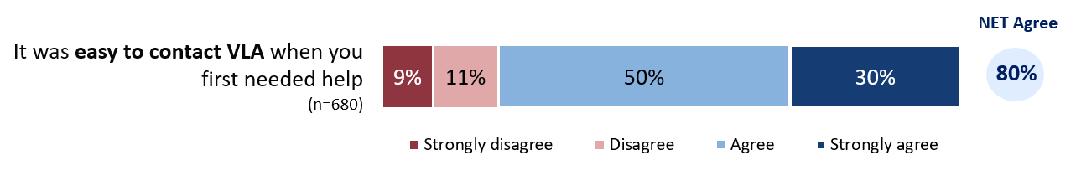

Question: How much do you agree or disagree that it was easy to contact Victoria Legal Aid when you first needed help?

Base: All respondents (n=680).

20% felt that it was not easy to contact VLA when they first needed help. Of these, 77% reported difficulty in making initial contact with VLA, and a much smaller proportion (8%) had difficulties communicating with the VLA staff member when they were able to make contact.

Figure : Why was it difficult to contact Victoria Legal Aid? (129 respondents)

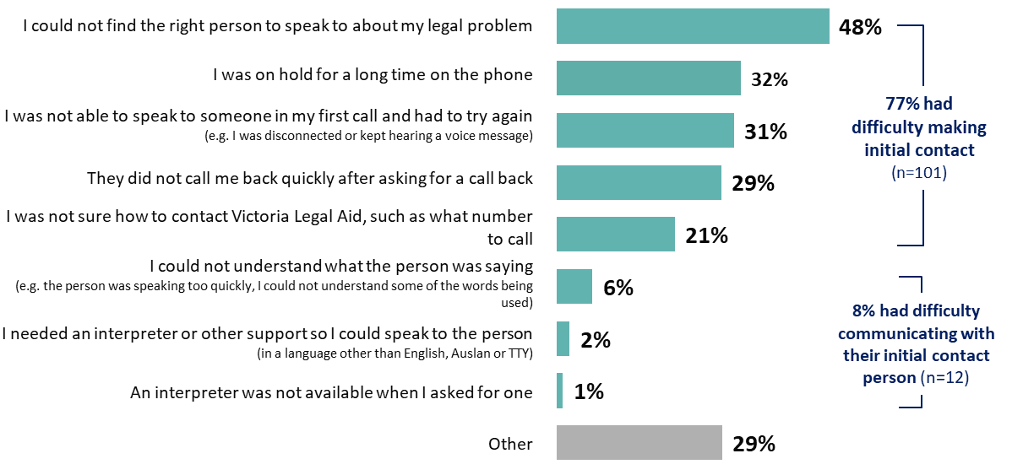

Question: Why was it difficult to contact Victoria Legal Aid?

Base: All those who disagreed or strongly disagreed with the statement “It was easy to contact Victoria Legal Aid when you first needed help” (n=129)

# Experience

This section of the report focuses on the various factors influencing the quality of the experience clients have while interacting with VLA. These can be summarised as:

perceived expertise of the legal advisors,

quality of communication between clients and legal advisors,

the extent to which services are person-centered and tailored to individual circumstances, and

support needs and considerations of clients, and whether these were adequately met.

## Expertise

Respondents generally felt assured about the expertise of the lawyer.

Around three-quarters (77%) agreed the lawyer understood their problem and seven in ten (69%) had been confident the advice provided would help them.

One in six (16%) did not think that their lawyer understood their problem and one in five (21%) had not been confident that the lawyer’s advice would help them, disagreeing or strongly disagreeing with the statement.

More details can be found in Figure 3.

Figure : Expertise of Legal Aid lawyer

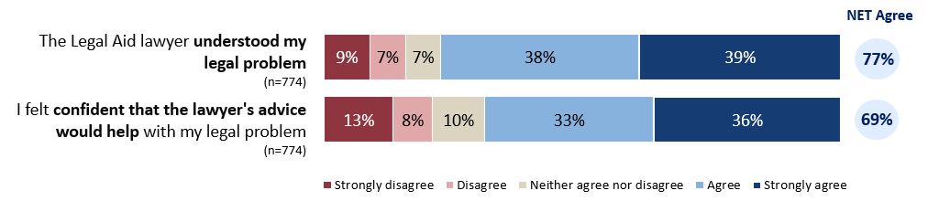

Question: How much do you agree or disagree with the following statements about the Legal Aid lawyer? – the Legal Aid lawyer understood my legal problem. Question: How much do you agree or disagree with the following statements about how you felt? – I felt confident that the lawyer’s advice would help with my legal problem.

Base: All respondents (n=774). Excludes ‘not sure / I can’t remember’ responses.

Some respondents praised the knowledge of their lawyer, and the suitability of their advice. Some also highlighted that a positive outcome came from their lawyer’s legal expertise.

“The lawyer handling my problems was very well versed in case law, in situations similar to mine. He treated me very professionally and was patient in dealing with my emails, some sent late at night. The service that I received was gold standard.”

“The lawyer assigned to us was fantastic. Achieved a better result than we could have hoped for. Extremely grateful for his understanding of the situation and the solution he sought from the prosecution and the outcome he achieved.”

Some respondents felt that their lawyer did not provide advice or information that was helpful or was inexperienced.

“Because no solution or instructions on what to do with my problem was provided.”

“Get experienced family lawyers that genuinely want to help victims of family violence. The Junior family lawyers are useless and don't understand family violence.”

## Communication

Communication between lawyers and clients was viewed positively.

More than three-quarters (77%) agreed it was easy to understand the lawyer and 76% said they were able to ask all the questions they wanted.

More information can be found in Figure 4.

Figure : Ease of communication with the legal aid lawyer

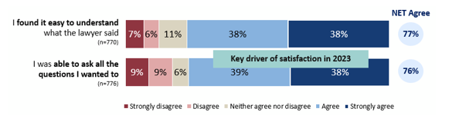

Question: How much do you agree or disagree with the following statements about how you felt? – The last time I got help from the Legal Aid lawyer… I found it easy to understand what the lawyer said. Question: How much do you agree or disagree with the following statements about how you felt? – The last time I got help from the Legal Aid lawyer… I was able to ask all the questions I wanted to.

Base: All respondents (base sizes ranged from n=770 to n=776). Excludes ‘not sure / I can’t remember’ responses.

Some respondents praised the positive impact of VLA’s good communication skills:

“Good communication, friendly & helped us understand more clearly to get a positive outcome.”

“Both my legal aid lawyers explained everything to me and answered any questions that I had and showed me respect and were very supportive and understanding about my circumstances.”

A few respondents provided negative assessments on the communication measures. These respondents mentioned a lack of communication and language that wasn’t accessible.

“I was referred and case was accepted, but no human contact there after multiple calls.”

“Wanted to speak to someone, happy when l received a phone consultation, but she must have been reading off a sheet of all legal jargon that went way over my head, didn't really answer any questions that l managed to ask, offered nothing.”

## Person-centred

Respondents generally perceived the service to be person-centred.

At least three-quarters agreed or strongly agreed that their lawyer treated them with respect (85%) and listened to their legal problem (77%).

More information can be found in Figure 5.

Figure : Perception of the service as person-centred

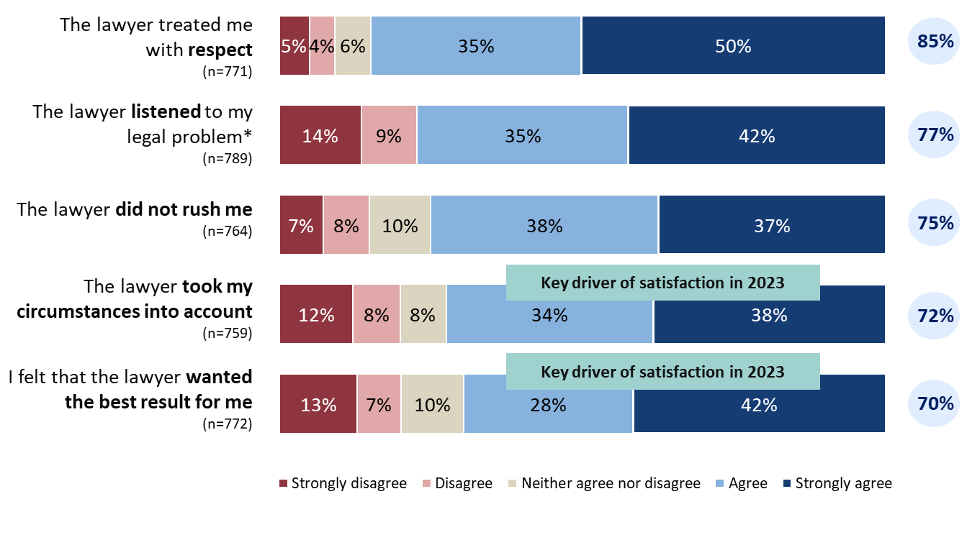

Question: *How much do you agree or disagree with the following statements about the Legal Aid lawyer?* Question: *How much do you agree or disagree that the lawyer listened to your legal problem?*

*Base: All respondents (base sizes ranged from n=759 to n=789). Excludes ‘not sure / I can’t remember’ responses. *This question about the lawyer listening to their legal problem was asked on a 4-point agreement scale without a mid-point (e.g. ‘neither agree nor disagree’).*

Many respondents felt they were respected, listened to, that their personal circumstances were taken into account.

“[name] was so respectful towards my problems and knew I didn’t have the mental health to deal with some of my problems/ So thank you again.”

“I was treated with dignity and respect and my medical defence was taken seriously.”

A minority indicated that their lawyer seemed rushed and that they did not attend to the respondent’s individual circumstances or specifics about the problem.

“The staff member was quick and didn’t want to listen he treated me like a number he didn’t want to spend time explaining it was absolutely horrendous knowing these staffers don’t have our best interests at heart.”

“The lawyer didn't listen to me, and had everything muddled when she spoke to the judge.”

## Support needs and considerations

Three in ten (30%) respondents had support needs when using VLA’s services: feedback on whether these needs were met was mixed.

Among 778 respondents, 30% had specific support needs or considerations when using VLA’s services (see Figure 6). 18% of respondents had a disability, mental health issue, or other health concern. 10% of respondents had experienced violence at home, school, or work.

The respondents who had difficulty reading or writing, who needed an interpreter (including Auslan), and who had caring responsibilities accounted for 5%, 5%, and 4% of the total sample, respectively.

For the respondents needing cultural support from elders, community leaders, or family, for those with needs related to their gender or sexual orientation, and for the respondents who had needs related to their religious or cultural beliefs, the numbers were 3%, 2%, and 1% respectively.

2% of respondents had other support needs.

Figure : Support needs and considerations

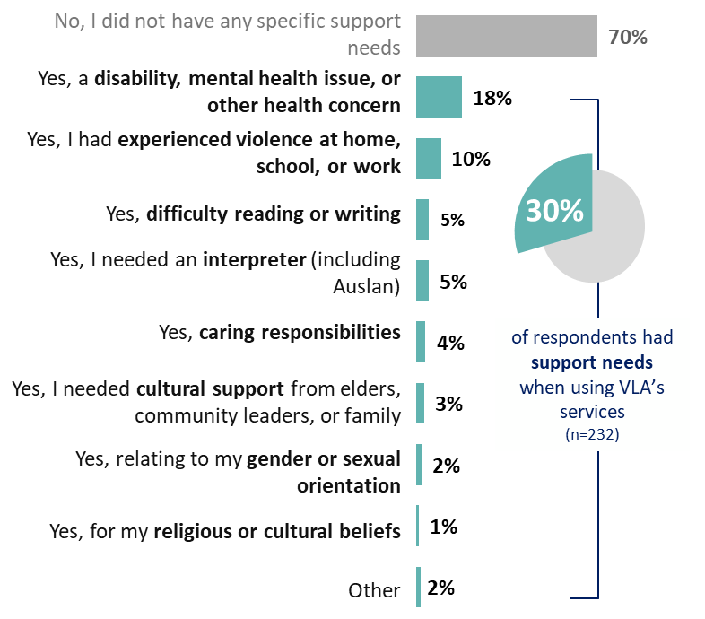

Question: Regardless of whether you asked for any additional help, did you have any support needs when you used Victoria Legal Aid’s services? If so, what were they?

Base: All respondents (n=778).

### Extent to which support needs and considerations were met

Feedback from respondents on whether their support needs or considerations were met were mixed (as shown in Figure 7). Respondents requiring interpreter services were the most likely to say that their needs were fully met (78%). Although respondents’ disability, mental health or other health concerns and previous experience with violence were the most commonly identified areas for supports, only a minority of these respondents indicated their needs were fully met (42% and 29% respectively).

Figure : Extent to which support needs and considerations were met

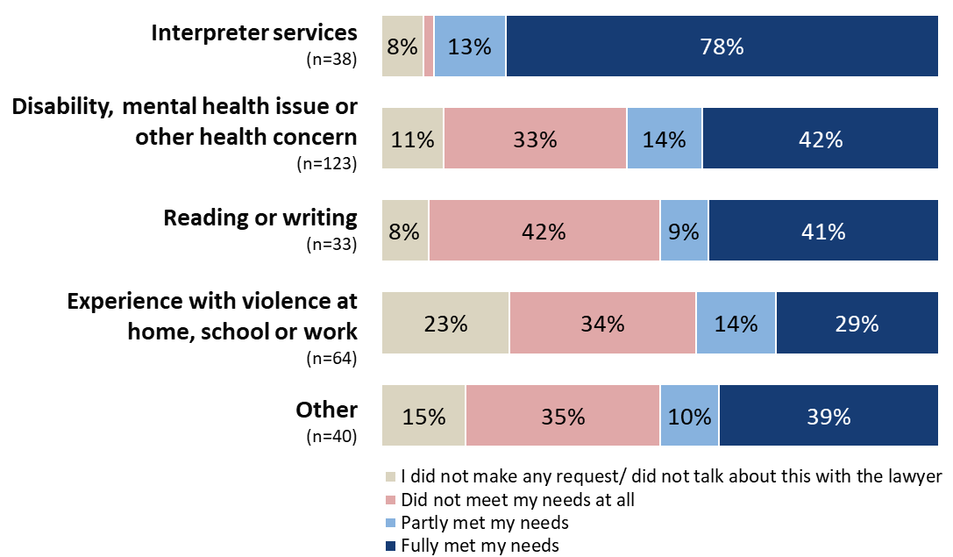

Question: How well did Victoria Legal Aid support these needs?

Base: Respondents who indicated supports were needed, (base sizes ranged from 33 to 123). Excludes ‘not sure’ responses. Note: Results relating to cultural support from Elders, community leaders or family, gender or sexual orientation, caring responsibilities, and religious or cultural beliefs are not shown due to small response numbers (n=8-27).

## Comments and suggestions for assisting clients with support needs

When respondents were asked why their support needs/ considerations were not fully or only partially met, many felt VLA did not consider how their particular circumstances would impact the way they received or engaged with services:

“ADHD and anxiety means the limited options available for explaining my issues made the process overly stressful and meant it was hard to get my meaning across.”

“I been waiting all day, while I have had back injury and been on medication.”

“I sustained 2 forms of an acquired brain injury a number of years ago. The frontal lobe damage makes dealing with my daily life rather difficult. During the coma that caused my brain injuries, I also sustained bilateral ulnar nerve palsy. So, I am unable to write. That obviously isn't a concern for anyone from Victorian Legal Aid.”

When respondents whose support needs were not fully met, they were asked how VLA could better meet their needs. Many suggested that VLA could improve their communication, take the time to listen to and understand clients’ circumstances, receive education around domestic violence and trauma-informed service and ensure that the staff understands the needs of people with mental health conditions:

“Time management and following up with clients and update them.”

“Understand the individual's situation first before the operators make any recommendations.”

“I guess just understanding that family violence survivors can be further traumatised by the court system. When I broke down crying at one stage I got told that I had better not do that in court. Maybe being trauma informed in order to work with your clients with compassion.”

“Not just legal aid but everyone needs to understand that violence doesn’t just stop when you leave the person and that you will possibly still need that help ongoing.”

“Provide a more personalised service where neurodivergence and hidden disabilities are a factor.”

A small proportion of respondents indicated that although they had support needs, they did not make any requests. A few explained that they were too overwhelmed to think of it at the time, that their family member supported them so they didn’t need additional support, and that they didn’t feel they would get the support if they asked:

“Was too overwhelmed at the time to think of them.”

“I felt like they were hardly listening to my problem or circumstances anyways so why add something extra in.”

“I did not need. My family member came along with me and was with me when speaking to my lawyer.”

# Legal capability

This section describes the impact of VLA’s assistance on clients’ ability to understand their most recent legal problem, how to deal with it, as well as their impact on building client capability in dealing with future legal problems.

The experience of interacting with VLA left most respondents feeling more capable of dealing with legal problems in the future.

Slightly more than three-quarters (77%) of respondents agreed they would know where to get help with future legal problems, and 75% felt more confident in getting legal help should they need to do so in the future. Respondents also agreed that the lawyer was instrumental in helping them to understand (72%) and deal (74%) with their legal problems (see Figure 8).

Figure . Capability of respondents

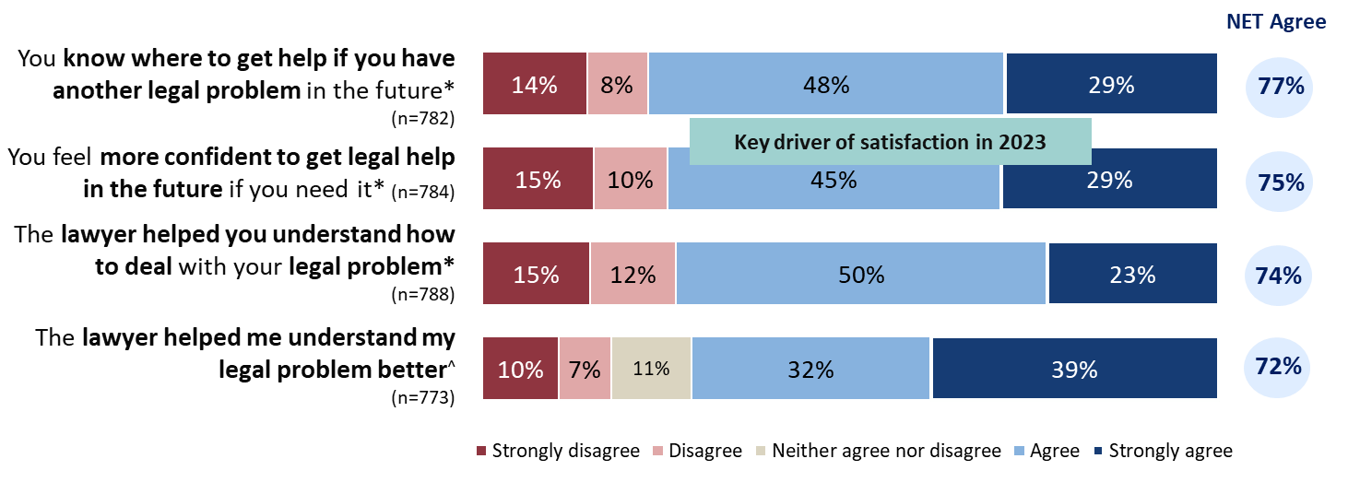

Question: How much do you agree or disagree with the following statements? – You know where to get help if you have another legal problem in the future. Q25b. How much do you agree or disagree with the following statements? – You feel more confident to get legal help in the future if you need it.

Question: How much do you agree or disagree with the following statements? – The lawyer helped you understand how to deal with your legal problem. Q7d. How much do you agree or disagree with the following statements about the Legal Aid lawyer? The last time I got help, the Legal Aid lawyer… helped me understand my legal problem better.

Base: All respondents (base sizes noted above).

Notes: *Two of the questions were asked on a 4-point agreement scale without a neutral mid-point (e.g., ‘neither agree nor disagree’). ^Excludes ‘not sure / I can’t remember’ responses.

# Resolution

This section focuses on client perceptions of VLA’s impact on their legal matters. In the survey there was a separate set of questions for those who had a fully resolved legal matter to those whose legal matter was yet to be resolved. The former focused on the perceived impact of VLA assistance on the outcome, and the latter focused on the perceived impact of VLA assistance on the progress of their case or anticipated outcome.

## Resolution status

Of the legal problems respondents went to VLA for help with, 48% were fully resolved, 17% were partially resolved, and 30% were unresolved.

Of those whose most recent legal problem was fully resolved, 58% had an outcome that was completely in their favour, 25% had an outcome that was partly in their favour, and 12% had an outcome that was not at all in their favour (as shown in Figure 9).

Figure . Resolution status

Two horizontal stacked bar charts displaying frequencies against different metrics.

The first chart is a stacked bar chart assessing whether or not respondents’ legal problem had been resolved with the following options: ‘yes, fully’, 'partially', ‘no’, and 'Don't know, not sure or other'. 

The second chart is a stacked bar chart assessing the outcome of respondents’ most recent legal problem with the following options: ‘completely in your favour’, 'partly in your favour', ‘not at all in your favour’, and 'don't know or not sure'.  

Question: *Has the legal problem you went to VLA for help with ended or been resolved? Base: All respondents (base size noted above).* Question: *Was your most recent legal problem resolved…?*

*Base: All respondents with a fully resolved legal problem (base sizes ranged from n=362 to n=794).*

## Resolution – fully resolved matter

VLA’s involvement was generally perceived to have had a positive impact on the outcomes of respondents’ legal problems where the legal matter had been resolved.

For the respondents with a fully resolved legal matter, 85% thought Legal Aid gave them enough help for their problem. 84% of respondents reported that the help they got from VLA had a positive impact on the outcome of their legal problem. 82% reported they were satisfied with the outcome of their legal problem. 80% of respondents thought VLA helped them fix their legal problem. The outcome of their legal problem was perceived to be fair for 79% of respondents (as shown in Figure 10).

Figure 10. Resolution - Fully resolved matter

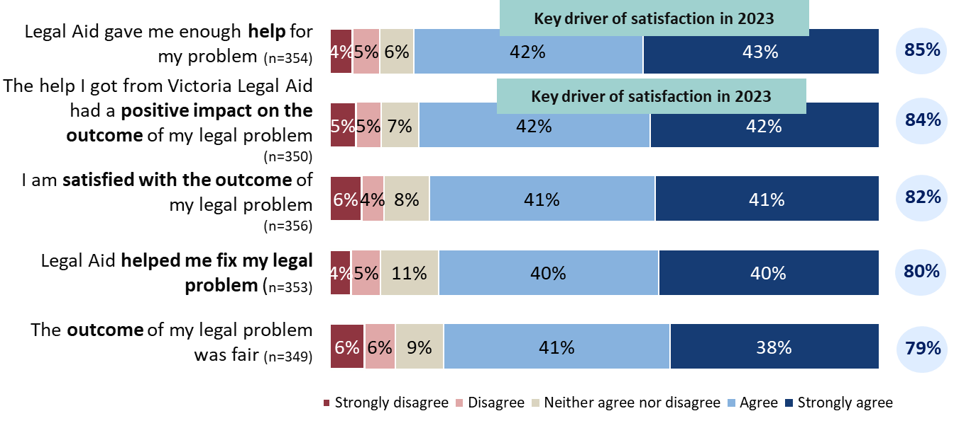

Question: Thinking about the resolution of your legal problem, how much do you agree or disagree with the following?  
Base: All respondents with a fully resolved legal problem (base sizes ranged from n=349 to n=356). Excludes ‘not sure / I can’t remember’ responses.

Respondents who perceived VLA to have a positive impact on their legal matter praised VLA’s support which helped them to achieve their outcome:

“My lawyer did a good job. I was very pleased with the outcome.”

“My solicitor did everything in her power to represent my case and succeed to a very positive outcome i.e. - winning the case for me.”

## Resolution – partly or unresolved matter

Clients tended to be less positive if their matter had not been fully resolved.

For the respondents with an unresolved legal matter, 52% reported that the help from Legal Aid helped them to get to the next step(s) in their legal problem. 45% thought Legal Aid gave them enough help for their problem. 44% of respondents reported that the help they have got from VLA so far will have a positive impact on the outcome of their legal problem. 39% of respondents felt satisfied with how their case was going (as shown in Figure 11).

Figure 11. Resolution partly/unresolved matter

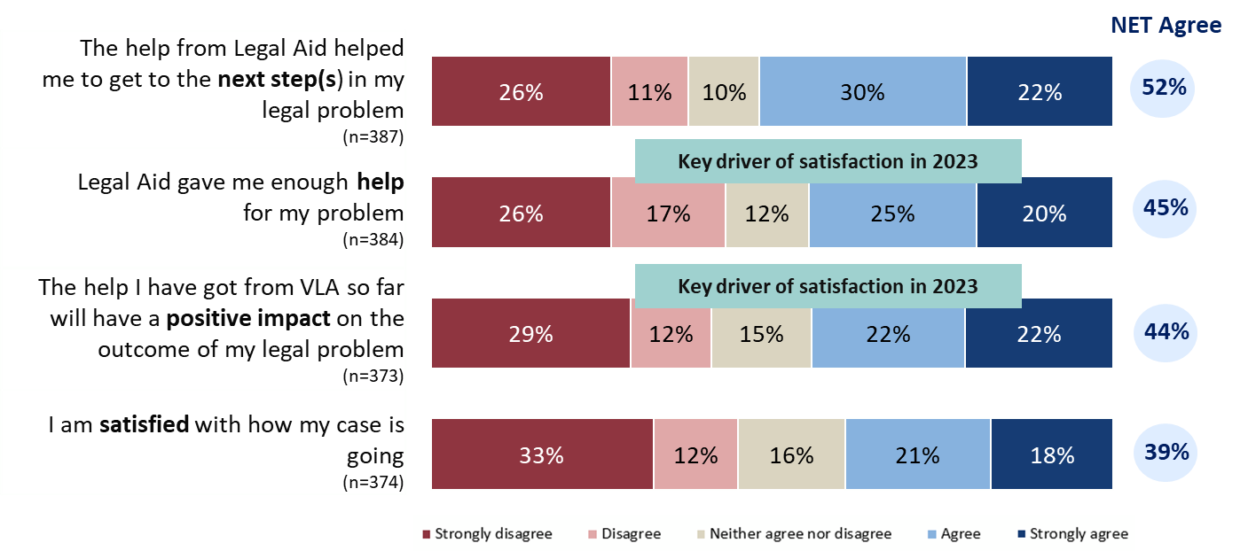

Question: How much do you agree or disagree with the following? Question: How much do you agree or disagree with the following? – The help I got from Victoria Legal Aid so far will have a positive impact on the outcome of my legal problem.

Base: All respondents with a partly resolved or unresolved legal matter, excluding those who did not know if their legal problem was resolved (base sizes ranged from 373 to 387). Excludes ‘not sure / I can’t remember’ responses.

Respondents who were not satisfied with their overall experience and whose legal problem had not been resolved described concerns about the level of communication and support from VLA:

“They were not interested in my problem, were not interested in assisting and provided no direction to where I might be able to go to get my problem resolved.”

Although most clients were generally less positive if their matter had not been fully resolved, some expressed satisfaction with VLA despite their case not being resolved. In many cases this was due to the person-centred engagement of legal staff:

“Because the lawyer always took my calls and if he wasn’t available at the time, he got back to me straight away. And that is a big thing. And it was very efficient and I knew the lawyer was there for me and not for anyone else.”

The quality of the advice or service was also mentioned as a reason for satisfaction, despite the lack of resolution.

“I’m very satisfied with the help of legal aid. They are following my case up today and gave me valuable information and advice.”

# Wellbeing

This section discusses VLA’s impact on the wellbeing of clients*, including stress levels, overall wellbeing and mental health.*

## Stress

Respondents whose legal problem was resolved generally indicated that VLA’s services had a positive impact on their stress levels. In contrast, a minority of respondents whose problems were partially or entirely unresolved agreed that VLA’s services had a positive impact on stress levels.

Overall, three in five (63%) respondents agreed that they were less stressed after talking to the lawyer. Four in five (80%) respondents with a resolved legal matter agreed they were less stressed after talking to the lawyer, but this was less than half (45%) for those without a resolved matter (as shown in Figure 12).

Figure 12. Wellbeing – stress levels

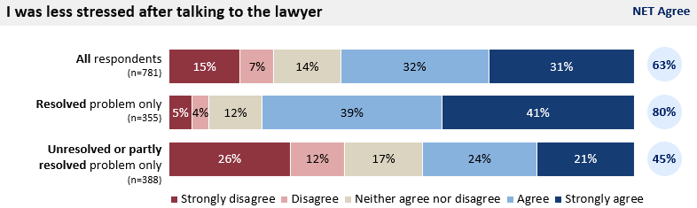

Question: Thinking back to the last time you got help from the Legal Aid lawyer, how much do you agree or disagree with the following statements about how you feel? – I was less stressed after talking to the lawyer. Base: All respondents (n=781), those with a fully resolved legal problem (n=355), and respondents with a partly resolved or unresolved legal problem, excluding those who did not know if their legal problem was resolved (n=388). *Excludes ‘not sure / I can’t remember’ responses.*

Those with unresolved problems indicated that their involvement with VLA may have been detrimental to their wellbeing, with many citing stress as a cause.

“All I can say is that when people need legal assistance, they need it fairly immediately. Having waiting lists causes more stress and anxiety to already stressful situations. A phone consult is ok for some basic advice but to actually have some representation at a case conference would have been more beneficial and may have resolved my case already.”

“Legal aid only gave me half hour consultation and advised me to lodge my own documents. The legal terms are mindboggling and so difficult to understand but I was advised to lodge them all myself. I felt so stressed.”

“They were not interested, they rushed me. They were vague. My mental health got much worse.”

## Overall Wellbeing

Respondents whose legal problem was resolved generally indicated that VLA’s services had a positive impact on their wellbeing. In contrast, a minority of respondents whose problems were partially or entirely unresolved agreed VLA’s services had a positive impact on their wellbeing.

Half (50%) of all respondents agreed that the help they got from VLA improved their overall wellbeing. Two in three (67%) respondents with a fully resolved matter agreed that the help they got from VLA improved their overall wellbeing. One in three (32%) respondents with an unresolved or partly resolved matter agreed that the help they got from VLA improved their overall wellbeing (as shown in Figure 13).

Figure 13. Overall wellbeing

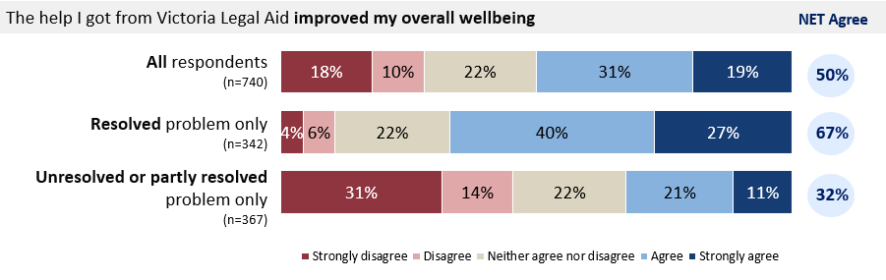

Question: How much do you agree or disagree with the following statements?

Base: All respondents (n=740), those with a fully resolved legal problem (n=342), and those with a partly resolved or unresolved legal problem, excluding those who did not know if their legal problem was resolved (n=367). Excludes ‘not sure / not applicable’ responses.

## Mental health

Respondents whose legal problem was resolved generally indicated that VLA’s services had a positive impact on their mental health. In contrast, a minority of respondents whose problems were partially or entirely unresolved agreed VLA’s services had a positive impact on their mental health.

Half (50%) of all respondents agreed the help they got from VLA improved their mental health. Two in three (66%) respondents with a fully resolved matter thought the help they got from VLA improved their mental health. One in three (33%) respondents with an unresolved or partly resolved matter thought the help they got from VLA improved their mental health (as shown in Figure 14).

Figure 14. Wellbeing – mental health

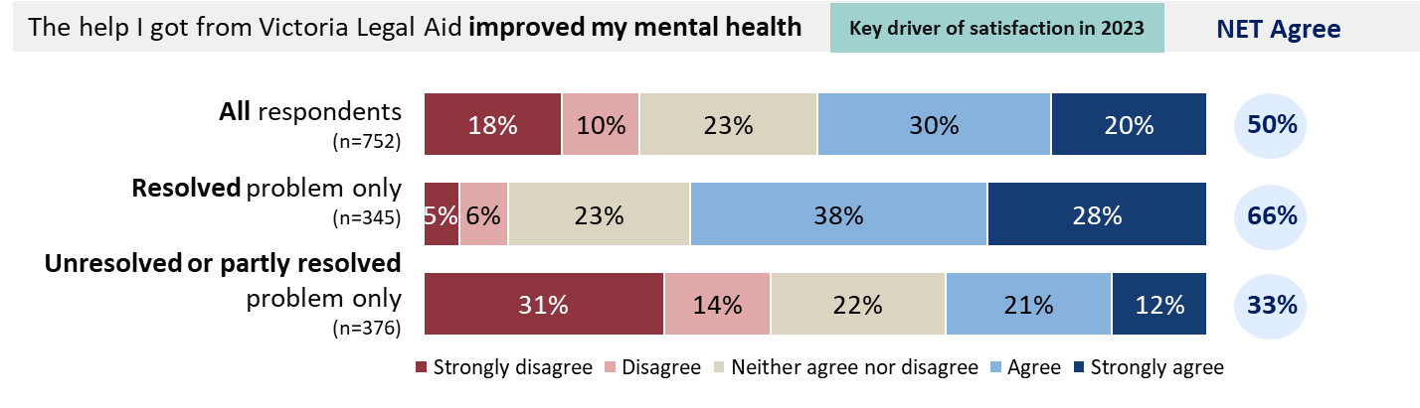

Question: How much do you agree or disagree with the following statements? Excludes ‘not sure / not applicable’ responses.

Base: All respondents (n=752), respondents with a fully resolved legal problem (n=345), and respondents with a partly resolved or unresolved legal problem, excluding those who did not know if their legal problem was resolved (n=376).

Respondents who felt that they had good mental health outcomes, praised VLA’s assistance:

“It was daunting in the extreme and very stressful when trying to handle my legal problems, so having Vic Legal Aid represent me has saved my wellbeing and allowed me look to the future...without that help my life would have been very bleak indeed.”

“The legal problem was quite distressing and the lawyer who provided my advice was able to reduce my distress and give me clear guidance.”

# Overall client satisfaction

Two in three (65%) respondents were either very satisfied or satisfied with the service they received. This is the first increase since 2015. From 2013 to 2023, the rate of respondents who were satisfied with the help they received from VLA had dropped from 73% to 62%, while the rate of dissatisfaction had increased from 18% to 27%. In 2024, the rate of respondents who were satisfied with the help they received from VLA increased to 65%, while the rate of dissatisfaction had dropped to 23% (as shown in Figure 15).

Figure 15. Overall satisfaction in 2024 and time series comparison

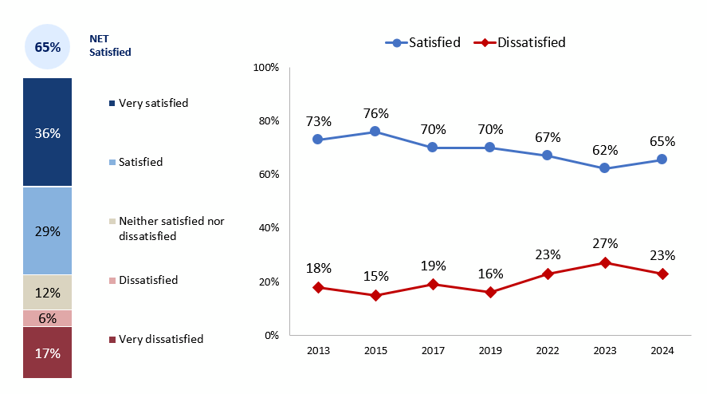

Question: Overall, how do you feel about the help you got from Victoria Legal Aid? Base: All respondents (n=802 in 2024 and n=783 in 2023; base sizes are not available for 2013-2022 data). *Both 2023 and 2024 results are weighted. Significance testing between these years have not been conducted. Any trends described are indicative only.*

Respondents were asked the reason for their level of satisfaction. The top reason among those satisfied with the help they received from VLA was to note that their request for services was fulfilled (i.e., they felt VLA helped) and/or were satisfied due to the outcome of their legal problem:

“Problem was resolved and they were great.”

“The outcome was in our favour and the lawyer was great.”

Satisfaction was also attributed to the Legal Aid lawyer, with commentary highlighting their empathy, kindness, respectfulness, professionalism, expertise, understanding and work ethic.

“The lawyer I spoke to before and during the legal process was not only knowledgeable and competent, but extremely understanding of my personal situation. She treated me with respect and compassion. I was not just a number.”

“We're very satisfied with the lawyer, she was very professional, caring and into the case straight away.”

## Overall satisfaction comparisons by cohorts

Regarding the rate of **overall satisfaction by the outcome of respondents’ legal problem**, the rates of satisfaction for “completely in your favour”, “partly in your favour”, and “not at all in your favour” were 93%, 82%, and 47% respectively.

Regarding the rate of **overall satisfaction by resolution status of legal problem**, 85% of respondents with a fully resolved matter were satisfied, 74% of respondents with a partially resolved matter were satisfied, and 32% of respondents with an unresolved matter were satisfied.

Regarding the rate of **overall satisfaction by service type, 74% of respondents that received case work services were satisfied, 69% of respondents that received duty lawyer services were satisfied, and 56% of respondents that received legal advice services were satisfied.**

**Regarding the rate of overall satisfaction by problem type, 71% of respondents that had a criminal law matter were satisfied, 59% of respondents that had a civil matter were satisfied, and 55% of respondents that had a family law matter were satisfied.**

Figure 16. Overall satisfaction comparisons by cohorts

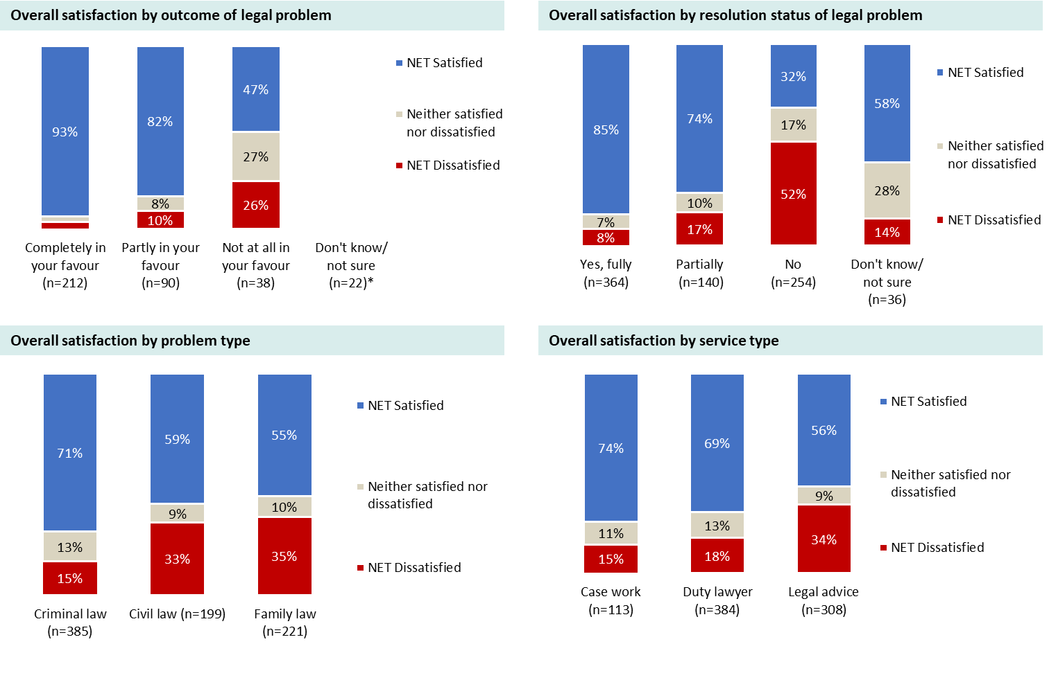

Question: Overall, how do you feel about the help you got from Victoria Legal Aid? Base: All respondents (base sizes ranged from n=38 to n=385). Note: *Some results are not shown due to small response numbers (n<30).

## Overall satisfaction trends

Overall satisfaction ratings have generally followed a gradual trajectory of decline across all program areas between 2015 and 2023. In 2024, ratings have stabilised across all program areas although are still lower than those recorded in 2015 (as shown in Figure 17).

Figure 17. Overall satisfaction by program area and time series comparison

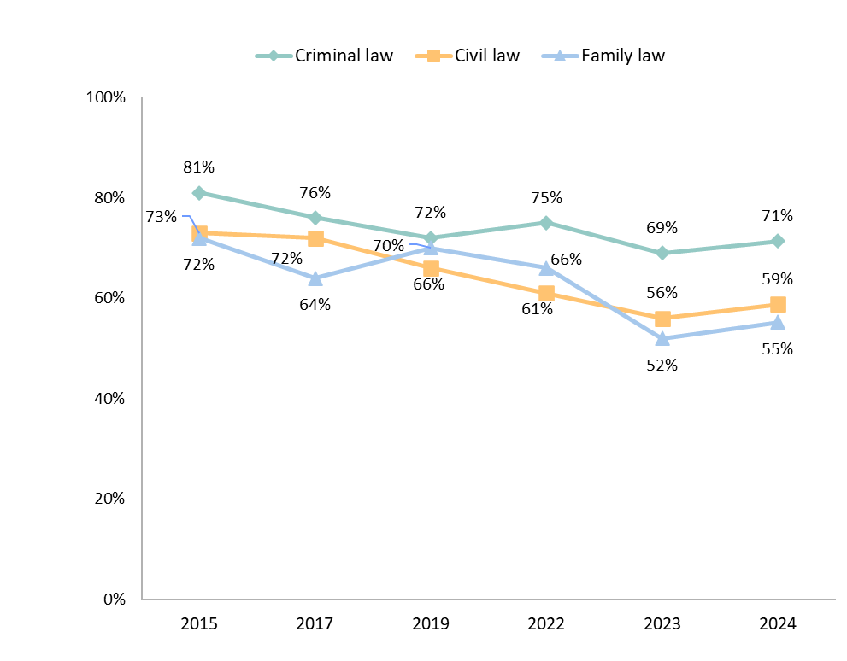

*Base: All respondents by program area (2023 and 2024 results are weighted). 2023 (weighted): Criminal Law (n=269), Civil Law (n=189), Family Law (n=326). 2024 (weighted): Criminal Law (n=385), Civil Law (n=199), Family Law (n=221).*

Figure 18 shows that overall satisfaction ratings have also been gradually declining in each service area between 2015 and 2023. Legal advice has experienced the steepest decline, particularly between 2019 and 2023. In 2024, ratings have stabilised across all services areas, however they remain lower than that of 2015.

Figure : Overall satisfaction by service area and time-series comparison

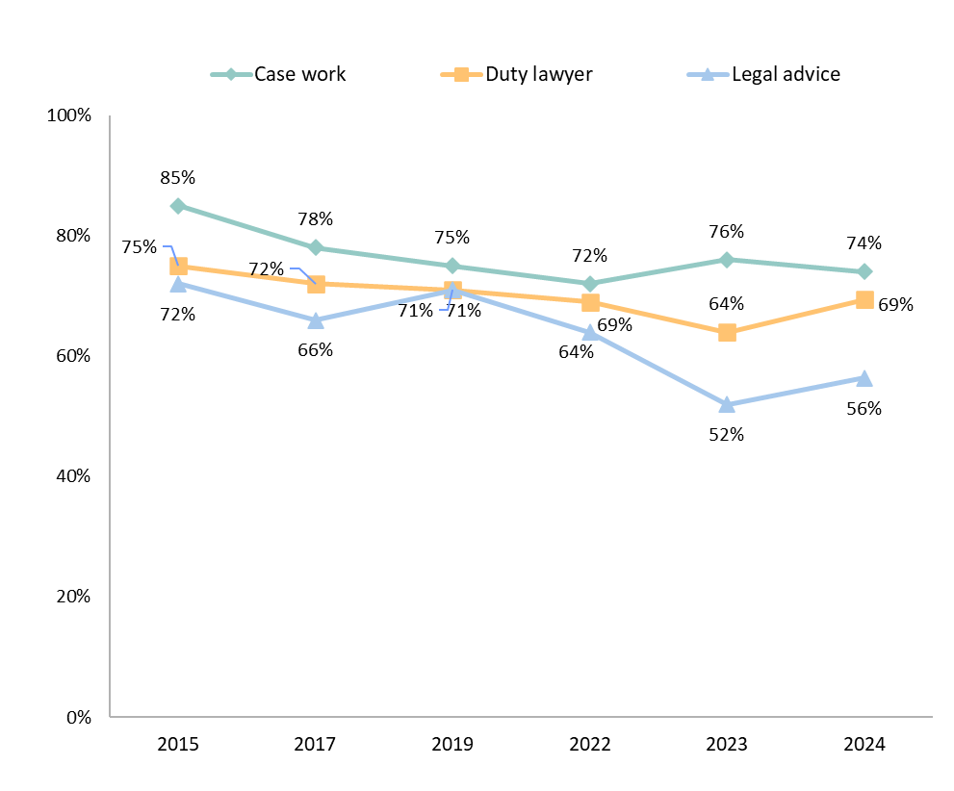

*Base: All respondents by service area (2023 and 2024 results are weighted). 2023 (weighted): Case work (n=127), Duty Lawyer (n=334), Legal advice (n=329). 2024 (weighted): Case work (n=113), Duty Lawyer (n=384), Legal advice (n=308).*

# Key themes from client interviews

Client interviews facilitated greater insight into the topic areas of resolution and support needs of people with disability, a mental health condition or experiencing violence. A summary of the primary themes and considerations for VLA service delivery are outlined below.

## Defining resolution

There is commonality in how ‘resolution’ of a problem is defined – as the ending of a court issue.

Additionally, the outcome of the problem being a perceived a fair process, and the level of impact the outcome had on the person’s life are also features of a positive resolution.

“Fair resolution and being treated with equality. I want to be heard through the judge.”

## Service level expectations for resolution

There is variance in how VLA can contribute to the expected ending of a legal problem due to the nature of the VLA service provided, and the stage that these services are delivered.

The expectation of the VLA Legal Advice service is not always related to obtaining legal resolution, but to build their knowledge on the next steps.

“(Expected) they would give me some advice, but not expected all to be resolved.”

“…phone consult was all that I really needed. If the process to get that could have been easier... Not knowing the process or anything legal, being able to talk to someone was important.”

## Working together

When features of a person-centred approach are working well together, this creates a sense of genuine mutual respect and engagement. The most powerful expression of this experience was when participants felt that VLA was in ‘their corner’ and prepared to ‘advocate’ or fight for their best possible legal outcome.

“They helped me. It took a long time and interactions) varied a lot but they did their job.”

“…because of the care of the VLA lawyer to get full background, (VLA provided) advocacy around the background, my character.”

## Use of support need information

While clients were generally comfortable in disclosure of disability or support needs, this information was either not discussed with lawyers due to it being assumed ‘unimportant’ in the context of the service, unlikely to be ‘utilised’ by the lawyer or not seen as being possible to be accommodated.

“I was comfortable – but it is expensive time that you can’t go into (support needs) … Be grateful for what you get. The focus was ‘how do I get across what I need in the limited time I have.”

“(PTSD triggers) might not make sense to VLA but it doesn’t make the disability any less valid.”

## The complete personal context

Lack of a proactive approach to discussing support needs may miss opportunities to obtain the client’s perspective around accommodations that could be needed, and for the lawyer to obtain greater context into the person's situation as part of considering their legal issue.

“…need to have a good breadth of experience, complexity, and understanding of people’s backgrounds…They need to be bridge from legal to public, if that bridge is broken, confidence in VLA goes down.”

“…did her own research …to get a good understanding of how to relate to me and work with me better.”

## Information for agency

Information about the role of VLA and the justice system is highly sought after as clients, who are often overwhelmed and highly stressed, try to gain some semblance of control and understanding of a system that is considered complex and intimidating.

“Struck me how much the system relies on VLA. Demand is high. It is people’s only chance to have a voice.”