Community Legal Services Program reform report
  - Phase one final report
  - Agreed framework for modernising and improving accountability and administration of CLC funding
  - September 2018
© 2018 Victoria Legal Aid. Reproduction without express written permission is prohibited. Written requests should be directed to Victoria Legal Aid, Corporate Affairs, Level 9, 570 Bourke Street, Melbourne Vic 3000.
Disclaimer. The material in this publication is intended as a general guide only. The information contained should not be relied upon as legal advice, and should be checked carefully before being relied upon in any context. Victoria Legal Aid expressly disclaims any liability howsoever caused to any person in respect of any legal advice given or any action taken in reliance on the contents of the publication.

Table of Contents
Executive summary 4
Background 7
The new CLSP framework 11
Key reforms 13
Reform the service agreement 18
Performance accountability – the elements and the process 20
Modernising the CLSP Workplan 23
Reforming financial accountability – the elements and the process 25
Elevated reporting and compliance 27
A second funding stream for specific purpose and short-term projects 29
Funding certainty 31
Greater use of technology to share information and support CLCs 33
Rationalising multiple-source funding and/or accountability 35
Next steps 37

Executive summary
The CLSP was created in 1996 as a national program for funding community legal centres and has not been structurally or substantially changed since. As a result, the program does not meet contemporary needs of the CLC sector or funders.
The CLSP Reform Project is being undertaken in close consultation with the community legal sector, and is being undertaken in two phases. Phase 1 of the project is concentrated on developing a high-level framework that provides a sound foundation to consider and develop a detailed and comprehensive new CLSP in phase 2.
This final report is the last deliverable of phase 1 of the project. The next phase will springboard from this work to develop, in detail, a new CLSP that is fair, effective, and best meets the evolving needs of stakeholders and, ultimately, the communities being served. A key consideration in the next phase of work is what supports may be needed to assist centres to be able to meet any new requirements and how best to facilitate any capability building, where required. For more information about the next steps in this project please see Next steps on page 36.
VLA and the CLC sector are committed to providing relevant, high quality services to our clients and communities. It is essential that the new CLSP is built on an understanding of the varied challenges and operating contexts across the sector and supports adequate governance and development to enable us to meet our shared goal. Among the key shortcomings of the current CLSP are that accountability under the program and its governing Funding and Service Agreement between VLA and CLCs are mainly based on service outputs (without proper consideration of client outcomes and service quality); the program has little within it to ensure targeting of services towards the most disadvantaged clients and communities; and it is cumbersome to administer. Detailed information and analysis of the deficiencies in the current agreement and ways to address them can be found in the CLSP Reform Discussion Paper (released May 2017) and Options Paper (released August 2017) that were prepared as part of this project.
Phase 1 of the CLSP reform project delivers, in this report, a new CLSP framework that sets out the elements of a modern funding and accountability agreement. Phase 2 will implement the framework by developing the detailed provisions of a new service agreement, as well as supporting policies and procedures.
During consultation, it became clear that an overarching statement of partnership principles between VLA and the CLC sector (with the Federation of CLCs as its peak body) would facilitate meaningful collaboration across the range of legal assistance sector reforms. We will work with the sector to develop partnership principles that will underpin all collaborative work between VLA and the sector, including phase 2 of the project.
The Discussion and Options papers set out the following ten areas for reform:
- Transparent criteria and eligibility for funding
- Reform the service agreement
- Performance accountability – the elements and the process
- Modernising the CLSP Workplan
- Reforming financial accountability – the elements and the process
- Elevated reporting and compliance
- A second funding stream for specific purpose and short-term projects
- Funding certainty
- Greater use of technology to share information and support CLCs
- Rationalising multiple-source funding and/or accountability
A diagram showing the new CLSP framework and how each reform contributes to it can be found on page 9.
This project has generated extensive stakeholder engagement and feedback that confirmed CLCs and VLA have a shared goal: modernising and improving accountability of CLC funding in the interests of better outcomes for our clients and communities.
How this report is structured
VLA has written this final report on the basis of significant contribution and involvement from the CLC sector, and has been guided at each step by the project’s steering committee (which includes VLA members and representatives of CLCs, the Federation of Community Legal Centres and the Department of Justice and Regulation). For more details about how the report has been put together and how stakeholder input has been managed, please see the Methodology section on page 10.
There are three main sections in this report:
Background and contextual information, which describes the funding relationship between CLCs and VLA and explains the CLSP program and the CLSP reform project.
Overview of the ten reforms canvassed in the options paper, including the feedback we received about them and conclusions and actions that flow from each reform.
A high-level plan of how we intend to implement the CLSP framework and immediate next steps. Following the release of this report, we will work with the CLC sector to confirm a detailed plan of the practical steps necessary to give life to the framework.
Acknowledgements
VLA would like to acknowledge the significant contribution of the community legal sector, VLA staff, the Federation of Community Legal Centres, the Victorian Department of Justice and Regulation and other government agencies in this project.
The strong participation in consultation activities from such a wide range of stakeholders has provided a robust sounding board for the issues identified at each stage of the process and has paved the way for more in-depth discussions as part of phase 2.
We would also like to thank the steering committee for their insight and guidance over the course of the project.

Background
The funding relationship between VLA and CLCs
The National Partnership Agreement on Legal Assistance Services (NPALAS) provides for Commonwealth funding to be distributed to legal aid commissions and community legal centres in each state. This funding, along with state funding, is administered by government departments (such as each state’s justice department) and the relevant legal aid commission. The objective of the NPALAS is to support “a national legal assistance sector that is integrated, efficient and effective, focused on improving access to justice for disadvantaged people and maximising service delivery within available resources”. For more information about the NPALAS see the CLSP Reform Discussion Paper.
Community Legal Centres (CLCs) are independent, self-managed entities that provide free legal services to their defined communities. CLCs vary in size, resourcing, location and focus. Each of these factors can present unique challenges for a centre and may influence the way a centre designs its service delivery. Services delivered by CLCs include legal information, advice and casework. CLC services are concentrated more in lower intensity services, although duty lawyer work continues to grow. Most CLCs also do strategic casework, community legal education and policy and law reform. The linking of these activities is commonly seen as intrinsic to an effective CLC model.
CLCs generally (through core funding from government) determine their own client eligibility, casework and service guidelines and organisational structure. Generalist CLCs provide legal services to people in their local geographical area. Specialist CLCs focus on particular groups of people or areas of the law.
The CLC sector is an important part of the mixed model of legal assistance service delivery in Victoria. Individual centres’ connection to their communities gives them valuable insight into the needs of their local populations; their compact size and structure (relative to Victoria Legal Aid) enables them to respond nimbly to changing demands in those communities and their independence from VLA and government allows them to campaign publicly on a range of critical legal and related issues that have a significant impact on their clients and the broader community.
VLA funds 37 of the 52 CLCs in Victoria, with the remainder receiving grants from other government and philanthropic sources. Most CLCs are members of the Federation of Community Legal Centres (the Federation) which, as the peak body, aims to lead and support excellence across the CLC sector.
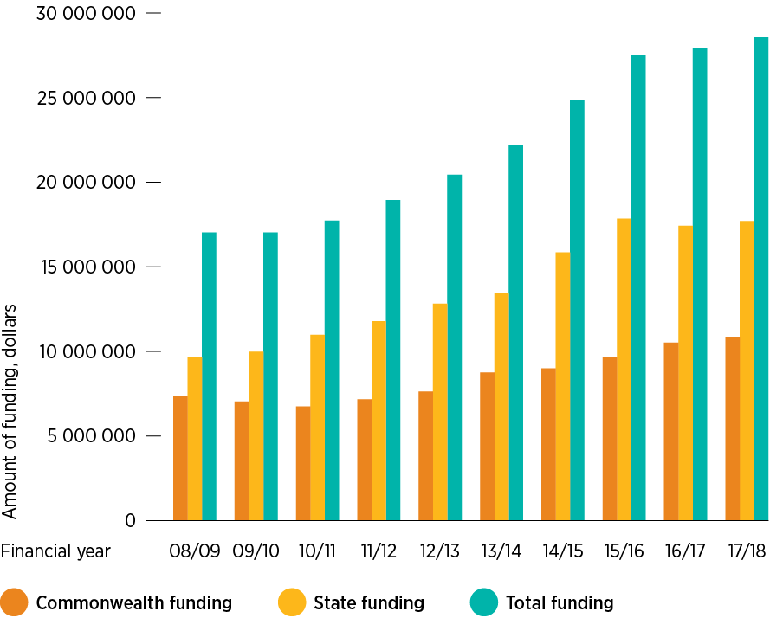
Over the past 10 years, VLA and other state government funding to CLCs has increased significantly.
CLC funding, 2008–2018
The CLC services that are funded by VLA are managed through service agreements under the Community Legal Services Program (CLSP). CLSP accountability arrangements include six-monthly reporting on service provision and financial management, annual service planning and organisational financial assessment, plus targeted assessment of service outputs through a common database known as Community Legal Assistance Services System (CLASS).
VLA allocates, administers and monitors the use of CLSP funding to Victorian CLCs to ensure that CLC services are planned and targeted to maximise the number of services delivered to priority clients and legal needs, and that CLCs meet contemporary legal and best practice organisational governance and management requirements.
VLA regularly invests additional shorter-term resources in CLCs, most often for CLCs to undertake specific projects and pilots. Recent examples are the CLC Innovation and Transformation Fund and funding for Child Protection and Family Law services.
The CLSP Reform Project
Over the last 15 months, the CLSP Reform Project has worked with CLCs and other key stakeholders to produce a draft new funding framework that would provide for:
- clearer, stronger and more consistent accountability mechanisms with simplified reporting and established procedures for dealing with performance or governance issues
- improved, co-ordinated planning, evidence-based service design and service targeting
- quality and outcomes measurement
- greater financial certainty through multi-year agreements instead of the current annual arrangements
- flexibility so that CLC responsiveness is maintained, and service structures and commitment are not overly prescriptive.
Phase 1 of the project was guided by a Steering Committee chaired by VLA and with a membership that included CLC board members and CEOs, the Executive Officer of the Federation of CLCs (as the CLC sector’s peak body) and representatives of the Victorian Department of Justice and Regulation.
The project published a discussion paper in May 2017, which was the basis for in-depth discussion at workshops in Ballarat and Melbourne. Feedback from workshop participants and other stakeholders informed the preparation of the project’s options paper in August 2017. Most CLCs (board members and staff), several VLA programs and practice areas and other key organisations (including the Department of Justice and Regulation, Commonwealth AGD, the Legal Services Board and other funders and partners) took part in consultations on the options paper. VLA received 24 written and verbal submissions on the paper – 9 from the CLC sector, 12 from individuals and program areas within VLA and 3 from other funders. Around 40 people participated in the two workshops the project held to discuss the options.
Following the release of this final report, VLA (in collaboration with the CLC sector) will design a new Funding and Service Agreement between VLA and CLCs (the New Agreement) and supporting policies and procedures by June 2019. This will be done with the aim of implementing the New Agreement when the current agreement expires on 30 June 2019. Some of the changes described in the remainder of this report will need more time to implement, which means that the New Agreement may contain interim provisions while we work with the CLC sector on longer term changes.
The following diagram outlines the CLSP reform process and next steps.
CLSP Reform Project process
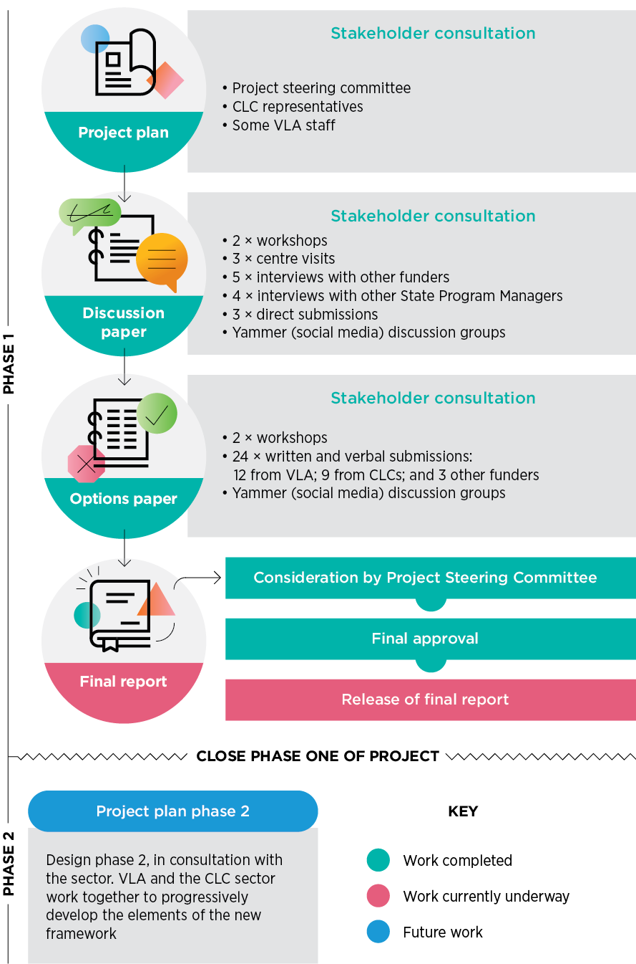
The new CLSP framework
Overall, the new CLSP framework aims to provide a sound foundation for VLA and community legal centres to work together to understand and best meet and respond to the needs of our clients and communities. There are six core components of the CLSP framework (the service agreement; CLSP service plan; monitoring, reporting and compliance; risk management; quality management; and policies and procedures). Each of the core components is made up of a range of supporting elements (such as processes, documents, frameworks and guidelines etc.). In developing this overarching framework, this project has also identified where there are gaps in, or changes needed to, existing supporting elements to ensure that they enable us to achieve the overarching framework, these are the ten reforms outlined in this final report.
The diagram below represents the core components of the new CLSP framework, and how these align with the ten reforms.
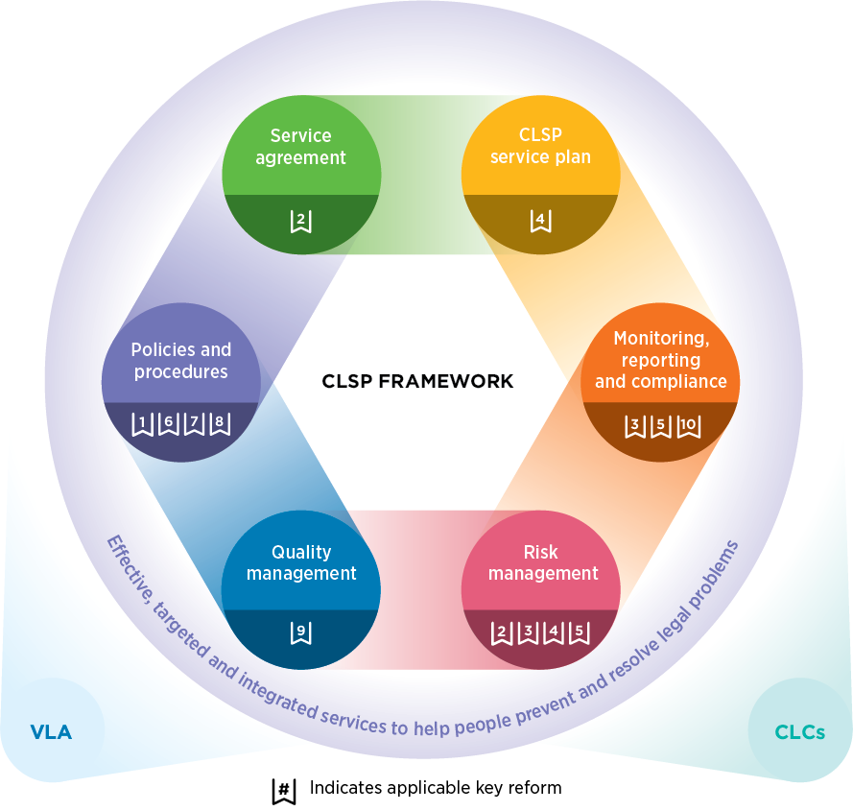
Extensive consultation and feedback underpinned identification of gaps and changes required to adequately achieve the framework. This feedback was synthesised into the ten reforms. The main feedback included that the new CLSP framework needed mechanisms for:
- providing and effectively administering funding, including ensuring that funding is linked to existing and/or new risk management frameworks and continuous learning and quality improvement
- improving and streamlining future funding and service agreements, and reporting and compliance
- creating a simpler and more transparent agreement, with mutual obligations
- building sector wide capability in outcomes measurement (OM)
- designing objective frameworks for monitoring and improving CLC quality and performance
- continually improving management and governance of CLCs by setting new minimum standards for boards and management
- developing new CLC service plans (and defining the reporting that flows from the plans) to ensure that they are not onerous or burdensome but are fair, reasonable, useful and meaningful to the individual CLC and the sector
- ensuring co-ordination of legal assistance service delivery through meaningful service guidelines and shared data across all relevant sectors
- ensuring that CLCs have access to data (both quantitative and qualitative), resources and frameworks for effectively identifying and responding to legal need
- using evidence-based planning, including through local and sector-wide service planning
- reforming and streamlining financial accountability
- improving opportunities for CLCs to access to training, practice resources, tools, templates and precedents
- encouraging and building new partnership approaches, including by clarifying and improving the relationship and different roles between the Federation, CLCs and VLA. This will guide work on phase 2 of the project but will extend to all collaborative work between VLA and the CLC sector
- ensuring greater transparency in all dealings between the Federation, VLA and CLCs
- supporting the Federation and its role in leading CLC stakeholder engagement.
Each of these points has been picked up and explored further in the relevant reform/s in this document.
VLA will work with the CLC sector, via the Federation, to develop an implementation plan for these proposed changes.
During consultation, the CLC sector proposed that an overarching statement of partnership principles be created to increase clarity around the respective roles and obligations in the relationship between VLA and CLCs. This would be like those in other funded sectors such as human services and education. VLA agrees this would be a valuable way to facilitate meaningful sector collaboration and ensure better alignment with other legal assistance sector reforms. We will work with the sector to develop partnership principles as a precursor to phase 2 of the project.
We also agree that modernising and improving accountability and administration of CLC funding requires mutual respect, and joint consideration and effort.

Key reforms
The options paper identified 10 key areas for reform. These were subject to extensive stakeholder consultation and have formed the basis of this paper and the actions arising from it.
Methodology
Throughout the project, stakeholder feedback has been crucial and has provided the basis for each successive step in the process. Each paper released has been developed on the basis of feedback received from stakeholders about the previous paper, our analysis of that feedback, and sounding and refining the draft with the project steering committee (which includes representatives of VLA, the Federation of Community Legal Centres, CLCs and Department of Justice and Regulation).
The process for managing feedback has been:
- gathering and collating all raw data. This has come from written submissions, notes from interviews, participants’ written notes from workshop sessions and online forum responses
- analysing data for consistent themes, general consensus points and key points of difference
- synthesising responses where there is consensus, and articulating the issue and proposed solution clearly
- examining the issues around points of difference, with reference to other areas (for example, financial experts) where needed, and developing a stance or solution that attempts to acknowledge the differences, is viable and best meets the underpinning goal or need being addressed
- examining all other ideas, comments or suggestions and assessing whether they are viable and support the ultimate aims of the project and considering how best to address them
- finding a way to translate the feedback into actions, where appropriate, and capturing other considerations and suggestions so that it can be used to inform discussion about the detail of reforms in phase 2.
As such, while consensus feedback underpins most of the proposals in this report, some actions may arise from minority feedback (or a single submission) where that feedback is clearly relevant, necessary and/or significantly advances the aims of the reform.
Overall, our analysis of the feedback is that there is strong agreement throughout the sector that key elements of these reforms (in combination) will provide a new and improved CLSP accountability framework. We are therefore confident that major reform is achievable within the timeframe.
There were some relatively minor differences of opinion on how to prioritise and implement reforms, but reform 1 (transparent criteria and eligibility for funding), reform 5 (reforming financial accountability), and reform 8 (funding certainty) are generally supported as high priority reforms that are viable and achievable in the short term.
The following section provides a breakdown of each of the key reforms, including a summary of feedback received and further action to be taken in Phase 2 of the project.
Quotes used throughout are taken from either a CLC submission or from participants’ notes from the workshop sessions held on 18 and 20 September, 2017.
Under the current CLSP funding arrangements, the rationale for funding decisions is not always consistent or clear and occasionally, individual strategic grants have been made outside of specific, advertised grant rounds.
Furthermore, funding is currently not strictly linked to a centre’s ability to demonstrate that they can effectively meet identified legal need.
This reform generated extensive feedback:
- Throughout the consultation, stakeholders highlighted the need for a more robust and transparent system for VLA allocating and managing funding to CLCs, including transparent criteria and eligibility for funding. VLA agrees that we need a transparent system with clear criteria and eligibility, and funding that is targeted to address legal need.
- VLA expects that future funding will be directed to services that can demonstrate capacity and capability to address legal need by providing a range of high quality legal services.
- Over the longer term, VLA and CLCs should invest further in building sector wide capability in outcomes measurement (OM). Some stakeholders felt that OM should be a condition of CLSP funding, while others said that the nature, timing and resources required should be explored further in phase 2. One contribution was that OM should not be mandatory. Feedback also noted that the OM framework recently developed by the Federation (in collaboration with CLCs) could provide a useful starting point for this work, while some CLC contributors believe they should be supported to develop their own impact/outcomes measurement arrangement, adapted to meet the needs of their unique environment and focus.
- There was general agreement that evidence-based planning should inform the targeting of services and future funding decisions. As with outcomes measurement, there is a need for workforce skills and knowledge development that needs to be further explored and implemented in phase 2, and over the longer term.
- There was strong interest in CLCs being adequately resourced to provide a combination of service approaches, including but not limited to: early intervention, information, advice and casework, alongside strategic case work, community legal education and community development, systemic advocacy and social change work-as appropriate to the needs of the community being served.
- Some feedback highlighted the need for additional resources to achieve this, while others said that the combined services approach is an intrinsic and unique feature of CLCs, achieved within current funding and resources.
- There was feedback that greater clarity is needed on what is meant by strategic advocacy and strategic casework in the contexts of CLCs and VLA.
- Some responses noted that size and scale (relative to a centre’s capability) needs to be considered in phase 2, particularly in relation to CLC capacity to deliver a mixed service approach.
- There was general agreement that CLCs should provide high quality legal services, effectively manage risk, and target their services to identified client groups and communities. It was also proposed that CLCs should be well managed and governed to be eligible for funding. VLA as a major funder and administrator of CLCs intends to take up a stronger and more decisive role in relation to funding decisions and ongoing monitoring of funded CLCs. VLA will also update its current funding eligibility guidelines.
- It was noted that CLCs should be sustained as independent organisations (funded through various means) and that opportunities for refining and aligning reporting and compliance need to be explored further. As part of this, VLA should be more effective in taking up its role as funder in relation to monitoring CLC board and management capability, by setting new agreed minimum standards.
- One submission noted that the proposed eligibility criteria requiring ‘sound management and governance’ (as part of reform 1) should be expanded to include the requirement that at least a majority of CLC board members have formal training and/or qualifications. One proposed reform is a formal requirement that CLC Boards satisfy the requirements cited in Australian Institute Company Directors (AICD), Good Governance Principles and Guidance for Not for Profits, or some other rigorous and comprehensive benchmark for ensuring effective governance.
- Several submissions noted that funding should be linked to existing and/or new risk management frameworks and continuous learning and quality improvement. For example, the CLC National Accreditation Scheme (NAS) and the PII Risk Management Guide and scheme, and other frameworks to be developed and agreed with the sector.
- Several submissions said that CLCs should meet agreed attributes and competencies. Some noted that this should be accompanied by reasonable acknowledgement of the vast differences between CLCs, including consideration of the unique needs of rural, regional and remote (RRR) services, CLC specialisations and centres receiving multi-source funding (especially where VLA is not the major funder).
- It was noted that agreed attributes and competencies ought to be developed between VLA and the CLC sector in phase 2, and there should be mechanisms for these attributes to be regularly reviewed and updated over the longer term.
- Several contributors noted that CLCs should have the same access as VLA does to professional tools and development opportunities. This is seen as a safeguard for building consistency and quality of services across the legal assistance sector. This was proposed by VLA practice and corporate support areas as well as CLCs.
- There is agreement across the board that timely notification and disbursement of funding facilitates efficient and effective running of a CLC – effectively avoiding double handling of budgets – and that timely notification of funding can mitigate risks of losing staff due to funding uncertainty.
- It was also acknowledged that timely funding decisions will require further investigation and work between agencies (notably between VLA and DJR) before VLA can offer any guarantees on the point of timely notification and disbursement of funds. See Reform 8: Funding certainty on page 30 for more analysis of these issues.
- Clear funding guidelines are welcome, although some felt these should be high-level to avoid prescription of CLC activities. They should also be relatively stable over time so that CLCs can effectively and strategically plan services over the longer term.
- One contributor noted that alignment with the National Partnership Agreement on Legal Assistance Services (NAPLAS) shouldn’t inhibit early intervention or systemic advocacy activities.
- Many noted that there needs to be stronger alignment/integration of legal assistance sector reforms, including CLSP Reform, CLASS implementation, outcomes measurement, implementation of recommendations from the Access to Justice Review (A2J review) and jurisdictional and sector planning.
- Two submissions highlighted that funding guidelines must place sufficient emphasis on the importance of CLCs providing culturally competent and safe legal services for Aboriginal people. All proposed CLSP reforms must also respect the right of self-determination for Aboriginal people, including the right of Aboriginal organisations to be community led and controlled.
- Coordination of legal assistance service delivery should be a cornerstone of future funding agreements (including amounts of funding and targeting of services to meet legal need). One clear and compelling example noted was that the provision of family violence duty lawyer services should be fully considered, evidence-based and rationalised, without delay. This needs early and close consideration in phase 2.
- Whilst stakeholders generally agreed that a new and increased level of transparency is crucial, some proposed that future agreements should include reasonable limits on shared information.
Feedback highlighted a range of important issues that will inform work in phase 2. VLA agrees that there needs to be clear and transparent criteria and eligibility for funding that ensures that funding is allocated effectively and in accordance with demonstrated legal need for the benefit of the local communities being served. It is important that CLCs have flexibility to design their services in accordance with identified legal need in their community. At the same time, VLA’s role under the CLSP means that it has a responsibility to ensure that funded centres are supported (including through monitoring and direction) to effectively identify and meet legal need. VLA recognises that there are often unique challenges associated with a centre’s size, location or focus, and that it is important to consider, where required, how best to support centres to develop the capacity and capability to effectively address legal need in their community.
Taking into account the feedback, we have developed the following actions to give effect to the intention of the reform. VLA and the CLC sector will work collaboratively on them.
“CLCs must be well-governed, with strong and independent leadership both through their boards, and senior management, as well as well-trained staff, and a happy and supportive workplace culture.”
Actions to give effect to reform 1
Actions arising from this report will be further investigated and implemented as part of phase 2 of the project. VLA and the CLC sector will work collaboratively on phase 2 under the FCLC–VLA partnership agreement. A key step in planning for phase 2 will be determining who is responsible for implementing each action: VLA, CLCs or joint action. As such the following list of actions does not say who will undertake the action, except where the action can only feasibly sit with VLA.
Action | Deliverable
Action 1 As a major funder of CLCs, with a commitment to increasing the size of the CLC sector, VLA will take up a stronger and more decisive role in relation to funding decisions and ongoing monitoring of funded services | Supporting practice
Action 2 VLA will allocate all future funding to services that can demonstrate capacity and capability to address legal need through providing a range of high quality legal services | Funding guidelines
Action 3 develop more transparent criteria and eligibility for funding which is targeted to address legal need | Funding guidelines
Action 4 support workforce skill and knowledge development in evidence-based planning | Training and capacity building
Action 5 VLA will continue to support CLCs to operate using a mixed service approach, including by encouraging CLCs to advocate on behalf of their clients and communities. This will be noted in the New Agreement | Guiding principle, supported by clause/s in the New Agreement
Action 6 refine and align reporting and compliance to improve overall efficiency and reduce any unnecessary burden on VLA and CLCs | Process
Action 7 set new minimum standards for CLC board and management capability | Standards document, supported by policies, procedures, tools and the New Agreement
Action 8 ensure that all future funding is allocated to services that comply with existing and/or new risk management frameworks and continuous learning and quality improvement; for example, the CLC National Accreditation Scheme (NAS) and the PII Risk Management Guide, and/or other frameworks to be developed and agreed with the sector | Funding policy
Action 9 ensure that all funded CLCs meet agreed attributes and competencies (acknowledging differences between CLCs) and with due consideration of the unique needs of rural, regional and remote (RRR) services, CLC specialisations and centres receiving multi-source funding, particularly where VLA is not the major funder. These attributes will be regularly reviewed | Attributes and competencies document
Action 10 ensure that CLCs have the same access as VLA does to professional tools and development opportunities | Policy and technical recommendation
Action 11 VLA will work within its role, power and authority to ensure timely notification and disbursement of funding to CLCs | Interdepartmental procedural agreement
Action 12 set clear funding guidelines that avoid over-prescription of CLC activities and remain relatively stable over time | Funding policy
Action 13 VLA will not seek to inhibit early intervention or systemic advocacy activities in CLCs | Clause/s in the New Agreement
Action 14 ensure there is stronger alignment/integration of all legal assistance sector reforms, including CLSP Reform | Communication policy supported by the New Agreement
Action 15 ensure that all CLSP reforms respect the right of self-determination for Aboriginal people, including the right of Aboriginal organisations to be community led and controlled. Competencies will be adopted to ensure that non-Aboriginal controlled CLCs can provide culturally competent and safe legal services to Aboriginal people | Competencies document and guiding principle
Action 16 ensure that co-ordination of legal assistance service delivery is a cornerstone of future funding agreements | Policy document and clause/s in the New Agreement
Action 17 ensure that there is greater transparency around funding arrangements and better public access to service data. This will include establishing reasonable limits on shared information to uphold privacy and confidentiality of client and service information | Policy document, clause/s in the New Agreement and shared data

Key reform 2
Reform the service agreement
Under the current agreement there is a strong focus on reporting and compliance. The New Agreement aims to reset the balance between mutual obligations and a meaningful focus on standards and quality.
Feedback on this reform was fairly consistent:
- There was broad agreement that we need a simpler and more transparent service agreement that is linked to objective policies and procedures, and that procedural fairness (including timely and sufficient notification of change) and measurable mutual obligations are considered and included. There was also agreement that meaningful service and casework guidelines and data should be shared across all relevant sectors (within agreed parameters and with appropriate limitations on shared data) through effective policies and guidelines.
- Some submissions noted that partnerships and collaboration should not be confined to the legal assistance sector but should also include opportunities for health and mental health justice partnerships. Other service partnerships should be explored and encouraged. VLA strongly supports this proposition.
- Some contributors noted that the principle of having a simpler agreement is good, but they questioned whether there will be mutual obligations, noting that as an example ‘getting data from VLA about the regions has been difficult’.
- Others said that further consultation, information and support will need to be provided to the CLC sector before formalising new obligations. The nature of these obligations needs to be explored further in phase 2. Ongoing monitoring of CLC capability should be strengthened and CLCs should be connected to relevant practice development, support and resources.
- One submission from VLA noted there should be an obligation (in some form) on CLCs to maintain information about their service provision in ORBIT, such as contact details, casework guidelines, eligibility, referral methods and current capacity.
The actions required to address these concerns will focus on creating a simpler and more transparent Funding and Service Agreement between VLA and CLCs (the New Agreement) that is connected to service quality, clarifies individual service guidelines and incorporates minimum standards.
“Need clarity about what policies and procedures are proposed to be included – won’t simplify the Agreement if it links to dozens of other procedures etc.”
Actions to give effect to reform 2
Actions arising from this report will be further investigated and implemented as part of phase 2 of the project. VLA and the CLC sector will work collaboratively on phase 2 under the FCLC–VLA partnership agreement. A key step in planning for phase 2 will be determining who is responsible for implementing each action: VLA, CLCs or joint action. As such the following list of actions does not say who will undertake the action, except where the action can only feasibly sit with VLA.
Action | Deliverable
Action 18 design a new, shorter and clearer Agreement that is connected to service quality and includes detailed and transparent policies and procedures that will clarify expectations, mutual responsibilities and complaints mechanisms | New Agreement
Action 19 ensure that the new funding and service agreement clarifies individual service guidelines | Service guidelines document supported by clause/s in the New Agreement
Action 20 incorporate minimum service standards into the New Agreement | Minimum standards, supported by clause/s in the New Agreement
Action 21 ensure that funded CLCs are responsible for maintaining information about their service provision on the most effective shared platform | Recommendation on platform, supported by clause/s in the New Agreement

Key reform 3
Performance accountability – the elements and the process
Reporting and compliance mechanisms should not cause an unnecessary burden. This area of reform seeks to reduce and streamline the nature and timing of monitoring and reporting, while having more meaningful and efficient accountability, including through clear indicators of CLC service provision and results for clients.
Early consultation confirmed there is broad agreement that the current CLSP workplan is burdensome and inefficient in capturing and monitoring CLC performance. In the future, there is an opportunity for a new approach that reduces the compliance burden, improves the quality of the data available to VLA and CLCs and satisfies our obligation to be accountable for our use of public funds.
This reform generated broad and useful feedback:
- There is strong interest in increasing the ability of the sector to monitor outputs, outcomes and impact. Part of achieving this may be a focus on, and support for, capacity building (through workforce skill and knowledge development) and re-prioritisation of existing efforts and resources, through evidence-based research and planning. The current agreement and reporting falls short in meeting this expectation. It focusses on service activities, targets and outputs alone (many of which have been rolled over from previous agreements) without rigorous scrutiny. In some cases, activities and outputs are misaligned to current client need and demand.
- In future agreements, the reporting mechanism and associated accountability should have a stronger focus on appropriate identification of legal need, service designed to meet that need, and assessment of outcomes and impact. This will enable VLA and CLCs to critically review, monitor and report on the results achieved for our clients. This is in line with the current community and broader public expectation that services are properly designed to adequately assist and resolve legal problems for our priority clients.
- The key difference between the current state and the desired future state will be a transparent and consistent mechanism for capturing key information and data to achieve this. Some centres are already collecting information and measuring data well. Their experience and capability will help to inform future sector-wide models for monitoring CLC performance. VLA’s expectation is that the Federation and individual centres will implement the change required to adapt to this expectation in time for the New Agreement to be signed in July 2019.
- There is broad agreement that the mechanism for performance accountability needs improvement and strengthening, including through VLA oversight of activities, outputs and outcomes measurement, and that as a sector we need to be better at assessing our impact.
- It was noted by some that VLA needs to be better at asserting its role as funder by being clearer and more consistent in its approach to managing performance accountability. VLA intends to use the CLSP reform project as an opportunity to improve its policies, procedures and overall effectiveness as the CLC funding program manager.
- Some noted that developing knowledge and capability for using theories of change and outcomes measurement in VLA and CLCs requires substantial cross sector investment, prior to its inclusion as an accountability requirement. VLA’s expectation is that funded centres will continue to prioritise this reform work using existing resources and implement the necessary workforce skills and knowledge development.
- It was also highlighted that there needs to be stronger performance accountability in relation to improving coordination of legal assistance services, particularly in relation to family violence and duty lawyer services and services that operate in geographic proximity.
- Several submissions noted that the legal assistance sector (VLA, CLCs and private law firms) should be competent in providing and managing universally accessible and culturally safe services, and that these competencies need to be strengthened through performance accountability mechanisms.
- There is broad agreement that there will need to be a transition period to new performance accountability requirements, including through the provision of adequate notice and training across the sector.
- There was also broad agreement that the ‘data dashboard’ and ‘shared data’ referred to in the options paper needs further investigation, negotiation and clarification of the type of data and the mechanism before implementation, and that VLA should take up its role as funder and show transparent leadership on data informed approaches (e.g. through its sector planning initiatives, the use of new tools like the ORBIT referral tool, and other mechanisms for capturing useful data).
- There was broad consensus that there should be reasonable flexibility in accountability requirements, acknowledging the unique differences between VLA and CLCs, and between CLCs themselves.
- There was agreement that CLCs and VLA should have transparent casework guidelines, and one submission asserted that CLCs should be able to determine their casework guidelines internally, without direction from VLA.
- There is agreement that there needs to be a better understanding of the various state and territory CLSP agreements and performance accountability systems. A Table of state and territory comparisons, CLSP administration can be found on our website.
- Contributors noted that any change to performance accountability needs to be appropriate, fit for purpose and not unreasonably burdensome. VLA supports this proposition.
While there was some question about how involved VLA should be in setting and monitoring a centre’s activities, there was broad agreement that the workplan needs to help centres and VLA ensure meaningful accountability for the quality of services provided, in the most effective and efficient way.
“We strongly support performance accountability that focuses more strongly on outcomes, rather than activities or outputs.”
Actions to give effect to reform 3
Actions arising from this report will be further investigated and implemented as part of phase 2 of the project. VLA and the CLC sector will work collaboratively on phase 2 under the FCLC–VLA partnership agreement. A key step in planning for phase 2 will be determining who is responsible for implementing each action: VLA, CLCs or joint action. As such the following list of actions does not say who will undertake the action, except where the action can only feasibly sit with VLA.
Action | Deliverable
Action 22 ensure the reporting mechanism and associated accountability has stronger focus on appropriate identification of legal need, service designed to meet that need and assessment of outcomes and impact | Reporting policy and procedure, and clause/s in the New Agreement
Action 23 prioritise the development of skills and aptitude in client outcomes measurement | Identification of training resources
Action 24 ensure that any changes to performance accountability are fit for purpose and not unreasonably burdensome | Guiding principle

Key reform 4
Modernising the CLSP Workplan
The current workplan is out of date and not fit for purpose. Originally, the workplan was intended to be the primary means of clarifying planned activities and outputs, and simultaneously provide VLA with the information it needed to fulfil its role as the fund manager. CLCs currently generate 6-monthly progress reports against these plans.
Currently, there are no tools or templates in place to assist CLCs to submit high quality plans and reports that focus on outcomes and impact, or to ensure consistency and quality in the design and articulation of the vision, goals, objectives and activities across the sector. As such there is often significant work required by centres and VLA to get workplans and reports into a meaningful format that adequately supports the centre’s work and planned outcomes and impact for the year. This is inefficient and can prove frustrating for both parties.
Feedback on this reform showed general consensus that the workplan needed revising and provided practical points to be considered:
- There is broad agreement that VLA should replace the CLSP Workplan with a newly developed, fit for purpose CLSP Service Plan that provides meaningful oversight, data and accountability.
- There is also agreement that the methodology for ‘local and sector planning’ and evidence-based approaches needs more work before implementation. The quality of reporting against the plan will be enhanced through the use of more objective data and less narrative reporting.
- It was also noted that to avoid duplication and create time efficiencies, current systems like the National Accreditation Scheme (NAS), could be better utilised to set service standards in relation to funding. VLA will work with the sector to identify which new and existing quality frameworks will serve to enhance the New Agreement and CLC standards and quality. Under the New Agreement, funded services will be required to comply with new standards (to be developed).
- Some stakeholders felt that templates for service plans might support greater transparency, and improve the quality of service plans, while reducing the burden on CLCs and VLA administration. VLA supports the use of templates and tools that will reduce the compliance burden and improve the quality of reporting. These will be considered further in phase 2.
- Many said that partnerships, collaboration and coordinated service delivery should be cornerstones of all contemporary funded services. These initiatives should not be confined to the legal assistance sector and partnerships should be developed because of local and sector planning evidence and a commitment to connecting clients to appropriate services.
- It was noted that any changes to the funding guidelines (or the proposed new CLSP Service Plan) should respect self-determination of Aboriginal people and Aboriginal community controlled organisations. VLA will honour its continuing commitment to Aboriginal self-determination and Aboriginal controlled services.
- Future CLSP service plans should consider that most CLCs receive funding from multiple sources, and where possible the service plan and reporting that flows from the plan, needs to be fair, reasonable and meaningful to the individual CLC and the sector (including to VLA as the administrator of the funds). VLA agrees that multi-source funding is an important consideration and that reporting should be fair, reasonable and meaningful.
There is widespread agreement that the CLSP Workplan should be replaced. This is also recognised as a major opportunity for reform in phase 2.
“Currently, the process for completing CLSP workplans is not transparent. Requirements are unclear and there no examples or guidelines on what VLA considers to be a high quality, or high value workplan. There should be a standardised form and process. This would reduce burden on CLCs.”
Actions to give effect to reform 4
Actions arising from this report will be further investigated and implemented as part of phase 2 of the project. VLA and the CLC sector will work collaboratively on phase 2 under the FCLC–VLA partnership agreement. A key step in planning for phase 2 will be determining who is responsible for implementing each action: VLA, CLCs or joint action. As such the following list of actions does not say who will undertake the action, except where the action can only feasibly sit with VLA.
Action | Deliverable
Action 25 replace the existing CLSP Workplan with a newly developed, fit for purpose CLSP Service Plan | CLSP Service Plan tool
Action 26 identify new and existing quality frameworks that will enhance the funding and service agreement and CLC standards and quality | Recommendation supported by clause/s in the New Agreement
Action 27 research and consider the application of templates and tools that will reduce the compliance burden on CLCs and enhance the quality of reporting | Tools and templates or appropriate guidance

Key reform 5
Reforming financial accountability – the elements and the process
There was strong consensus from stakeholders that the current financial reporting mechanisms are out of date, inefficient and burdensome. This was the most frequently raised opportunity for reform, alongside a shared desire to meet current standards for financial accountability.
Feedback indicated broad consensus:
- There was strong support for a proposal to accept financial reports based on Australian Accounting Standards (AAS). CLCs currently provide financial reports to their boards, as well as audited financial statements to the Australian Charities and Not-for-profits Commission (ACNC). Alignment of reporting requirements will reduce the reporting and compliance burden. There was broad agreement that reforming financial accountability is an opportunity for ‘quick-win’ reform, and should be implemented immediately.
- It was noted that VLA together with financial experts should design a model or set of indicators for determining organisational financial health. Some feedback also suggested that efficient and meaningful reporting could be at 6 or 12 monthly intervals. One contributor noted that the needs of smaller centres should be considered and that some might benefit from a standard template. One submission suggested that it may be of value for VLA to create a list of approved auditors for CLCs to use.
- One submission said that indicators of financial health can be useful for checking good governance where there is not a high level of financial management capability or fluctuating capability at the board and service management level.
- Some feedback noted the need for standardisation of some of the detail in budgets, for example the relative percentage of expenditure on salaries and staff related expenses (including staff training, conferences, PLE/PD and practicing certificates) against non-staff related expenditure.
- There was broad agreement to remove the financial reporting requirement through CLASS.
There is consensus that reforming financial accountability is a necessary change and will create efficiencies for centres and VLA.
“We strongly support the proposal to accept financial reports based on Australian accounting standards. Given centres produce financial reports for their boards, as well as audited financial statements for the Australian Charities & Not-for-Profits Commission as well as the public, aligning financial accountability with such reporting will improve the efficiency of centres.”
Actions to give effect to reform 5
Actions arising from this report will be further investigated and implemented as part of phase 2 of the project. VLA and the CLC sector will work collaboratively on phase 2 under the FCLC–VLA partnership agreement. A key step in planning for phase 2 will be determining who is responsible for implementing each action: VLA, CLCs or joint action. As such the following list of actions does not say who will undertake the action, except where the action can only feasibly sit with VLA.
Action | Deliverable
Action 28 rationalise financial reporting in line with the Australian Accounting Standards | Revised reporting requirements
Action 29 work with financial experts to design a model set of indicators for setting and reviewing funded services’ organisational health | Financial health check tool
Action 30 define criteria for selecting financial auditors to assist CLCs | Financial auditor selection criteria
Action 31 provide clearer guidance to funded services about standardised costings in budgets, in light of CLC independence and the considerable differences between CLCs | Guidance notes
Action 32 undertake consultation on an optimal financial reporting method that is not through CLASS | Financial reporting recommendation

Key reform 6
Elevated reporting and compliance
This project aims to make reporting more meaningful and less burdensome. Meaningful reporting will give VLA vital information and data to inform effective allocation of resources, and the ability for VLA to make objective assessments of an individual centre’s performance at any given time. Less burdensome reporting should free up resources so that centres can refocus these resources to meet the legal needs of their priority clients.
Through these reforms, VLA aims to better understand the effectiveness of our funding decisions and be more able to determine if funding is being dispersed to the right centres, for the right purpose, in the right place, at the right time.
VLA will continue to administer and grow funding to services that are well designed and provide high quality legal services. In the future, all funded services will be able to demonstrate that they are effective in providing appropriate legal assistance to resolve their clients’ legal problems. Client feedback will be an important measure of CLC success.
There will be a new policy framework to address issues when VLA has identified a problem with service provision and/or management, or where a CLC is underperforming or failing to meet agreed outcomes, including its financial management or governance responsibilities.
Elevated reporting will mean that reporting and compliance arrangements will be varied and VLA will have stronger oversight of CLC activities (consistent with transparent policies and procedures, that will be referenced in the New Agreement).
The existing VLA policy framework for responding to concerns about CLC operations or performance (developed in consultation with the sector) forms a good basis for this work. VLA will work with the sector to revitalise this document and ensure that the policy and procedure are fair, contemporary and aligned to the range of reforms and new expectations covered in this final report.
Feedback on this reform included:
- There was general agreement that VLA as the funder has a role to manage reporting and compliance, and that the early identification of risk should trigger a timely and appropriate investigation that could lead to a range of different strategies, including a higher level of support and/or elevated reporting and compliance.
- There was general support for elevated reporting and compliance where a centre is underperforming, and where centres are experiencing persistent difficulties. There was strong encouragement for VLA to take up its role and intervene. Most feedback preferred that VLA adopt a supportive approach, while acknowledging that we need a fair and robust system to deal with underperforming centres. It was also noted that there should be mutual obligations.
- CLCs want to ensure that, as part of the New Agreement, there is clarity around the complaints mechanism for when VLA fails in its duty and obligations.
Other feedback noted the importance of consistency in all VLA’s dealings with CLCs.
While there was general consensus that a mechanism for dealing with underperformance is essential, it was noted (and VLA agrees) that effective performance management needs to be constructive and collaborative rather than punitive.
“We support the proposals for elevated reporting and compliance where a centre is under-performing. The approach suggested is risk-based, which means that well performing centres are not over-burdened. Where centres are experiencing persistent difficulties, we encourage VLA to take a supportive approach without overly burdensome reporting.”
Actions to give effect to reform 6
Actions arising from this report will be further investigated and implemented as part of phase 2 of the project. VLA and the CLC sector will work collaboratively on phase 2 under the FCLC–VLA partnership agreement. A key step in planning for phase 2 will be determining who is responsible for implementing each action: VLA, CLCs or joint action. As such the following list of actions does not say who will undertake the action, except where the action can only feasibly sit with VLA.
Action | Deliverable
Action 33 develop new policies and procedures for dealing with centres where there are performance concerns | Performance management policy and procedure
Action 34 include a clear complaints mechanism in the New Agreement that is for all parties and mutually binding | Clause/s in the New Agreement

Key reform 7
A second funding stream for specific purpose and short-term projects
VLA administers short and longer-term funding to CLCs.
The current CLSP agreement does not provide clear guidance or a systematic way to manage specific or short-term projects and programs. Consequently, funds have at times been allocated without a fully competitive and transparent process. Monitoring and compliance related to this short-term funding has been inconsistent and at times inadequate. VLA will strengthen the system and framework for managing and monitoring short-term funding.
Feedback on this reform included:
There was broad agreement that all CLSP funding (short and long-term) should be delivered through a purpose built fair and transparent criteria and allocations system.
- Feedback also supported using short-term or specific funding for the full range of CLC services including targeted individualised service delivery, strategic casework, community legal education, policy and law reform and strategic advocacy and social change work, not just direct legal service provision.
- Some noted that CLCs and VLA should consider opportunities to collaborate through short-term funding opportunities.
- It was also proposed that the new system needs to be flexible in its assessment process (for example, additional costs associated with being a RRR centre or specific overheads for short term projects should be factored into budgets). While this is already part of the process, it is noted that additional clarity and transparency on how this is managed will be required as part of the New Agreement.
- Some contributors noted it would be beneficial for CLCs to have insight and input into the development of broader budget bids by VLA. While this already happens (for example, recent years’ joint family violence ERSC government budget bids and demand management bids) this collaboration should be further improved, clarified and formalised going forward.
VLA and CLCs agree that there is work to be done in phase 2 on clarifying a transparent framework for the administration of all short-term funding. This will include through advertised opportunities with clear funding guidelines (fairness and transparency) and notice of funding allocations.
“We support clarity about any additional funding streams for specific purpose and short-term projects. Transparency about additional funding is critical, and contributes to improved trust between VLA and CLCs.”
Actions to give effect to reform 7
Actions arising from this report will be further investigated and implemented as part of phase 2 of the project. VLA and the CLC sector will work collaboratively on phase 2 under the FCLC–VLA partnership agreement. A key step in planning for phase 2 will be determining who is responsible for implementing each action: VLA, CLCs or joint action. As such the following list of actions does not say who will undertake the action, except where the action can only feasibly sit with VLA.
Action | Deliverable
Action 35 develop a new framework (linked to the New Agreement) for short-term grants that improves notification, funding criteria, allocations and monitoring and reporting | Short-term grant framework
Action 36 consider and promote opportunities for CLCs and VLA to collaborate through short-term funding opportunities | Collaboration procedure
Action 37 VLA and CLCs will consult each other at the start of funding cycles to ensure joint planning and the development of joint bids, where appropriate | Collaboration procedure
Action 38 VLA will consider the additional costs that might need to be factored in for RRR centres and other centres with special needs and expenses | Short-term grant framework

Key reform 8
Funding certainty
Currently centres are notified of their funding annually, and it may only come into effect after the start of the financial year. This makes it difficult for centres to undertake longer term service planning or plan for growth and development.
Feedback on this reform showed that there was strong consensus from stakeholders about the need for greater funding certainty for CLCs, including through timely notification of funding amounts and multi-year, longer-term funding agreements. Feedback included:
- There was general consensus that longer term funding certainty would allow centres to plan more effectively.
- One submission noted that they recognise the challenge VLA faces given the timing of State and Federal Government budget decisions, but would like to receive early notification of the likely funding for a financial year. Another submission noted that indicative funding still creates uncertainty.
- One submission noted strong support for longer funding agreements with consideration of indicative funding, but queried why it had to be indicative only.
Generally, state funding is released one year at a time, and is dependent on VLA receiving confirmation of its funding allocation from DJR. Indicative levels of the Commonwealth component of the funding are already provided in schedule one of the funding agreement.
VLA agrees that funding certainty improves centres’ capacity to carry out long-term planning and retain staff, and that the current situation makes this difficult.
The Victorian Access to Justice review recommended that VLA move to four-year funding agreements with CLCs where government can provide the necessary funding certainty. The Victorian Government is considering this recommendation. Until the Government clarifies its position, options for increasing funding certainty will need to be considered in the context of VLA’s current legal and financial capacity to provide earlier notification of funding and multi-year agreements. The process and timing of government notification to VLA of annual funding means there can be delays beyond VLA’s control. Funding certainty under current arrangements would require VLA taking a significant risk in that VLA would be guaranteeing funds to CLCs before they are actually allocated to VLA. VLA is undertaking further work on options to improve funding certainty, considering the significant potential implications for VLA’s prudential financial management.
A related challenge for CLCs is when they are notified of their funding. In some years, DJR is not able to confirm VLA’s funding allocation (from which CLC allocations are taken) in time for VLA to sign agreements with and make payments to CLCs before 30 June. The CLSP reform project proposed moving the start and end of the financial year to reduce the financial uncertainty and administrative burden that such late notification causes. Whilst some felt this might help, most said it would create more problems than it solves, resulting in double handling of budgets and misalignment with other funding sources. Taking into account this feedback, at this time VLA does not support changing the financial year to achieve alignment between allocations and budgeting.
Longer term financial agreements and the provision of indicative funding amounts need further investigation in phase 2 of the project.
“We do not support shifting the funding year to 1 October to 30 September, especially if only ‘indicative’ funding levels would be provided. This creates double handling developing the budget and can also negatively impact on work planning and project planning.”
Actions to give effect to reform 8
Actions arising from this report will be further investigated and implemented as part of phase 2 of the project. VLA and the CLC sector will work collaboratively on phase 2 under the FCLC–VLA partnership agreement. A key step in planning for phase 2 will be determining who is responsible for implementing each action: VLA, CLCs or joint action. As such the following list of actions does not say who will undertake the action, except where the action can only feasibly sit with VLA.
Action | Deliverable
Action 39 develop options to improve funding certainty for CLCs, with full consideration of the significant potential implications for VLA’s prudential financial management | Funding policy
Action 40 VLA will act within its role and authority to enter into longer term agreements with CLCs, where appropriate | The New Agreement

Key reform 9
Greater use of technology to share information and support CLCs
As part of the modernisation of CLSP arrangements, there is an opportunity to use technology to enable VLA and CLCs to more easily access systems and frameworks related to CLSP (for example, through an online portal). There are many examples of technological solutions used in other sectors that simplify access to information and administration. These can be explored further, in phase 2, including investigation of any capacity building and resources that might be needed to support their use.
Feedback highlighted that while there are benefits and opportunities associated with greater use of technology, it has to be carefully managed to ensure that it is effective:
- Throughout the consultation, stakeholders noted the need to introduce new systems that ease the burden of reporting. VLA will work with the CLC sector to design a platform where VLA and CLCs will have access to shared data, information and tools to support their work.
- There was also a call from across the sector for greater transparency in allocating and managing funding to CLCs. This information could be made publicly accessible through the new platform.
- There were many ideas and solutions posed, and general agreement that there is untapped potential for greater use of new technology across all areas of CLC and VLA activity.
- There is broad agreement that there is far greater scope for VLA to share its online resources with CLCs – including ActiveDocs, professional legal education (PLE), the ORBIT referral tool and ATLAS, and other VLA intranet services and support to be developed in the future. Consideration should be given to how best to access and share useful resources and training across the sector from all providers.
- Some said the rollout of the CLC CLASS data system has highlighted the challenges faced when rolling out large system reform. The introduction of any new technology needs to be properly resourced, scheduled and managed, taking account of the varied capability of centres. Some said they would prefer the Federation to be adequately resourced to take up this capacity building role.
- Some also noted there are untapped opportunities for more effective use of technology to improve client access to services, especially for clients living in rural regional and remote areas. These technologies could also be better used for lawyers and other CLC employees to share practice skills, knowledge and expertise.
VLA is committed to improving CLC access to professional tools, and learning and development opportunities that will capitalise on and enhance CLC capability, service standards and quality. We will collectively explore these opportunities further in phase 2.
“We support the greater use of technology to share information and support CLCs. However, we urge VLA to consider how any new technology or platform is adopted without additional burden on centres, staff or requirement for more IT expenditure.”
Actions to give effect to reform 9
Actions arising from this report will be further investigated and implemented as part of phase 2 of the project. VLA and the CLC sector will work collaboratively on phase 2 under the FCLC–VLA partnership agreement. A key step in planning for phase 2 will be determining who is responsible for implementing each action: VLA, CLCs or joint action. As such the following list of actions does not say who will undertake the action, except where the action can only feasibly sit with VLA.
Action | Deliverable
Action 41 VLA will take immediate action to support CLCs to get better access to professional learning and practice development tools | Training and development policy and implementation framework
Action 42 consider an appropriate dashboard and/or online portal for the CLC Funding and Development Program | Recommendation
Action 43 explore opportunities for the effective use of technology in the delivery of legal services | Recommendation

Key reform 10
Rationalising multiple-source funding and/or accountability
Most CLCs are funded through multiple sources. The majority of CLCs receive most of their funds through the CLSP but VLA is the minor funder for some CLCs, and some CLCs receive no CLSP funding. Multiple sources of funding can result in multiple reporting and compliance obligations and inefficiency.
In its response to the 2016 Access to Justice Review, the Victorian Government agreed that multi-source funding accountability should be rationalised for efficiency and simplicity, including by aligning monitoring and accountability requirements and processes for different sources of CLC funding. The government also agreed that it should streamline state funding arrangements to CLCs and require departments and agencies that fund CLCs to provide VLA, through DJR, with information about those arrangements.
The clear intent of the Access to Justice Review is for the legal assistance sector to be more client-focussed and improve how it plans, co-ordinates and evaluates its services and efforts to prevent and respond to legal need. VLA supports this approach, and we will work with the sector to achieve relevant change as part of the CLSP reform project.
Stakeholder feedback highlighted opportunities and challenges posed by rationalising multi-source funding and accountability:
- Some CLCs noted that whilst a single system manager function might simplify administration and reduce reporting and compliance, it is also valuable for CLCs to have direct relationships and communication with various government departments to ensure that they have a good understanding of the work and outcomes achieved by CLCs.
- Some noted there is an opportunity for funders across government to develop a more collaborative approach to service plans, data collection and reporting requirements.
- One submission noted that Aboriginal-controlled services must be autonomous. They expressed concern about proposals for VLA to act as ‘agent’ for other funders and that any system for management of funds should not compromise community control and independence.
- There was consensus that this reform is a low priority and should be considered after means of increasing funding certainty have been explored.
Consultation highlighted that the significant benefits of maintaining multiple funding relationships and appropriate independence need to be balanced with effective coordination to ensure that administrative and reporting burdens are minimised.
“Multiple funding relationship can help to sustain the centre.”
Actions to give effect to reform 10
Actions arising from this report will be further investigated and implemented as part of phase 2 of the project. VLA and the CLC sector will work collaboratively on phase 2 under the FCLC–VLA partnership agreement. A key step in planning for phase 2 will be determining who is responsible for implementing each action: VLA, CLCs or joint action. As such the following list of actions does not say who will undertake the action, except where the action can only feasibly sit with VLA.
Action | Deliverable
Action 44 VLA will consider its role as system manager and will support CLCs to continue to have direct relationships with multiple funders and different areas of government, as appropriate | Guiding principle
Action 45 consider opportunities for improving and reducing multiple reporting requirements | Recommendation
Action 46 VLA will ensure that any streamlining of funding arrangements occurs in consultation with affected Aboriginal Community Controlled Organisations (ACCOs) and does not undermine their self-determination and autonomy. We will continue to acknowledge and respect the importance of both of those characteristics of ACCOs | Guiding principle

Next steps
This final report is the last key deliverable of the CLSP Reform Project (Phase 1). Finalisation and VLA management’s endorsement of this report will mark the closure of phase 1. This will trigger initiation and project planning for CLSP Reform (phase 2).
We intend that major reform will be completed and implemented by June 2019, in readiness for the New Agreement.
Before implementation of phase 2 begins, VLA and the Federation will work together to develop the partnership principles and agreement as the foundation for project work. We will jointly write the draft CLSP Reform phase 2 project plan in late 2018 and implement the project between May 2018–June 2019.
Individual CLCs and the Federation have communicated to VLA that the CLC sector is ready to take up a stronger role in phase 2 of this project. VLA supports this stance.
Details about roles and responsibilities and the resources required will also be further discussed and confirmed as part of the project planning stage.
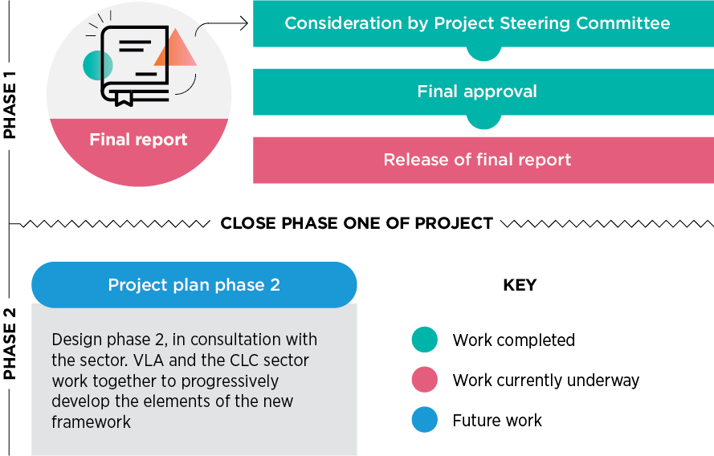
VLA will publish quarterly reports of its progress on its website.
Resources for implementation
The work needed to achieve the aims of the CLSP Reform Project (Phase 2) and each of the proposed reforms requires a range of different skills and levels of expertise. As such, an essential part of the phase 2 initiation will be to determine the skills and resources required to make the desired change.
This will be done in collaboration with the Federation, as part of project planning.
Options for resourcing different parcels of work will include:
- joint Federation, CLC and VLA working groups (including CLC board members, experts, managers, principal lawyers and others) for each relevant area, for example data
- VLA’s Sector Planning project and the Sector Innovation and Planning Committee (SIPC)
- VLA’s ORBIT team
- agreed financial experts
- VLA’s project management team
- the CLC funding and development program team (CLCFDP)
- other VLA program areas, including the Legal Practice Directorate’s quality teams, VLA’s in-house counsel and risk team, and VLA’s Corporate Services and finance areas
- VLA Management.

National Partnership Agreement on Legal Assistance Service, Commonwealth Government of Australia, 2015, p3.

