Guide to using Cisco WebEx for online hearings
This guide sets out instructions for using WebEx – the platform used by the Victorian Courts for online hearings in response to COVID-19. It covers key functions, how to set up and participate in an online hearing.
Before you do an online hearing via WebEx you should:
- Read this guide and the guidance note
- Do a test hearing: https://www.WebEx.com/test-meeting.html
- Watch this video for an overview of key WebEx functions: https://www.youtube.com/watch?v=B-YgObuSOo0&feature=youtu.be
- Consider your set up – see Getting Ready for a Hearing
- Check the relevant Practice Notes or Directions for your Court
Contents
Guide to using Cisco WebEx for online hearings 1
Introduction 3
Should I agree to an online hearing for my client? 3
Getting started with WebEx 3
Do a test hearing first 4
Getting ready for a hearing 5
Use your tablet or laptop 5
Set up your equipment and check your background 5
Have you got all the contacts you might need during the hearing? 6
Turn off pop-up notifications 6
You’re ready to do an online hearing 8
How to join a hearing 8
How do I speak privately to my client or someone else? 9
How do I call a witness? 9
How do I tender a document? 9
How to leave a hearing 10
If you are disconnected or if your tablet freezes 10
Using common WebEx functions 10
Configure your view 10
Mute your microphone 11
Share content 11
Raise your hand 12
‘Chat’ function 12
Court user guides and practice directions 14
Supreme Court/Court of Appeal 14
County Court 14
Children’s Court 14
Magistrates’ Court Victoria 14
Questions 14
Training by WebEx 14
ICT 14

Introduction
As part of the response to COVID-19, several Victorian Courts – Supreme Court and Court of Appeal, County Court, Magistrates’ Court and Children’s Court – are conducting online hearings using the Cisco WebEx video-conferencing platform (WebEx).
This guide sets out instructions for using WebEx including how to set up, use key functions and participate in a hearing.
Some courts have also issued practice notes or directions that include more specific processes or requirements about online hearings, including filing notices of appearance. You should familiarise yourself with any Practice Notes or Directions relevant to your jurisdiction/matter ahead of any online hearing.

Should I agree to an online hearing for my client?
Online hearings minimise the need for people to physically attend court to progress their legal matters. However, some clients may find it hard to participate in an online hearing. For example, some clients may not have access to suitable technology or enough data to prepare for or participate in hearings and others may need additional supports to do so. Simultaneous language or Auslan interpreting may be difficult to arrange for some online hearings and some clients may express a strong preference for face to face attendance. You should provide the client with information about how the hearing will run and what to expect.
Further information about VLA’s approach to better understanding and responding to clients’ needs in the context of virtual proceedings is set out in the Guidance note – Adopting a Client First approach to legal assistance and proceedings in response to COVID-19. Understanding the best approach for your client and discussing it with them before the proceeding is important – avoid making assumptions about what might be best for them in the context of their characteristics, capacity to participate, personal preferences and the nature and seriousness of the proceeding.
The court will expect you to have obtained your client’s consent to participate in an online hearing – you should only seek this after you have considered their circumstances and preferences.
In some cases, you may need to outline any additional supports required to enable your client to participate effectively as part of pre-hearing documentation or preparation. If you have concerns about whether your client’s matter should proceed by way of an online hearing, please speak to your manager.

Getting started with WebEx
Using the WebEx app rather than an online link for online hearings provides better quality video-conferencing facilities.
You may have the WebEx app shortcut on your desktop, which looks like this:
If not, click on your Start button and find Cisco WebEx Meetings in your list of apps.
If you do not have the app installed on your tablet, you can:
- contact ICT for assistance;
- do a test meeting (instructions below) and download the app as part of the process;
- speak to your manager for assistance.
When you launch the WebEx app for the first time, WebEx will prompt you to sign in. This is only for the meeting host, which is the relevant court.
To use WebEx, you should click ‘Use as guest’ underneath the blue ‘Sign In’ button.
You will then be prompted to enter your name and email address.
You should use your professional name and work email address in a way that makes it easy for people to recognise who you are – for example, Jo Bloggs (VLA).
Click ‘Use as guest’.
When the WebEx app opens, it will display the name and email address you typed at the top.
In some cases, your VLA username may appear – for example, jb8764. You should update this so that your name appears instead – for example, Jo Bloggs (VLA).
To edit, click on the pencil icon next to your name and update it.

You can only edit your name and email when you are not in a hearing, so make sure you do this ahead of time.
Under ‘Upcoming Meetings’ in the app you will see your Outlook meetings pre-populated.
You can also see WebEx meetings here. Meetings that are due to start within the next 15 minutes have a green ‘Join’ next to them.
You can use this ‘Join’ button to enter WebEx hearings from the app.

Do a test hearing first
Before you do an online hearing, you can familiarise yourself with WebEx by doing a test. The test takes between 5-10 minutes depending on how many functions you test. You should do this at least a day prior to your hearing.
- To start, join the test meeting hosted by WebEx at https://www.WebEx.com/test-meeting.html. A new tab will open in your web browser called ‘Try out a real WebEx online meeting’.

- You will be prompted to enter a name and email address. After you have done this, click ‘Join’.

- Once the preview screen is open, you will be able to adjust your camera view (how others will see your video feed) and other personal settings such as mute, stop video, and audio feed.

- Ensure that you have chosen ‘Use computer for audio’ on the drop-down at the bottom of the screen. In the bottom right-hand corner, you will see ‘Settings’. Click on this to adjust your speaker, microphone, and camera.

- Turn off video and mute your microphone using the microphone and video icons at the bottom of the screen. Sound and video are disabled when the respective icon is red.

- When you are ready, press ‘Join meeting’ to enter the test meeting.

- Once you are in the test meeting, you can turn on video and audio.

- If you click anywhere on the screen, the icons for common WebEx functions will appear in a row (called the meeting controls bar). These are, in order:
- Mute audio
- Start video
- Share content
- Record the meeting (host only)
- Participants (for ‘Raise hand’ function)
- Chat
- More options
- Leave meeting
Whether these are used in a WebEx hearing will vary between jurisdictions so please check the relevant court user guide before your hearing.
You should practise using these functions, particularly the ‘Share’, ‘Chat’ and ‘Raise hand’ functions.
When you are finished testing the interface, press the red X icon and ‘Leave meeting’.

Getting ready for a hearing

Use your tablet or laptop
You should do any online hearing from your tablet, not a mobile device. There are usually multiple parties to an online hearing – your client, witnesses, legal representatives, judiciary and others. This makes it very difficult to follow and actively participate in an online hearing using the WebEx app on your mobile phone. It is a good idea to have set up WebEx on a back-up device in case you encounter technical difficulties during the hearing. You may use your phone for this purpose.

Set up your equipment and check your background
It is important to set up in a way that minimises disruptions and maximises the quality of the online hearing. This means:
- Using your headset or headphones with an in-built microphone to maximise sound quality and minimise feedback and background noise.
- Making sure you have access to a good quality internet connection. You should aim for at least 15 Mbps download speed and 10 Mbps upload speed. You can test your connection speed at the Speedtest website (https://www.speedtest.net) and contact ICT if you need assistance.
- Using an additional screen/display monitor (where possible). This will allow you to have documents open on one screen and maintain a continuous view of the courtroom throughout an online hearing.
- Make sure your tablet has been restarted recently to help ensure its performance is at its best.
- If you have been prompted for software updates, make sure these are installed in a timely fashion, and completed in plenty of time, prior to any hearing.
You should approach appearing at an online hearing with the same level of formality as you would if you were appearing in person at court. This means you should consider:
- Your appearance – wear what you would if you were attending court in person.
- Your background – you need to have your video on – what can be seen by the Judge/Magistrate and others while you are appearing? A neutral/plain background with minimal distractions is needed.
- Confidentiality and disclosure – what information will be discussed, disclosed or shown during the hearing? Are you in a quiet space where you won’t be interrupted and/or overheard? Can you comply with any confidentiality and/or non-disclosure requirements?
Other important considerations:
- Who do you share your space with? What is the impact of conducting an online hearing on those around you?
- Do you need any support, help or supervision during the hearing? What arrangements do you need in place for this?
- Have you considered how you will de-brief following the hearing? What arrangements do you need to put in place to ‘disconnect’ from the hearing and transition back to ‘home-work life’?
- What do you need to consider to ensure your personal home life is not impacted by conducting hearings from home? You should speak to your manager about how you will manage your wellbeing during this time and contact our EAP provider on 1800 808 374 if you would like further support.
If you are unable to participate effectively in an online hearing at home, you should come into a VLA office to do an online hearing. Speak to your manager about this.

Have you got all the contacts you might need during the hearing?
You may need to contact other parties quickly during the hearing. For example, to provide/tender documents, to confer with counsel, or to advise the court that you are having technical difficulties.
If counsel is briefed, it is likely that you and counsel will be in separate locations. Before the hearing, you should agree with counsel how you will relay messages discreetly – for example, you may need to communicate via text.
Before the hearing starts, you should make sure you have email addresses and phone numbers for key people – for example, the bench clerk and the prosecutor.
You should write down the hearing meeting ID and password to assist you with quickly re-joining the hearing from a back-up device should you encounter technical difficulties mid-hearing.

Turn off pop-up notifications
Before you join a hearing, turn off all other notifications on your tablet so that they do not interrupt the hearing or distract you or any other participants.
To turn off Teams, Skype and Outlook notifications, set your status to ‘Do Not Disturb’ in each of these programs. Keeping the applications open but minimised will allow you to contact the court quickly in the event you are disconnected. Remember to reset your status once the hearing is finished.

Microsoft Teams
In Microsoft Teams, if you click on your profile picture in the top right, your status will be the first item in the drop-down menu that appears. Change this to Do not disturb.
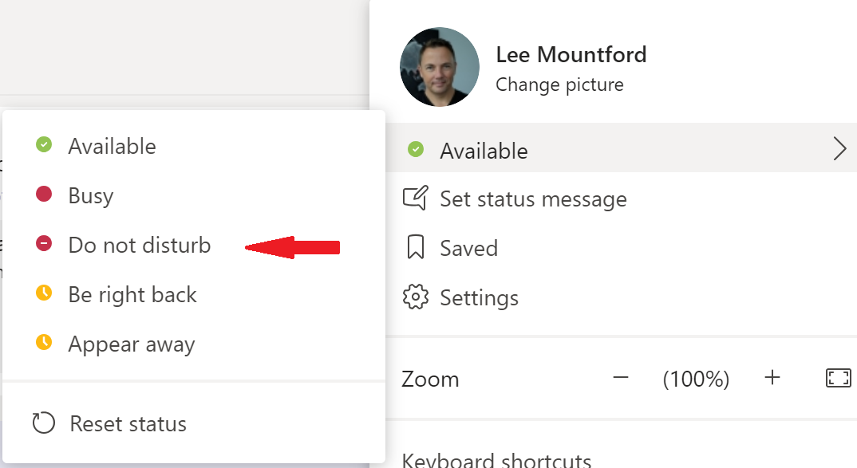

Skype
In Skype for Business, your status is displayed under your name, click on it and select Do Not Disturb from the list.
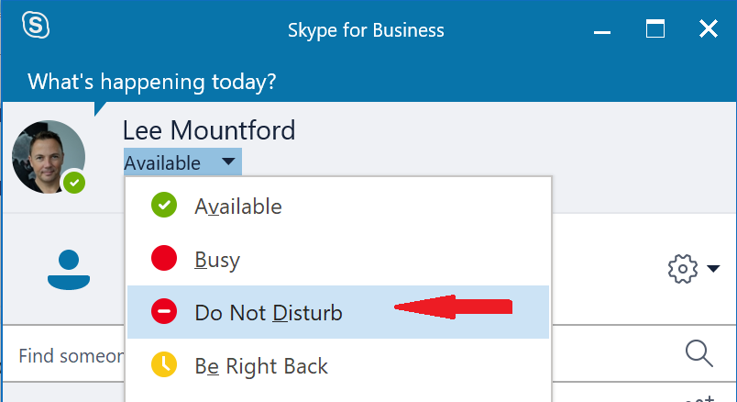

Outlook
To stop notifications in Outlook, go to File, Options and click on the option Mail. Under the Message Arrival section, you can choose not to receive sounds or desktop alerts when you received a new email.
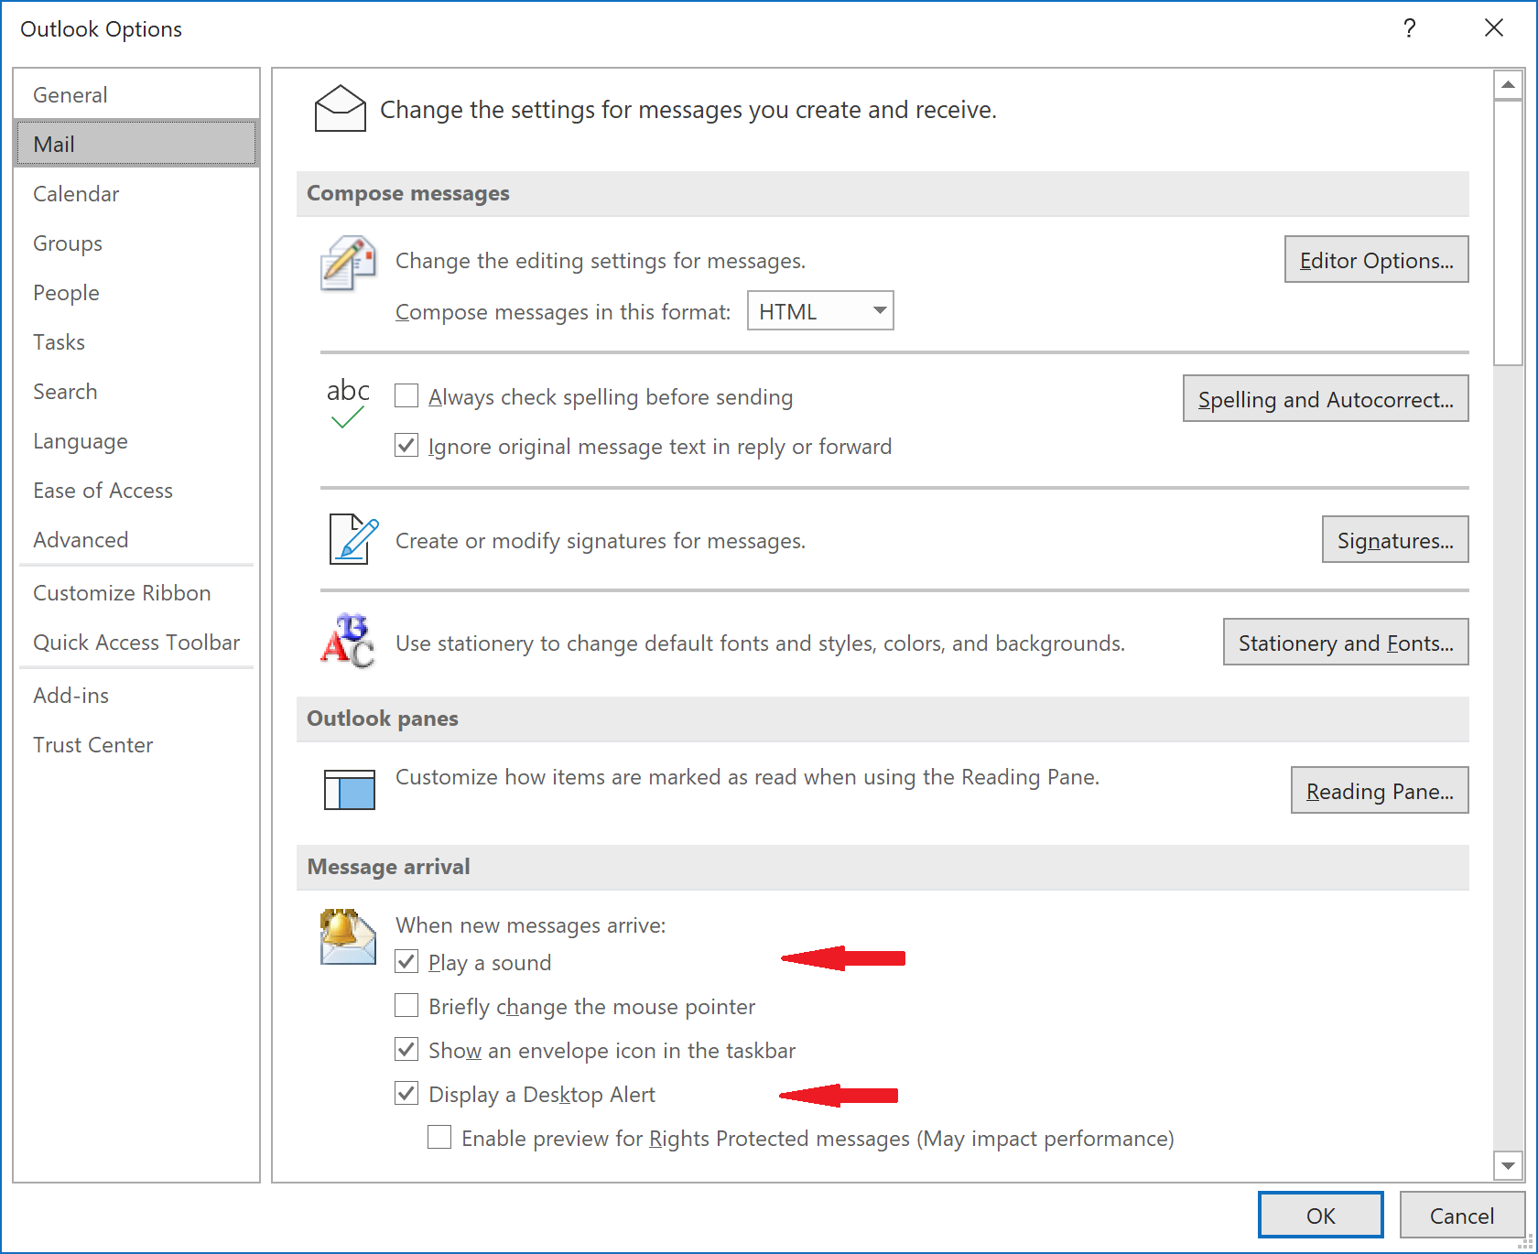

Check that you have all necessary documents open. Close any windows, programs or applications you don’t need during the hearing.

You’re ready to do an online hearing

How to join a hearing
The Court will ‘host’ any online hearing. This means that the Court will control who can attend and participate in the hearing.
Ahead of any online hearing, you will be sent a link to the hearing in a meeting request or email from the relevant Court. This will include the login details – an access code and password.
When you accept the relevant calendar invite, the meeting will appear in your Outlook Calendar and WebEx app.
You will not be able to join the hearing until the court has started the meeting. In most cases, the court will start the meeting at least 10 minutes ahead of the hearing time to allow parties to join and test that the link is working.
You should always join at least 10 minutes before the start of the hearing.
To join the online hearing:
- Open the WebEx app.

- Make sure your name and work email address are displayed properly at the top of the app in the black section – for example, Jo Bloggs (VLA). Edit this if you need to by clicking the pencil icon next to your name.

- If the meeting is listed under ‘Upcoming Meetings’ with a green ‘Join’ next to it, you can enter by clicking that button. Alternatively, input meeting login details in the bar under ‘Join a Meeting’. Click the green ‘Join’. You may be prompted to enter a password.

- A pop-up will open a preview screen with the name of the hearing at the top. Adjust your camera so that you are at eye-level and your head and shoulders are visible. Then ensure that both the ‘Mute audio’ and ‘Start video’ buttons are red.
- Click the green ‘Join Meeting’. You will see the courtroom and other participants. They will see your participant window but only see your initials.
- Configure your view using the tips below.
- Un-mute your audio and start your video when you are ready. Go back to your web browser and close the WebEx tab for better video/sound quality.
Once the hearing has commenced, the court will commence recording.

How do I speak privately to my client or someone else?
During the hearing, your client or another participant may want to speak to you privately. Similarly, you may need to give the client legal advice or seek their instructions.
Each court will have their own way of handling this. For example, all other participants may be asked to temporarily leave the meeting, leaving only you and your client in the courtroom. Alternatively, the bench clerk may use the WebEx Lobby function to move all other participants out of the courtroom and audio will be disconnected. During confidential discussions, the recording will be stopped by the court.

How do I call a witness?
The bench clerk/associate will send a WebEx invitation to your witness using the contact details you provided in the pre-hearing documents. This will be a meeting ID or hyperlink if your witness is appearing via video, or a ‘Call in’ invitation with a phone number and access code if your witness is joining by audio only.
The invitation will only be sent at the time that your witness is required during the hearing to avoid them joining the hearing at the wrong time. The court may also choose to telephone your witness using WebEx. The court should advise you in advance when your witness will be required.
Your witness will be sworn or affirmed by the bench clerk/associate.
If appearing by video, your witness will need to click the red and ‘Leave Meeting’ on their device when their evidence is completed, and they are dismissed.

How do I tender a document?
If you have any reports or submissions that you propose to tender, you should email or e-lodge and serve these to all parties in advance of the hearing. This avoids disruption or delay during the hearing. The court may also accept documents via email during a hearing for any last minute or unexpected circumstances.
You must have soft copies of all exhibits. No hard copies will be accepted. The court will advise which email address to use.
Some courts will allow you to use the ‘Share content’ function during the hearing to assist your submissions on e-lodged documents. It is useful to have practised this function beforehand and the ‘Annotate’ function.

How to leave a hearing
When your hearing has ended, the court may close the link for all participants, in which case you can simply close the app.
To leave the hearing manually, click on the red icon at the bottom of your screen, then click ‘Leave meeting’. If you need to re-join, you can do this by inputting the same meeting login details provided by the court into your WebEx app.

If you are disconnected or if your tablet freezes
If you are disconnected from the hearing, you should try to reconnect as soon as possible and advise the bench clerk/associate without delay (via email).
If your tablet will not reconnect, you may need to consider using a back-up device i.e. your mobile phone or iPad.
You can contact VLA’s ICT Service Desk on (03) 9269 0343 to troubleshoot any tablet-related issues.

Using common WebEx functions
An overview of key WebEx functions can be found in this video: https://www.youtube.com/watch?v=B-YgObuSOo0&feature=youtu.be

Configure your view
You can configure your view to change the way your screen and other participants are displayed. The view icons are accessed from the top right-hand corner of your screen. Changing your own view will not affect any other participants.
You can choose from ‘Active Speaker’, ‘Active Speaker and Thumbnail’ and ‘Grid’ by clicking on the first icon. Grid view is preferable because it allows you to see all hearing participants at the same time. The second icon is for ‘Floating Layout’.
When content is shared, your view will automatically change, and you will have different views to choose from – ‘Active Speaker and Thumbnail’, ‘Side-by-Side’, and ‘Floating view’.
- Active Speaker
  - Only speaker is displayed.
- Active Speaker and Thumbnail
  - Speaker will display prominently, and other participants will be displayed in thumbnails at the bottom of the screen.
  - When content is being shared, content will display prominently, and participants will be displayed in thumbnails at the top.
- Grid
  - All participants will be displayed on screen in windows of the same size (up to 25 participants).
- Side-by-Side
  - Shared content will display prominently, and participants will be displayed in thumbnails to the right-hand side.
- Floating Layout/View
  - Allows you to separate, resize and control your panels – for example, participants, shared content, or ‘Chat’ panels can be resized and moved around.
  - You can separate and drag panels to an external display monitor.
If you want to see a participant’s face close up – to have a better view of their facial expressions for example – you might choose the ‘Active Speaker and Thumbnail’ view. You can use the ‘Lock Video Focus’ function to always display a participant prominently, regardless of who is speaking. Hover your cursor over the participant and click the ‘pin’ icon. ‘Floating Layout’ is another way to do this while content is being shared. You can drag the ‘Participants’ panel to an external display and maximise it.

Mute your microphone
You should mute your microphone whenever you are not speaking.
This reduces background noise and feedback and limits distractions for other hearing participants. If you are in doubt, mute your microphone. This is particularly important if you are typing during the hearing.
When your microphone is muted, the mic icon will be red.
You can see which other participants are muted by their participant window displaying a red mic with a line through it next to their name.

Share content
Before the hearing, you should provide all documents needed to the Court and other participants.
It is possible to share content using WebEx, however, you should not rely on using this function to tender documents. This function allows other participants to view a document/app that you have open but on their screen. The court as host controls whether this function will be used – it may not be available in all cases.
To share content, click on the third icon in the meeting controls bar at the bottom of the screen, called ‘Share content’.
If you have multiple documents or apps open, you will be asked to choose which screen or document to share. You can share documents that are open on your tablet or on an extended display.
Hover over the screen/document you wish to share and click ‘Share’.
Your document will then be displayed to all participants.
You will see an orange bar at the top of your screen. The name of your document will be displayed on it. You can hover over this bar to bring down other controls such as ‘Annotate’. ‘Annotate’ allows you to draw over the document. You will see ‘Stop Sharing’ in this bar.

To stop sharing content, click on ‘Stop Sharing’ in that drop-down controls bar. This will close the document for all participants who will be returned to participant windows view.

Raise your hand
A virtual hand raise is a discreet way to attract the court’s attention.
To do a virtual hand raise, click on the ‘Participants’ icon in the meeting controls bar at the bottom of your screen. This will bring up the ‘Participants’ panel on the right-hand side of your screen.
Find your name. Next to it, you will see a ‘hand’ icon.
Click this to ‘Raise hand’. The court as host will see a raised hand icon next to your name and get an alert that you have raised your hand. You can click it again to ‘Lower hand’ (the icon next to your name will disappear).
To close the panel, click on the ‘x’ at the top right-hand corner of the panel.

‘Chat’ function
This function allows participants to send text messages using WebEx. The court as host controls whether this function will be used.
Depending on the settings activated by the host, you can choose who you wish to send a message to (private chat), or you can send a message visible to all participants (everyone).
If the chat function is available, care should be taken when using it. The chat function should not be used to communicate confidential or sensitive information, including with your instructor or counsel. You should not use the chat function to seek instructions or give advice to your client during the hearing.
- Chat between “everyone” will be stored in the meeting recording, owned by the host (relevant court).
- Private chat – between you and one other participant can be saved while the hearing is running. If chat is not saved while the hearing is running, the chat cannot be retrieved.
To use the chat function, click on the ‘Chat’ icon in the meeting controls bar at the bottom of your screen.
This will bring up the ‘Chat’ panel on the right-hand side of your screen. The ‘Send to’ drop-down box allows you to choose the recipient.
You can save in-hearing chat by going to File > Save > Chat while the hearing is running. A ‘Save Chat As’ dialog box will come up. You can then choose which location to save the chat to.
To close the panel, click on the ‘x’ at the top right-hand corner of the panel.

Court user guides and practice directions
Some jurisdictions have issued Practice Notes or Directions about online hearings and you should familiarise yourself with these documents ahead of any online hearing.

Supreme Court/Court of Appeal
Read the Supreme Court WebEx user guide.
The Supreme Court has also produced a number of factsheets.
- Electronic court books for virtual courtrooms
- Virtual Hearings: Practitioner’s fact sheet
- Virtual Hearings: Tips and tricks for practitioners
- Virtual Hearings: Technical FAQs

County Court
Read the County Court Criminal Division Hearings WebEx information guide.
For other important practice notes relating to online hearings, see Practice notes on the County Court website.

Children’s Court
For COVID-19 updates, see Public Notice: COVID-19 Measures on the Children’s Court website.
Other important information and resources:
- Fact Sheet for Online Hearings
- Remote Hearing Notice of Appearance
- Practice Directions. In particular, see Practice Direction 6 of 2020.

Magistrates’ Court Victoria
N/A.

Questions

Training by WebEx
WebEx has a number of guides and tips on using their interface and functions available on their website.
Some specific guides you might find helpful:
- Using the app as a guest
- Share content
- Configure your view
- Adjust audio and video

ICT
VLA staff can contact the ICT Service Desk on (03) 9269 0343 or use Staff Assist if you are having any technical issues. Note: as this is software Court Services Victoria has chosen to use, VLA ICT may have limited experience with WebEx functionality.

Note
Victoria Legal Aid acknowledges that content sourced from Cisco Webex website has been used to prepare this resource.
__________________________________________________________________________________
© 2020 Victoria Legal Aid.
Disclaimer: The information contained should not be relied upon as legal advice and should be checked carefully before being relied upon in any context. Victoria Legal Aid expressly disclaims any liability howsoever caused to any person in respect of any legal advice given or any action taken in reliance on the contents of the publication.

